'Communist Party' of the Russian Federation Leader: "Bible and Marxism Are Equal"
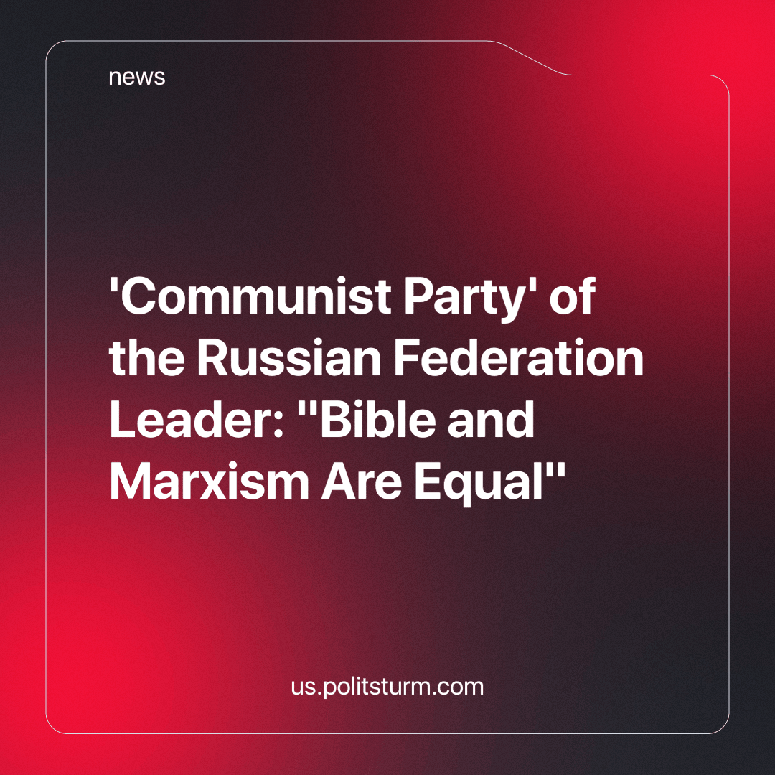

Original article
2024-06-10
2 min read

Gennady Zyuganov has asserted that the commandments of Christ align "one hundred per cent" with the "moral code of the builder of communism¹." The CPRF leader also expressed that all the needs of human life can be summed up in the phrase "Love thy neighbor as thyself."
"Mankind realized long ago that if we do not follow this principle, we will exterminate our own kind and return to the time when we were apes," said Gennady Zyuganov.
The politician also stated that Orthodox holidays did not contradict Soviet ones.
The moral code of the builders of communism differs from the commandments of Christ primarily in terms of the class component and the protection of public versus private property, respectively.
For example, the eighth commandment, "You shall not steal," was intended to protect private property from being stolen by the oppressed masses. In contrast, the provision on preserving and increasing public property in the moral code for the builders of communism protects it from theft by criminals and privatization by bourgeois elements.
Additionally, the seventh commandment, which prohibits adultery, helps preserve property within the family, contributing to its concentration and centralization. At the same time, the provisions from the code of the builder of communism concerning morality, purity, modesty in personal and public life, mutual respect in the family, and care for raising children, advocate for equality in the family between men and women. This demonstrates a relationship based not on self-interest but on trust, not on domination and submission, but on love and mutual support.
Moreover, the expression "Love thy neighbor as thyself" does not inherently prevent people from destroying each other. People need each other to produce material goods due to the social division of labor. Our ancestors could fight against nature for survival in the conditions of the primitive communal system together, collectively and jointly. Issues of empathy, compassion, and mutual assistance arise not from the realm of consciousness in a vacuum, but from the material conditions of society.
Since the head of the party is supposed to be its best representative, he sets trends and serves as a role model for others. From the above, it can be concluded that the question of faith in the CPRF is not seen as something to struggle against or a private matter, but something promoted for the whole party, which is unacceptable. The religious worldview is reactionary and always serves an exploitative ideology. Consequently, it is impossible to combat the oppressors of the working people by adopting conciliatory positions towards religion in general and Orthodoxy in particular. This behavior is entirely opportunistic.
¹. A set of 12 moral rules that every member of the Communist Party of the USSR was supposed to follow. Adopted at the 22nd Congress in 1961.
Source:
Komsomolskaya Pravda - “Zyuganov: the commandments of Jesus and the Moral Code of the builder of communism - the best that humanity has” dated May 05, 2024.

Original article

