Zetkin on the Women's Struggle
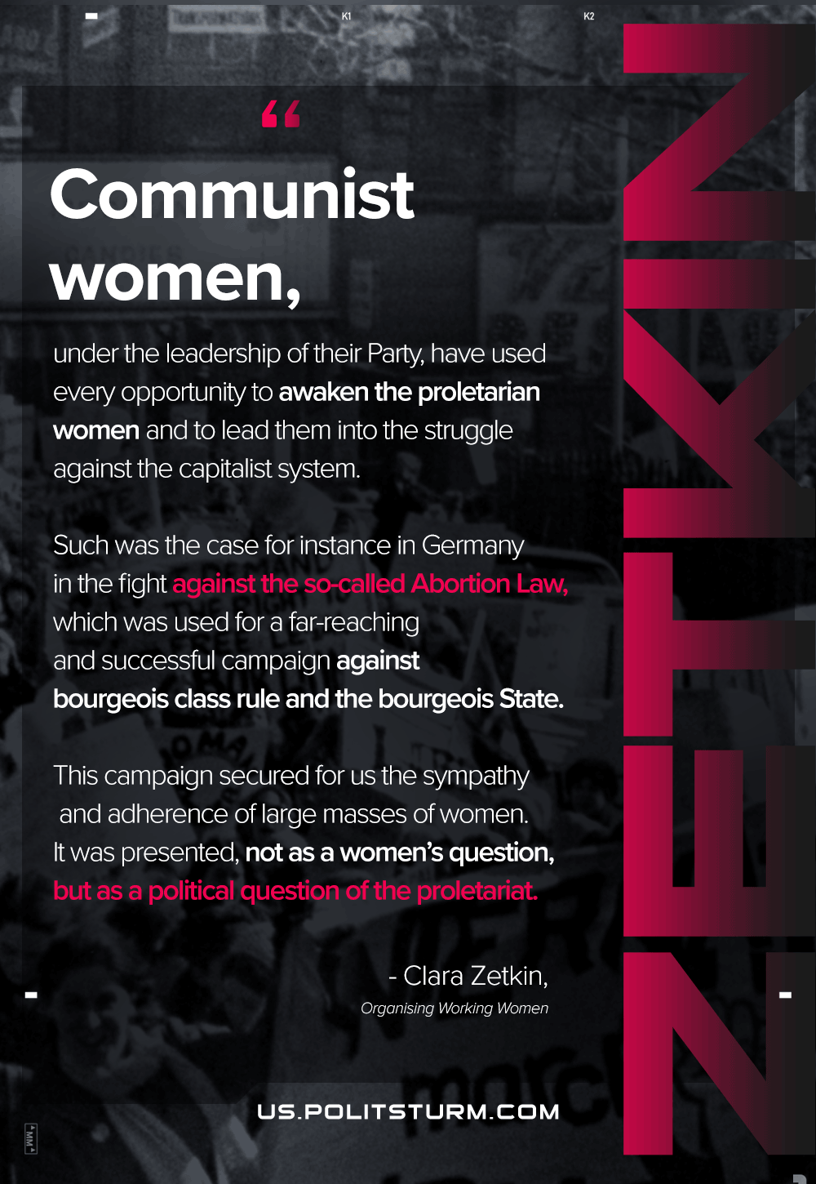

Original article
2021-03-09
1 min read

Communist women in each country, in accord with and under the leadership of their party, have, of course, utilized every opportunity and occasion to arouse the proletarian masses of women, to win them, and to lead them into struggle against the capitalist order. So, for example, in Germany the struggle against the so-called abortion paragraph provided the starting point for a very extensive and successful campaign against bourgeois class rule and class justice and against the bourgeois state. This campaign won for us the sympathy and support of broad circles of women. Yet the question was approached not as a women’s issue but as a political issue, a cause of the proletariat.

Original article

