Why Do Young Americans See Medicine as a Profession, Not a Vocation?
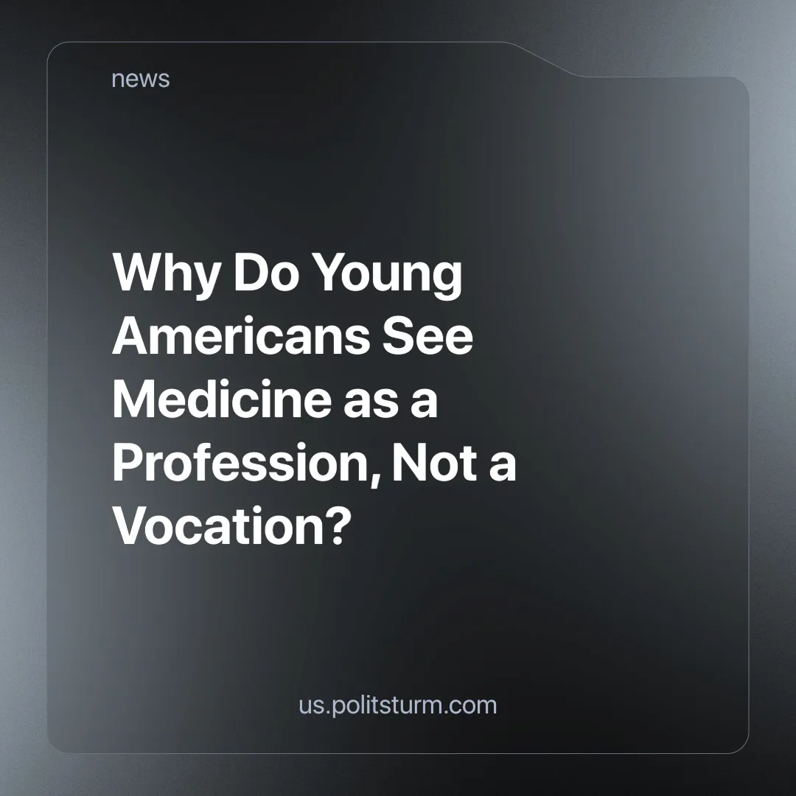

Original article
2024-12-12
3 min read

A new generation of American doctors believes that being a doctor is a job, not a calling.
For many years in the United States, it was considered normal for physicians to sacrifice their time for patients by agreeing to work off shifts and overtime. Doctors of the older generation recall having shifts for as long as 45 hours in one stretch, so the older doctors thought that workaholism and dedication were common among healthcare workers.
Young American doctors do not agree that self-sacrifice is a part of their work. They have already ensured that a doctor's shift should not exceed 24 hours, and they are not stopping there. In their opinion, being a doctor is a job like any other, and talking about a "vocation" is just a manipulation of the employer to further exploit the medical workers [1].
What is the reason for this change?
On the one hand, being a doctor in the USA is one of the highest-paid and most sought-after professions. For example, the salary of a cardiologist can reach over $450,000 a year. On the other hand, not all doctors receive such a salary [2]. For a pediatrician, it is almost half as much. The period of training is very long for everyone, and the full training of a specialist can take up to 16 years. A young specialist will be able to work and earn money only after 8 years of training and graduating from medical school, and incurring the associated debts [3].
Despite grants, scholarships, and various programs, it is very expensive for most Americans to become a doctor. High standards and workloads often make it impossible for a student to study and work a part-time job. Many are forced to study on credit and graduate from medical school with an average debt of $200,000. By comparison, graduates of the class of 1984 had a maximum debt of $27,000, illustrating why the two generations of physicians have such different life views [4] [5] [6].
Thus, the medical profession is not a vocation, but hard mental and physical labor that begins in medical school. While the most highly paid specialists form a labor aristocracy in this sector, the majority of the healthcare workers are exploited the same way as other workers - their labor is what produces the capitalists’ profit. And just like all workers, they cannot perform their job well when sleep-deprived and overworked. With workers in the medical sector, this can have deadly consequences. Medical error in the US is now the third-highest cause of mortality, with over 200,000 people dying annually [7].
Under the conditions of capitalism in the medical field, employers and officials often talk about duty, vocation, service to the patient and many other grand phrases, appealing to morality, selflessness and abstract humanity, citing their colleagues from the past as an example for young medical workers. But this is nothing but a deception to exploit the new generation “to work for peanuts”.
Most health workers in general that subsist by means of the sale of their labour to a capitalist should remember that they are all part of the exploited working class. They mustn’t trust the nice words, be quietly nostalgic, or dwell on the past. The pressure and offensive of the capitalists on the rights of the workers is getting stronger every year. Therefore, it is necessary and worthy for healthcare workers to begin to stand up for their rights and unionize.
A politically conscious working class, guided by its own party, is the only force capable of achieving true liberation from the oppression of exploitation. With its leadership, we can build a just society governed by the working people—a society where the medical profession will be valued as it rightly deserves.
Sources:
[1] Medwestnik — “In the U.S., young doctors refuse to consider working in medicine a vocation” — November 13, 2024.
[2] The white coat investor — “How much money do doctors make a year? Salaries are rising (a little), but not enough to satisfy them” — April 30, 2024.
[3] unipage.net — “Validating a medical degree in the US” — November 17, 2024.
[4] MD School — “How to get a medical degree in the US and become a doctor in America?” — October 18, 2023.
[5] Vedomosti — “The student loan situation in the U.S. resembles a mortgage bubble” — October 30, 2013.
[6] Forbes — “Reasons Not to Become a Doctor” — May 5, 2008.
[7] National Library of Medicine – “Medical Error Reduction and Prevention” – February 12, 2024

Original article

