Yacht Sales Spike During Pandemic
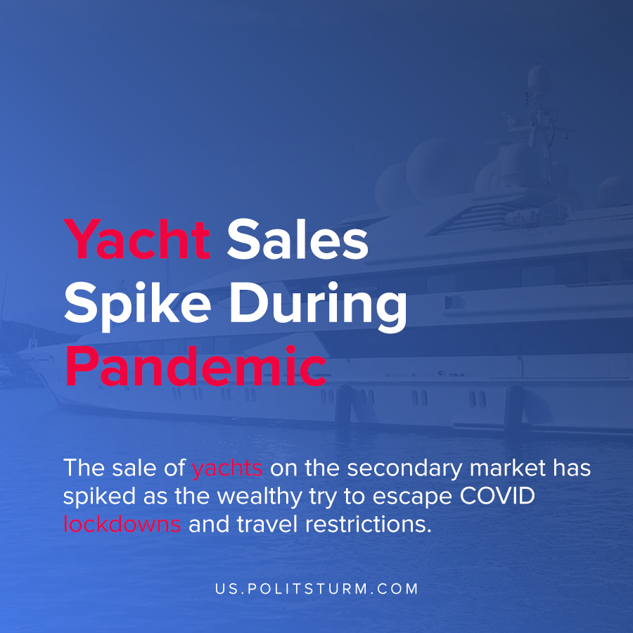

Original article
2021-05-22
1 min read

The sale of yachts on the secondary market has spiked as the wealthy try to escape COVID lockdowns and travel restrictions. Boat International claims that 2021 had the biggest surge in purchases of super-yachts which are defined as being longer than 24 meters and requiring a crew to operate.
Research also suggests that the market for yachts will continue to grow in the foreseeable future as the super-wealthy drive demand for the limited inventory. Grand View Research had the following to say about the global yacht market:

“The global yacht market size was valued at USD 8.15 billion in 2020. It is expected to expand at a compound annual growth rate (CAGR) of 5.2% from 2021 to 2028. The demand for yachts has gradually increased over the last few years owing to the increase in disposable income of individuals and their inclination toward leisure or recreational activities. The growing preference of travelers for luxury tourism, personalized service, and exclusive traveling are the primary factors propelling the sales of yachts.”
The wealthiest of the capitalist class like Jeff Bezos are buying much larger vessels. Bezos purchased a 127 meter super-yacht which even has an “accompanying support yacht” with a helipad.
As the wealth of the oligarchs has increased dramatically, the demand for non-practical luxury commodities has subsequently increased. Under capitalism, the private owners of the means of production are able to extract profits in the production process which can be reinvested or used to buy luxury commodities that only the capitalists can afford. Instead of a planned, rational economy under the control of the workers that would lead to balanced growth, a small group of exploiters are enriching themselves personally at the expense of billions of people.
Source: 1 2 3

Original article

