Xi Jinping Reasserts Reunification with Taiwan in New Year's Speech
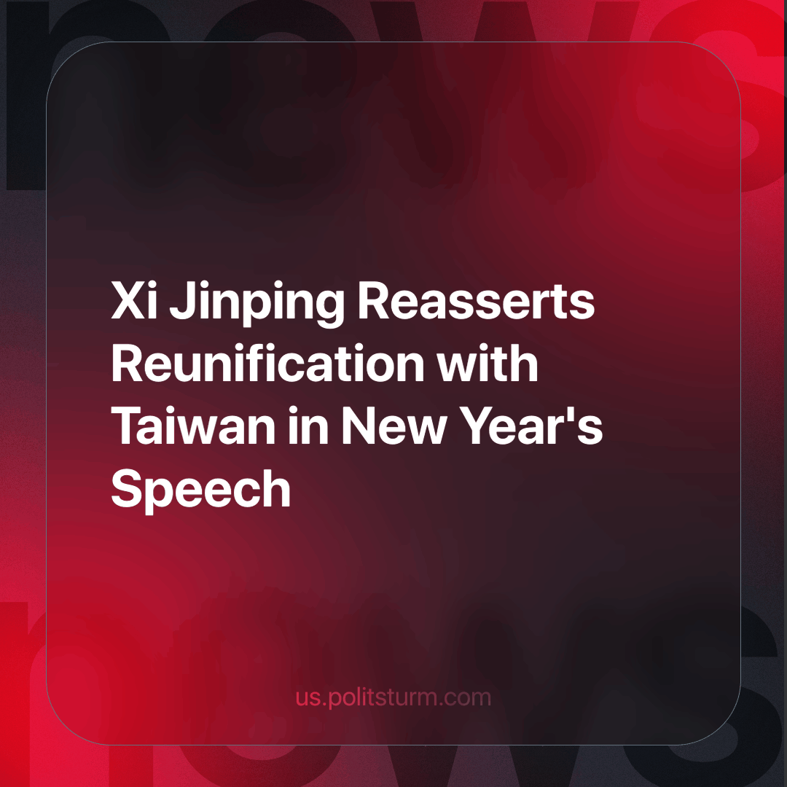

Original article
2024-01-03
3 min read

Xi Jinping said, in his New Year's speech, that China does not recognize Taiwan's sovereignty. He also called reunification with Taiwan a historical necessity. "China will surely be reunified, and all Chinese on both sides of the Taiwan Strait should be bound by a common sense of purpose and share in the glory of the rejuvenation of the Chinese nation", he stated.[1]
At a summit dedicated to reducing tensions between China and the United States in December, Xi told Biden that China prefers to “seize the island peacefully rather than by force”. Chinese officials asked the White House to make appropriate statements that the USA does not support Taiwan's independence and agrees with China's position on peaceful unification - a request that the White House naturally refused. [2]

Why is Taiwan so important?
- Taiwan's semiconductor industry is a world leader
The companies UMC and TSMC are headquartered in and operate in Taiwan and produce more than half of all semiconductors in the world: boards, processors, electronic components and chips. In 2020, more than 60% of the revenue from the entire global semiconductor production was accounted for by Taiwanese companies. At the same time, TSMC alone received 54% of all global revenue.[3]


2. 80% of world trade passes through the Taiwan Strait
Even a minor escalation of the U.S.-China conflict over Taiwan could threaten global supply chains. Bloomberg calls any action against the island a "blow to global shipping." The Taiwan Strait is the main route for ships travelling from China, Japan, South Korea and Taiwan to the West — goods produced in Asian factories are delivered through it to the markets of Europe, the United States and other countries. According to the agency, 88 per cent of the world's largest merchant ships and 48 per cent of 5,400 container ships passed through the Strait in 2022. [4]
3. The political factor
This is where the struggle of the Chinese bourgeoisie for the top of the imperialist pyramid manifests itself - and this struggle is being waged mainly against the United States.
Chinese workers are told that they are one people, that Taiwan is an echo of the civil war and only the separatists want independence. That unification is inevitable and the very course of history leads both sides to this.
In the West, the media relish this conflict solely as a struggle for Taiwanese independence and self-determination, for their democratic freedoms, and so on, clearly condemning China's claims to the island.
We have already described what lies at the economic basis of the conflict above, we only note that none of the parties even tries to promise any benefits from unification or independence for ordinary people - they simply do not exist. Instead, try to delude them with high-minded phrases. In reality, they are talking exclusively about who will control one of the key sectors of the modern world economy (microelectronics) and who will control one of the most important arteries of shipping around the world. Both of these reasons are important exclusively for the bourgeoisie because a simple worker has no other means of living but by selling their own labouring power and, of course, will not receive anything after a hypothetical resolution of the conflict in either case.
An important factor that will affect the further development of the situation around Taiwan will be the upcoming elections on the island. The presidential and parliamentary elections will be held simultaneously on January 13.
If the “democratic” party wins, it will likely pursue a course towards independence. China will prepare and carry out a seizure by force, as hinted at by repeated sabre rattling around the island and Xi's unequivocal statements at last year's party congress about the inevitable use of military force if Taiwan declares independence. [5]
If the “Chinese” party wins, then it is likely that a plan for peaceful unification with mainland China will be officially prepared, which will be rebuffed by the United States and its proxies on the island, which will certainly result in an armed conflict.
Imperialist contradictions are growing, and open and large-scale military and political conflicts are becoming increasingly commonplace. The Taiwan conflict shows us once again that until the workers unite and create a party that represents their class interest, they will be misgoverned in the interests of the bourgeoisie. The lives of workers will continue to be sacrificed in senseless conflicts for the profit of capitalists, the level of general welfare will continue to be lowered, the rights of workers and trade unions will continue to be attacked, and so on.
Sources: 1, 2, 3, 4, 5

Original article

