World Workers' Protests and Strikes Review, June-July 2022
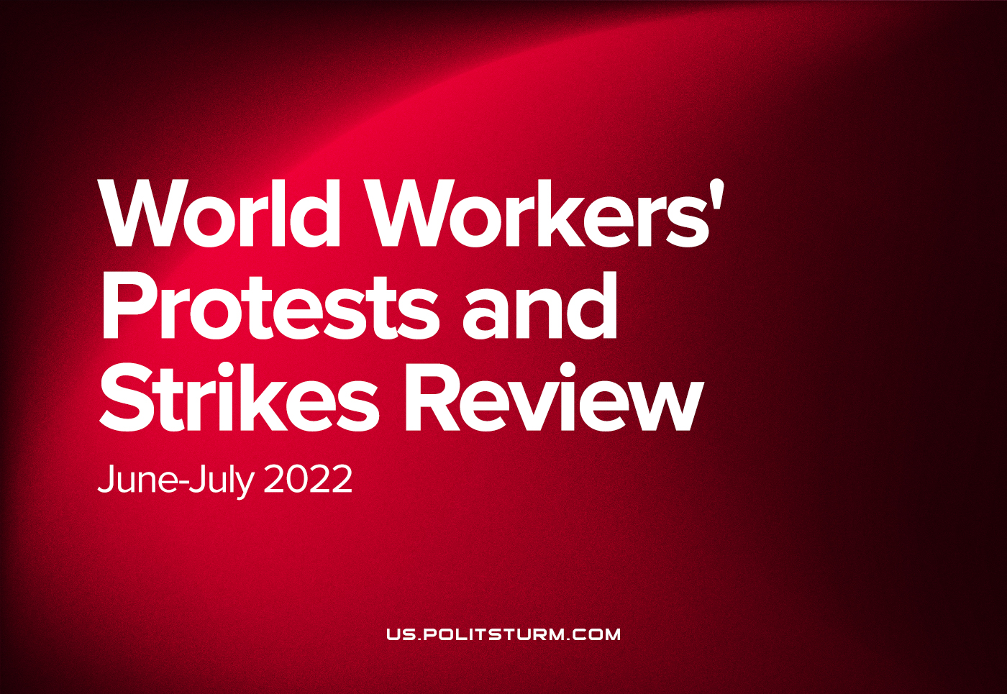

Original article
2022-07-13
6 min read

The capitalist world is shaken by protests and strikes.
Capitalism in the stage of imperialism cannot develop without intensifying the exploitation of the working class, without the half-starvation of the majority of the working people, without intensifying the oppression of dependent countries, without conflicts and clashes between the various imperialist groups of world capital.
Why do we call imperialism “dying capitalism”?
Because imperialism brings the contradictions of capitalism to the last line, to the extreme limits beyond which the revolution begins.
Three of the most important contradictions must be considered.
The first contradiction is between labor and capital – worker and owner.
The second contradiction is the contradiction between the various competing financial groups and the imperialist powers in their struggle for sources of raw materials and territory.
The third is the contradiction between a handful of dominating “civilized” nations and hundreds of millions of dependent peoples of the world.
FRANCE. On July 6, French SNCF railway workers went on strike demanding higher wages amid inflation and falling purchasing power. Air transport trade unions expressed similar demands, calling on workers in the industry to stop work on July 8–10, and also on July 13–17. The protests continue.
Error loading image
French farmers dump tons of rubbish near government offices to protest rising fuel prices
NETHERLANDS. On June 10, farmers began blocking roads, paralyzing many supply chains. The massive strikes were triggered by proposals for emission reduction reforms that would lead to the closure of 30% of livestock farms. On July 6, police opened fire on protesters who tried to block the highway. The protests continue.

Error loading image
GERMANY. On July 7, 450 to 500 farmers took part in protests in Bavaria, and expressed solidarity with their Dutch colleagues. The protests were also sparked by tougher environmental legislation and fuel issues threatening the entire industry. The protests continue.
ITALY. On July 8, farmers from Cantabria went on strike in the city of Lamezia Terme, dissatisfied with the growth of fuel and fertilizer prices, job cuts and poor working conditions. Another blow was the worst drought in 70 years, which resulted in large-scale fires. In some regions, a state of emergency has been introduced. The protests continue.
THE GREAT BRITAIN. Read our materials on the RMT rail-road strikes.
SPAIN. From June 1 to June 22, there was a strike of metallurgists. In the region of Cantabria, a trade union of 20,000 workers has decided to hold a general indefinite strike in order to increase wages and improve working conditions. After an appeal to the Deputy Prime Minister of Spain Yolanda Diaz (representative of the Communist Party of Galicia), the Ministry of Labor drew attention to the problem. The demands of the workers were met. Also, since June 24, there has been a strike of Irish Ryanair flight attendants, which has already led to disruption of hundreds of flights to Spain. The protests continue.
POLAND. On July 7 agricultural producers from the Agrounia association held a protest in Warsaw, demanding to stop the increase in interest rates on loans and introduce control over imports from Ukraine, which displace domestic products. The protests continue.
LATVIA. On July 27, the Latvian Union of Health and Social Workers will hold a warning strike for health workers, threatening to go on a full-scale strike at the end of September if it is ignored.
NORWAY. On July 5, a strike of oil and gas industry workers began, 6 fields were stopped. This led to an increase in gas prices in Europe, but after the intervention of the government, the union leadership decided to curtail the shares. The strike was strangled.
SRI LANKA. From mid-March, mass rallies have raged across the country, in which the widest sections of the population took part: from teachers, students and IT specialists to farmers and police officers. This was motivated by high inflation (more than 50%), problems with food, fuel and the energy supply. The crisis is considered the largest in the history of the country. On July 9, protesters broke into the palace of the fugitive president and seized several more buildings, setting fire to the prime minister’s residence. The next presidential and parliamentary elections should take place before March 2023. The protests continue.
IRAN. In December 2021, protests began and have continued to this day. Firstly, pensioners took to the streets, outraged by the size of pensions that did not keep pace with inflation (55%). Marches were held in Tehran and other cities under anti-government slogans. On May 1 there were demonstrations of teachers demanding higher salaries, which were severely suppressed by law enforcement agencies. In June, market traders joined the protests, unhappy with the sharp increase in taxes. In July, 1,200 workers at the country’s largest copper mine went on strike. They spent three nights in tents and cars at the mining complex. Arrests were made, and from the 7th the suppression of the protest became even more severe. The protests continue.
CHILE. On June 22, workers at Codelco, the world’s largest copper producer, went on a nationwide strike against the closure of the foundry for environmental reasons. It was attended by about 40,000 people who blocked roads and lit barricades. The demands of the workers were met.
VENEZUELA. On June 30, workers at the state-owned Siderurgica del Orinoco shut down a steel pellet plant for 8 hours. The reason was non-payment of salaries. The government tried to fire the strikers, and law enforcement agencies were involved. According to the latest reports, the demands were not met, but there is no further coverage of the protest.
LIBYA. In late June – early July protests broke out in northeastern Libya, including the city of Tobruk. Protesters demonstrated against deteriorating living conditions and prolonged power outages, exacerbated by the blockade of several oil installations due to clashes between armed groups, as well as political changes and the early reunification of the country. On July 1, protesters broke into the building of the House of Representatives (parliament in the territory under the control of the Libyan National Army of General Haftar), also blocking some roads. The protests continue.
YEMEN. In the second half of June, rallies began in the temporary capital of the state, Aden, against rising food and fuel prices. The immediate reason for the unrest was the decision of the government to reduce hours of electricity supply to the population. The protesters blocked main roads in the Mansoura area and set fire to tires, carrying out similar actions in a number of areas of Aden. There is no information about further events.
ECUADOR. On June 13, demonstrations of indigenous people began due to rising fuel prices and rising inflation, unemployment and poverty, after the huge protests against the previous Moreno government only 3 years before. They were attended by 14,000 people, of which about 10,000 went to streets of the capital. Clashes with the police began, as a result of which six people were killed and dozens of injured. Protesters blocked roads in at least 10 of Ecuador’s 24 provinces. By June 25, the actions were suppressed, and the state of emergency was canceled. The rallies led to the resignation of the heads of key ministries (economy, finance, health and transportation).
PERU. On June 27, protests by truckers and farmers broke out across the country. The reason was the rise in prices for fuel and fertilizers, as well as high inflation. The initiator of the movement was the trade union of drivers and carriers, uniting 400,000 units of freight transport in 14 out of the country’s 25 regions. The representative of the National Union of Transporters of Junina, Walter Solano, reported that 60% of heavy vehicles do not run on the central highway, and the general secretary of the Tacna Public Transport Drivers Union, Luis Conde, announced that all members of the union were participating in the strike. On July 11, nurses took to the rally demanding a salary increase .The protests continue.
GHANA. On June 28-29, protests were held in the capital against the increase in fuel prices and the introduction of additional taxes, incl. for electronic payments. Several hundred people took part in the action. Clashes with the police began as protesters threw stones, set cars on fire, and the police responded with tear gas, rubber bullets and water cannons. At least 12 police officers were injured and several official vehicles were damaged. No injuries were reported among the protesters, though over two dozen were arrested. There is no information about further events.
Error loading image
Protests in Ghana
ARGENTINA. On July 11, thousands protested in Buenos Aires over the repayment of debt to the IMF. Against the backdrop of rising inflation and economic instability, left-wing parties, trade unions and social organizations are calling for a general strike. Inflation in the country is at 30% and, according to analysts, could reach 70%, in addition to the deficit and the growth of the dollar. The protests continue.PANAMA. In early July, teachers’ protests began, joined by the indigenous peoples of the west of the country. The reason was the increase in fuel prices. Demonstrations engulfed the capital, and the Pan-American Highway, the longest highway in the world, was closed for 24 hours. The protests continue.

Original article

