Workers Suffer From Wage Cuts and Freezes
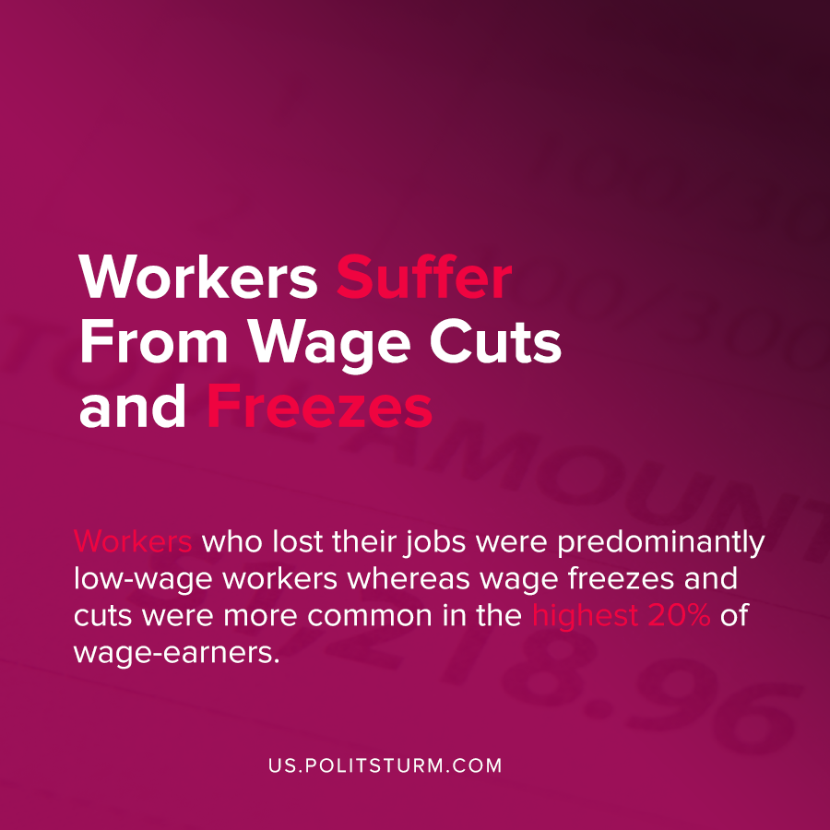

Original article
2020-09-22
1 min read

Research by economists at the University of Chicago tracked payroll data during from the onset of the coronavirus pandemic and concurrent economic crisis of overproduction to discern trends from the data.
The researchers found that those workers who lost their jobs were predominantly low-wage workers whereas wage freezes and cuts were more common in the highest 20% of wage-earners.
The United States experienced “the worst employment losses since the Great Depression” and after a temporary rebound in employment, job gains have slowed considerably.
As states have begun removing restrictions on economic activity, there has been a partial recovery but not to the pre-crisis level. The authors note that there will be significant challenges as “demand forces will still prevent employment from returning to pre-recession levels.”
This crisis has put the largest strain on low-income workers, and even higher wage workers have experienced wage cuts or freezes. In addition to wage cuts, the millions of workers who have had their wages frozen will not experience any wage growth, perhaps for many years.
The capitalist system is inherently unstable due to the anarchic market system and the need to constantly generate profit. During crises of overproduction workers are thrown out of work or suffer wage reductions and freezes as the supply of labor increases from unemployment. Under a planned system of socialist production the need to generate profit for the exploiting classes ceases to be a concern and also eliminates the unnecessary harm caused by unemployment for all workers.
Source: 1

Original article

