Workers Real Wages Fall
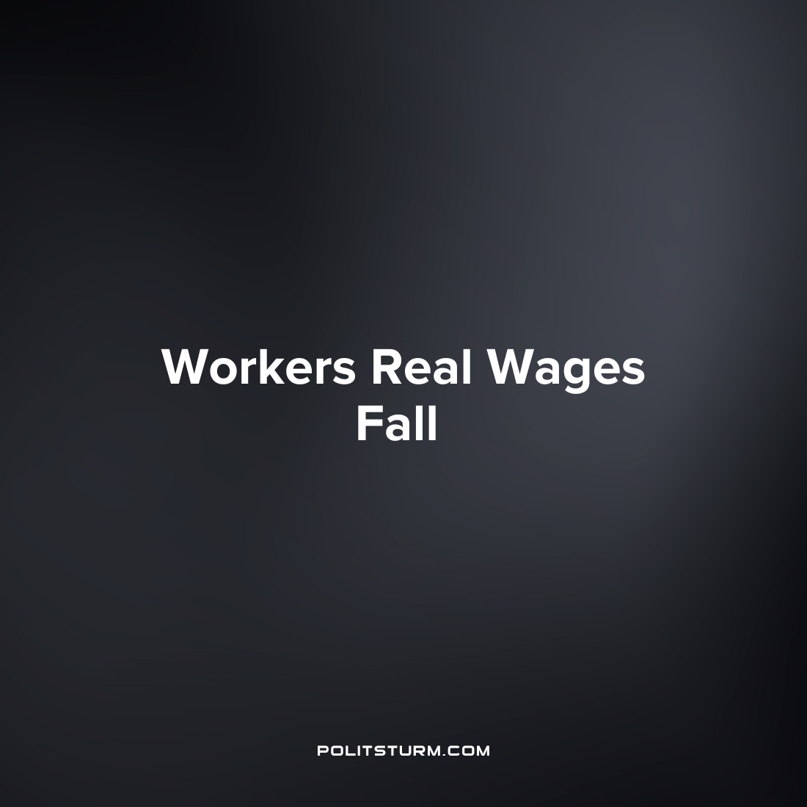

Original article
2022-08-10
1 min read

The Bureau of Labor Statistics (BLS) most recent release on real wages gives a glimpse into how wages have been impacted by inflation. While real wages have increased slightly in the last month, the longer-term trend paints a different picture.
From July 2021 to July 2022 real average hourly wages decreased 3% after being seasonally adjusted. Coupled with a 0.6% decrease in the average work week this means that over the period there was a 3.6% decrease in real average weekly earnings. This would imply that after factoring in inflation wage workers are able to purchase fewer goods with their income in July 2022 than they were just a year earlier.
The capitalist economy serves the interests of the bourgeoisie, namely the capitalist class who reap the profits of social production. While the workers are dependent on wage income and only have their labor power to sell to the capitalists, the capitalists reap enormous profits despite rising inflation. The negative repercussions of the anarchic system of capitalist production are pushed onto the working class who merely have the choice of which representative will serve the interests of the oligarchs, the essence of capitalist “democracy”.
10Even under conditions where wage earnings are not eroded by inflation, the capitalist class profits at the expense of the workers. It is imperative the workers understand Marxist-Leninist theory to ultimately end the exploitation of man by man which occurs regularly under the capitalist mode of production.
Source: 1 2

Original article

