Workers Real Incomes Fall As Prices Rise
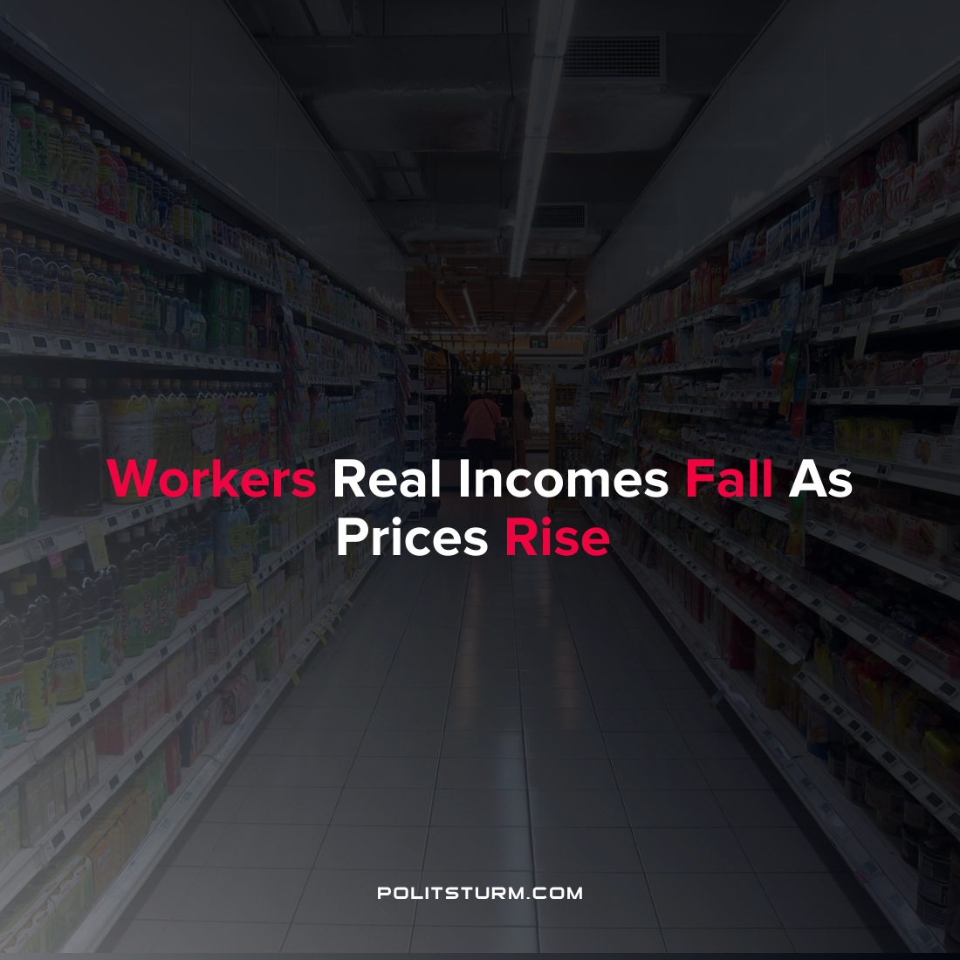

Original article
2022-03-12
1 min read

Real wages are on the decline for most American workers as prices continue to rise while wages remain relatively flat. According to the most recent data release by the Bureau of Labor Statistics, seasonally adjusted real wages fell 2.6% from February 2021 to February 2022. Over the last month alone workers faced a 0.8% decrease in real wages as wages remained unchanged while the prices of commodities measured by the Consumer Price Index increased by 0.8%.
Workers’ incomes have been strained by rising prices as the price of energy (including gasoline and fuel oil) alone has increased 25% over the last 12 months. Food prices have also risen 7.9% over the same time period. At-home food prices had the largest percentage increase since 1981. While capitalists have been able to simply raise prices for their commodities, workers have not been able to organize in a class-conscious manner in order to increase wages to keep up with inflation, essentially falling behind. While the capitalist class hold the majority of societal wealth and money, they are well-equipped to deal with rising prices. The working class, needing to sell their ability to work in order to survive, are in a much less enviable position. It is imperative that workers understand their class position and fight back against the bourgeois class who are well positioned to benefit under capitalism, regardless of circumstance.

Source: 1 , 2

Original article

