Workers Lose $3.7 Trillion Earnings During Crisis
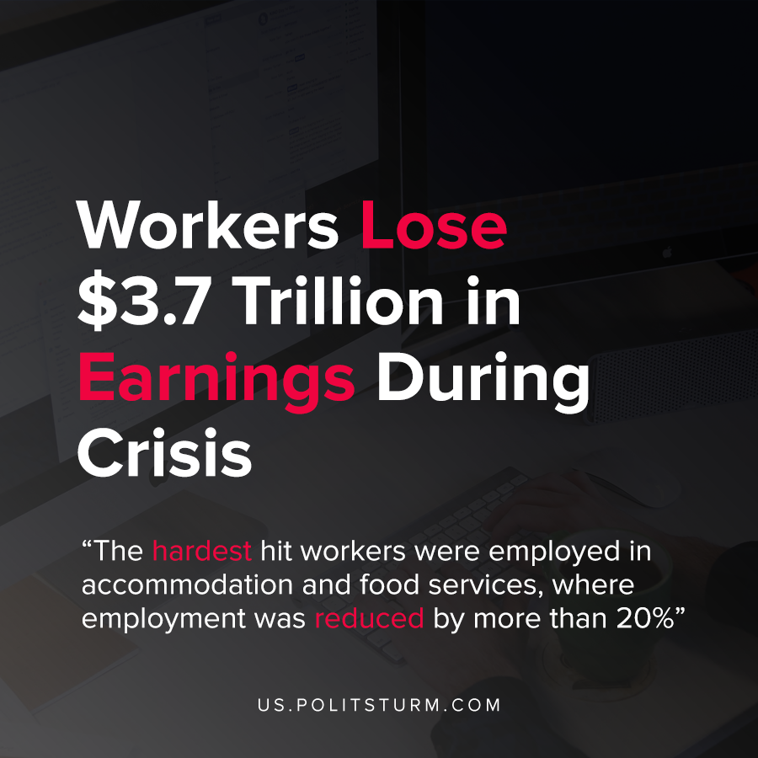

Original article
2021-01-29
1 min read

According to a new analysis of the labor market by the International Labor Organization (ILO), the global working class was devastated by the global pandemic. Estimates show that working hours were reduced by 8.8% for last year, equivalent to 255 million full-time jobs.
These lost working hours are accounted for by a reduction in worker’s scheduled hours, or loss of employment. Millions of people left the labor market because of restrictions, ceased looking for work, or were simply unable to work.
The losses in working hours led to an 8.3% reduction in working income which is equivalent to workers losing $3.7 trillion in earnings.
The hardest hit workers were employed in accommodation and food services, where employment was reduced by more than 20%. Other notable employment losses were in retail and manufacturing.
During the capitalist economic crisis, the crisis is borne by the working class. While billionaires are accumulating fortunes, the working class is suffering from loss of employment and wages. The capitalist class fight to protect their own interests, that is, the continued exploitation of the global working class and pushing the negative effects of the crisis onto the most vulnerable of the working class. Only the elimination of the private ownership of the means of production can eliminate the periodic crises of overproduction and the dictatorship of the bourgeoisie.
Source: 1

Original article

