Workers Buried Under Crumbling British Economy
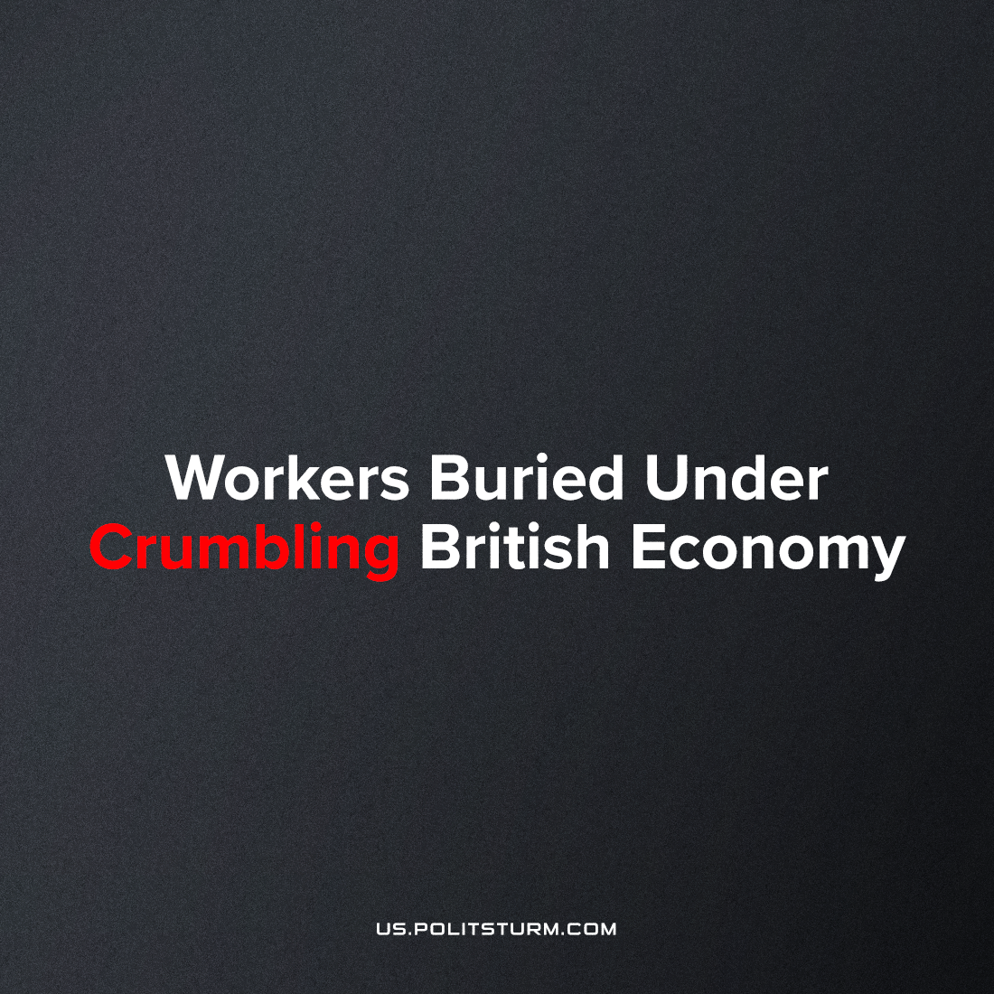

Original article
2023-06-23
5 min read

The latest woes of the ongoing crisis of capitalism has made itself known in Britain. As has been reported, the United Kingdom is notable among the major Western imperialist states for the depths of its decline amid the economic crisis now wreaking destruction across the world.
And how does the bourgeoisie get over these crises? On the one hand by enforced destruction of a mass of productive forces; on the other, by the conquest of new markets, and by the more thorough exploitation of the old ones. That is to say, by paving the way for more extensive and more destructive crises, and by diminishing the means whereby crises are prevented.
— Communist Manifesto
The most recent is the revelation that inflation remains stubbornly persistent despite the false assurances of the bourgeois media and bourgeois economists that inflation will start going down “any day now.”
This is now causing fresh concern among British society that due to inflation remaining extraordinarily high in comparison to Britain’s peers, the Bank of England will have to resort to a further interest rate increase in order to counter the effects of the economic crisis. This though is stoking fears that a recession or a contagion following bank runs could occur and plunge the economy into a more perilous position with the proletariat being the most hard hit as the rate of exploitation will inevitably intensify in such a scenario.
The primary driver of overall inflation is still food inflation. Despite the Secretary of State for Work and Pensions, Mel Stride claiming that food inflation ‘in Germany, Portugal and Sweden it's running at about 20%, so higher than it is here,’ reality begs to differ. These statistics cited by the government minister are out of date and in fact ‘the UK's food inflation in April was higher than the European Union average of 16.4% and higher than all the major European economies.’
The Office for National Statistics (ONS) has recently analysed the figures and has identified three key catalysts for the inflationary crisis regarding foodstuff. The ONS stated that prices were rising due to:
- Russia's invasion of Ukraine, which had a major impact on energy prices, as well as grain and fertiliser supplies
- Bad weather in Europe and North Africa (read our recent article on the climate crisis here)
- UK labour shortages, which have left some crops unharvested.
The crisis is now having a serious effect on the lives of working Britons. British brewers are now watering down pints, a staple of Britain’s social life, and reducing the ABV (alcohol content) due to ever-increasing costs. In January, Dutch brewer Heineken lowered the ABV content of Foster’s lager — which it sells in the UK — ‘to 3.7% from 4%.’ This has been followed by Greene King, a major UK brewer and pub chain, has ‘cut the ABV, or alcohol content, of its popular Old Speckled Hen pale ale to 4.8% from 5%,’ whilst in March, the country’s oldest brewer, Shepherd Neame, slashed the ABV of its bottled Spitfire and Bishops Finger ales ‘to 4.2% and 5.2% respectively, from 4.5% and 5.4%.’ This has been attributed to ‘significant increases in the cost of its raw materials, such as energy and glass, and had, as a result, increased the prices on all of its beers.’
This is just one facet of the crisis; what is left unsaid is this process is occurring in all sectors as monopolies seek to augment their profitability by cutting down production and lowering quality standards. This as a consequence endangers the health and lives of workers who now have to pay higher prices for worse food and drink.
This inflationary crisis however is reaching a point where it now threatens to consume the wealth of labour aristocrats and petty-bourgeois owners. According to the Financial Times:
‘About 1.3 [million] people have a fixed-rate mortgage deal that will expire in the 12 months from July 1, or about one-sixth of all households with mortgages.’
With inflation making lives difficult for even small owners and well-paid workers, such an increase would be intolerable and may even lead to further proletarianisation, unemployment and homelessness as higher mortgage rates would be pushed by landlords onto the workers via higher rent. This process is rapidly accelerating, statistics show that UK 2-year gilts rose by 5% ‘for the first time since 2008’ up by 7 basis points in a day. The gilt market is now in the same treacherous waters as almost a year ago during the brief tenure of Liz Truss as PM (the significance of gilts and Liz Truss’ policies can be read in this article written at the time.) In short, higher gilts lead to higher borrowing costs (already high) which means a larger government deficit leading to further economic contraction. Coupled with the effects of the wider crisis, this situation is leading to poverty expanding and being more deeply embedded.
The ruling Conservative Party, being servile stooges for the large capitalists like all major parties, have ‘ruled out’ a tax relief for mortgage payments and food price caps with Jeremy Hunt, the Chancellor, explaining that he was against prolonging the ‘inflation agony’ hitting households, saying:
‘Much as we sympathise with the difficulties and will do everything we can to help people who are seeing their mortgage costs going up, we won’t do anything that would mean we prolong inflation.’
Hunt brushed aside suggestions that the government should cap food prices, telling MPs:
‘I don’t believe capping prices is the right long-term solution.... I will be meeting the regulators next week to talk further about what needs to be done with respect to supermarkets.’
What the Chancellor has revealed is that the government shall do nothing as it would be against the profitability of the large owners and monopolists who are benefitting enormously from the crisis and the poverty that the crisis is inducing. This course charted by the Tories is championed by The Financial Times, a bourgeois newspaper par excellence, which states that:
‘Financial support would also be misguided in monetary policy terms. The BoE relies on the notion that raising the cost of borrowing will absorb demand. Handing out public money impedes that harsh but necessary process. Rates would need to rise even higher to stamp out inflation, and higher borrowing could push gilt yields up further.’
Concluding, ‘unfortunately for homeowners, things will have to get worse before they get better.’
This reveals the starkly the policy of the monopolists: no impediments to profitability and the concentration of capital into fewer hands can be tolerated. Even though this policy will drive the masses into destitution and potentially end the Conservative Party as a political force, the Tories are prepared to go down with the ship: ever loyal to the last.
What does this mean for the workers? In short, more workers shall understand their place in bourgeois society; more shall become hostile to the rule of the propertied few; more shall become aware of the proletariat’s world-historic role. The strikes of the past year could very well be a mere prelude to a further expansion in labour agitation as more and more workers fight back against their exploitation and destitution. The situation is revealing itself to be just the opening chapter of future and more intense class conflict between the exploited majority and the exploiting minority.
Sources: 1; 2; 3; 4; 5; 6; 7; 8

Original article

