Wisconsin UI Call Centers Answered 0.5% of Calls
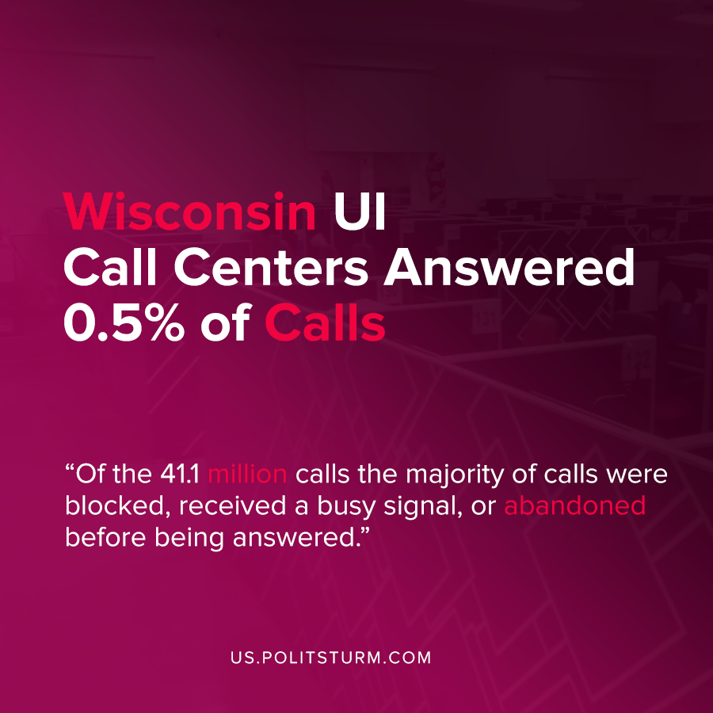

Original article
2020-09-27
1 min read

An analysis of the Legislative Audit Bureau of Wisconsin has been released pertaining to the call centers for state unemployment insurance. At the onset of the latest economic crisis and the COVID-19 pandemic, the call centers were flooded with inquiries relating to program eligibility, filing claims, accessing online accounts, etc.
For example, according to the analysis during the week of April 12, 2020 the call centers received 5,781,621 calls. Between March 15,2020 and June 30, 2020, of the 41.1 million calls that came into the call centers, 38.3 million were blocked or received a busy signal. Ultimately, only .5% of telephone calls were answered during that period.
Of the callers whose calls were answered by the Department of Workforce Development call centers, on average they waited on hold for 52.2 minutes.
The purported goal of the audit was to provide state oversight and to promote “efficient and effective state operations”.
The audit revealed that during an economic crisis, the unemployed in Wisconsin were not even able to readily get assistance regarding unemployment insurance. Under the capitalist system, a crisis of overproduction occurs roughly every 10 years, during which unemployment increases as workers lose their jobs. It is not surprising or unpredictable that there would be a subsequent increase in unemployment-related inquiries during these periods of time.
This audit reveals how in addition to the scourge of unemployment, the systems under capitalism to support the unemployed are inefficient and unsupportive of the workers. For as long as capitalism exists, federal and state governance will serve the interests of the capitalists and not the workers.
Source: 1

Original article

