Wisconsin Diverts $302 Million Taxpayer Funds Into Private Schools
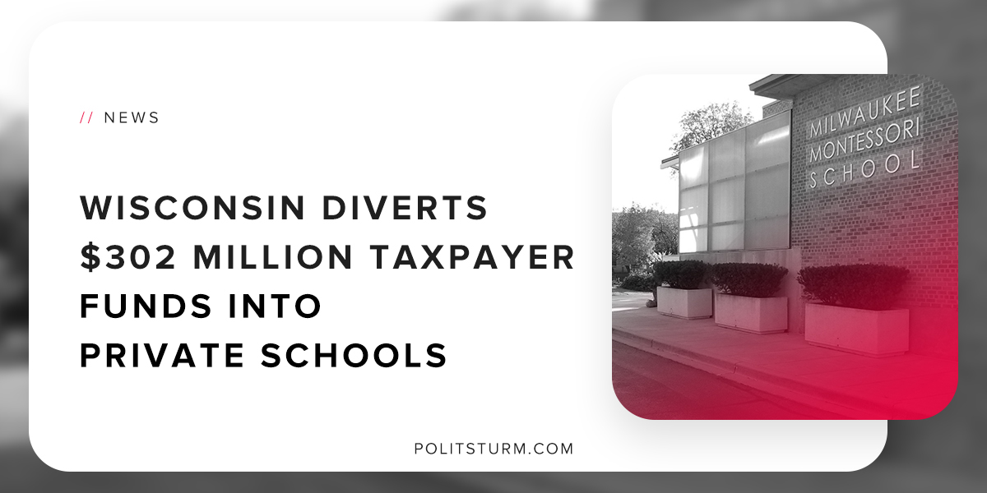

Original article
2018-11-03
1 min read

In Milwaukee, public school education enrollment has declined while simultaneously private school enrollment has increased substantially. One of the reasons for this phenomenon is the expansion of the states voucher program.
Vouchers give parents the freedom to choose a private school for their children, using all or part of the public funding set aside for their child’s education.
The voucher program allows eligible K-12 students to receive vouchers to offset the educational costs at eligible schools.
Schools receive $7,754 per student in Kindergarten through 8th grade, and they receive $8,400 per student for high schoolers.
In this way, public funds can be siphoned off into profit-driven educational enterprises.
The argument underlying the voucher programs is centred around the idea of freedom of choice. According to this theory, if consumers are given the greatest freedom of choice, they will have the best results.
The “freedom to choose” between public and private schools is used as the justification to take public funds and divert them into private schools. Many of the eligible private schools also have a religious orientation.
Voucher programs are just another method by which the capitalist class can erode the social services available to the public. Funds that are used in voucher schools are no longer available to the public school system. To make up the shortfall either taxes would have to be raised, or services to the public schools are cut.
Whenever the capitalist class uses the argument for increased “freedom”, this is merely empty rhetoric. The freedom is only for the capitalist class to exploit the mass of people and undermine the progress of society for the sake of profitability.
Source

Original article

