Why Don't We Have Enough money?
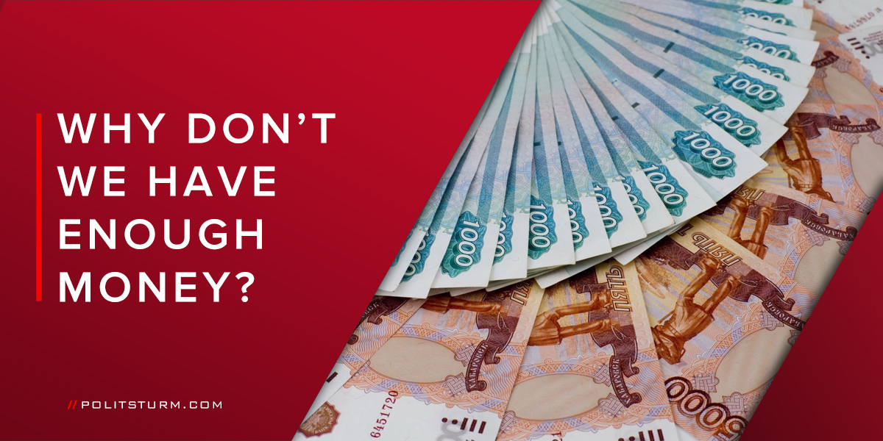

Original article
2017-10-24
7 min read
The reason is that we live under capitalism. We live in a system, where there is a small class of the richest people and millions of poor people.
Capitalism is a social system in which all means of production are the private property of the capitalist class. Businessmen exploit the labor of wage-workers for profit
.
The means of production are land, forests, water, soil, raw materials, tools of production, production buildings, means of communication and so on.
Why are we so poor? Why do we constantly need more and more money? Why can’t we live like rich people? Every Russian has asked themselves these questions at one point or another.
Why is this the case? Working people are often answered with phrases like “you need to work harder”, “raise your qualifications”, and “to make good money, you need to go into business”.
Is there any truth in these replies? What is really the root of this problem and what does one do about it?

“You are poor because you need to work harder.”
This is a very common reply. It is spoken on the TV, all over the Internet, by your friends and your boss. This answer is simple and, at the same time, unbelievable, because we work for about 10-12 hours in a day, 6 days in a week(and even 7!), 12 months in a year, in not the best conditions, but we still can’t earn more money. Your boss pays you a low salary, but drives around in a prestigious foreign car. There are a lot of cases when an employer refuses to pay for your hard work at all! This situation happens very often in our country, and no one is going to judge and punish this thievery.

“You are a low-skilled employee.”
All too often the employer has a response for these low salaries. “You want to increase your salary? Improve your skills!” – he says. Hah, it’s easy to say “improve your skills”. Raising one’s qualifications is undoubtedly a very difficult procedure. It is necessary to pass special courses, and, of course, pay for them. A simple worker doesn’t have enough money to satisfy even his basic needs, let alone improving his skills. But the boss does not give a damn about it. What is the capitalist’s motivation? Profit, profit and once again profit.Do you think such stereotypical “capitalists” are not real? Oh, they are! For businessmen wages are a cost of business. And they are interested in minimizing these costs whenever possible. It is quite logical that the lower the worker’s salary, the greater the profit the business owner reaps.

What is the cause of poverty?
The owners of the means of production – capitalists – buy the only thing worker can sell – his labour power. But you cannot determine the price for which you are ready to sell your “goods”, your labour power. The capitalist indicates the price (salary) for which he is ready to buy your “goods”. There is a myth that the boss pays for all the labour of an employee, issuing a salary for it. No. He pays only part of the cost of labour, and the rest, the surplus value, the capitalist will put in his own pocket. That’s why he’s so rich, and you’re so poor. His wealth consists of money stolen from workers.
The uniqueness of the labor power is that unlike other goods, the prices for which always grow (another way of robbing the workers by the capitalists), the labor price, as a rule, always falls.
And the fact that the salary raised, does not mean that the price of your labor has increased. After all, what you get in your hands is just a nominal salary. It’s the sum of money received by workers for the labor power sold to the capitalist. The real wage is the wages expressed in the means of existence of the worker; it shows how much of the means of subsistence and services a worker can buy for his monetary wages. Rising prices in the shops, utility tariffs and other unpleasant things negates the entire growth of nominal wages.

So, do I need to make a business to become rich?
No, it does not work in that way. The laws of capitalism are characterized by competition. When a successful businessman drives a competitor out of business they were subsequently ruined and therefore became proletarians. This is what happened in Russia in the 90-s. It was a dangerous and difficult time, forever entered into the popular memory as the “dashing 90’s”. Gangster wars and years of unpaid wages – all of this was the result of the collapse of socialism. There was a fight for the right to snatch a piece of public property, to rob the laboring people. By 2000, everything was already divided, and there was no point in fighting.
Now there are 96 billionaires and 130,000 millionaires in Russia. They will not tolerate new businessmen. They are just thinking how to ruin their fellow “classmates” and to become even richer themselves. Here the ceiling for the worker is the status of a small proprietor, for example, a stall holder, who is often even poorer than a worker. Therefore, in the capitalist system the worker has only two options – poverty or poverty. Capitalism does not offer anything else.

What to do?
Unite. The working class is fighting for the reduction of the working day and raising wages. But the working class can’t free itself using only economic struggle.
Сonditions for the economic and political oppression of the working class can be eliminated only with destruction of the capitalist mode of production, through the revolutionary political struggle. Only then it is possible to establish the power of the working class. Then the means of production will be socialized, the former property of the capitalists becomes the property of the entire working class, and then the labor of the worker stops being a commodity. It becomes a contribution to a socialist society whose goal is to ensure the well-being and comprehensive development of all its members. Only by this act can the worker eliminate poverty. There is no other way.

Poverty Facts
At least 80% of humanity lives on less than $10 a day.Source 1
More than 80 percent of the world’s population lives in countries where income differentials are widening.Source 2
In 2005, the wealthiest 20% of the world accounted for 76.6% of total private consumption. The poorest fifth just 1.5%
Every day, 25,000 children under the age of 5 die, mostly from preventable causes.
The global unemployment rate stood at 5.8 per cent in 2015, meaning that almost 200 million
people (an estimated 199.4 million) were unemployed.
Global real wage growth dropped sharply during the crisis (2008 and 2009), recovered some what in 2010 but fell back in 2011 and has decelerated again since 2012, falling in 2015 to its lowest level in four years, and below the 1 per cent mark in 2015 if China is excluded.
http://www.globalissues.org/article/26/poverty-facts-and-stats#src1
https://www.oxfamamerica.org/static/media/files/actfast-factsheet.pdf
http://www.ilo.org/wcmsp5/groups/public/—dgreports/—dcomm/—publ/documents/publication/wcms_537846.pdf

Original article

