Whole Foods Reducing Health Care Coverage Eligibility
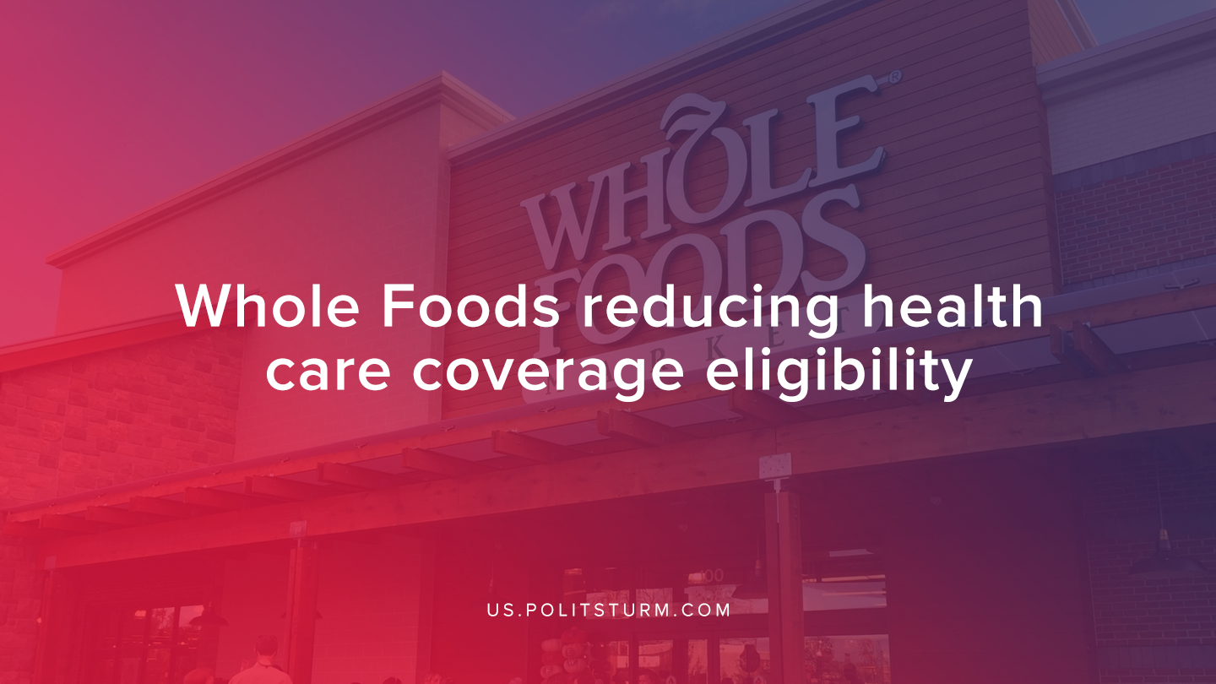

Original article
2019-09-23
1 min read

Whole Foods, a subsidiary of Amazon, announced that it would be reducing health care coverage effective January 1,2020 for approximately 1,900 of its employees. The specific change was to raise the eligibility for medical coverage from 20 hours to 30 hours per week.
“In order to better meet the needs of our business and create a more equitable and efficient scheduling model, we are moving to a single-tier part-time structure”, said a company spokesperson in an email.
The spokesperson also made it clear that the employees who lost health care coverage would still be able to buy commodities at Whole Foods for a 20% employee discount.
The Whole Foods Mission Statements says, “Our purpose is to nourish people and the planet. We’re a purpose-driven company that aims to set the standards of excellence for food retailers.”
The company is indeed purpose-driven, however, the purpose is the maximization of profits for the capitalist class at the expense of the workers. The cutting of health benefits is a manifestation of the inherent contradiction inherent in capitalist production. The interests of the workers are fundamentally in opposition to those of the corporate executives and investors.
Capitalists benefit from any reduction in costs and the increase of profits which are appropriated by investors.
Sources: 1 ,2

Original article

