Who Really Benefits from the Grain Deal in Ukraine?
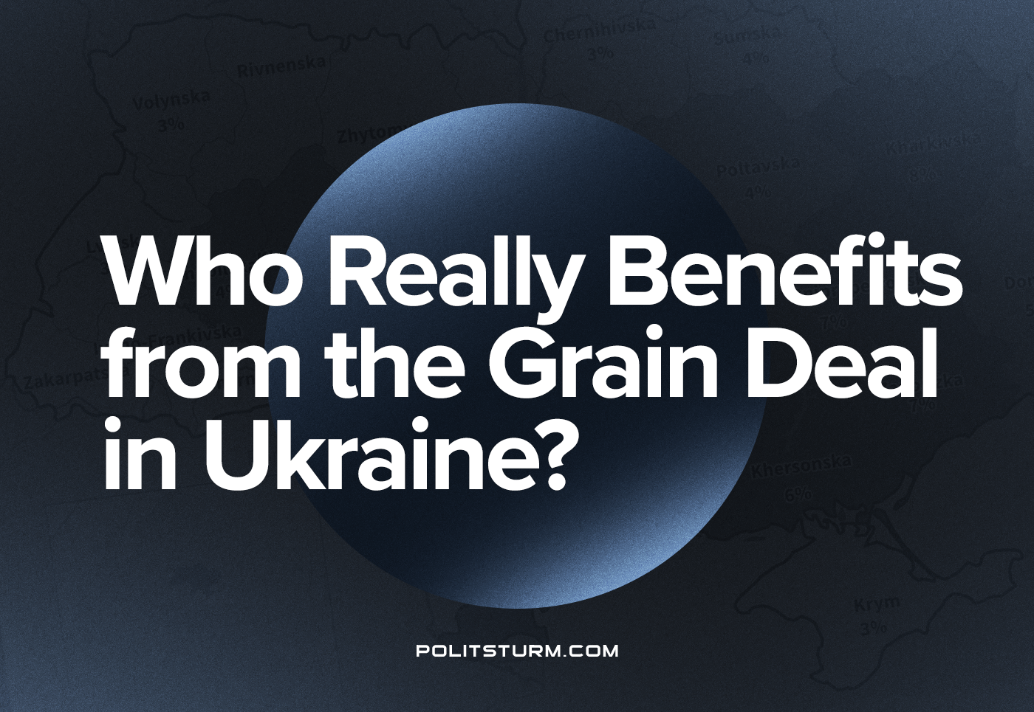

Original article
2022-10-03
12 min read

The blockade of Ukrainian ports has been actively discussed both in Ukrainian and international media since the very beginning of hostilities. The state’s top officials declared the need to unblock the seaports, arguing that the blockade would inevitably lead to a global food crisis.
Officials of the United Nations echoed the government of Ukraine. Speaking at the end of May at the World Economic Forum in Davos, the head of the UN World Food Program, David Beasley, stated:
“Failure to open the ports in Ukraine will be a declaration of war on global food security. It will cause famine, destabilisation & mass migration in nations around the world.”
However, after more than a month since the long-awaited unblocking of sea routes, some inconvenient facts have surfaced. Let’s look at them and draw our conclusions regarding the actual beneficiaries of the “grain deal”, the nature of the current military confrontation, and even the nature of the economic system in which we live.

Background
In early July, Western press reported that Russia and Turkey had reached a preliminary agreement to ensure the safe resumption of grain supplies through Ukrainian-controlled Black Sea ports. The proposed plan provided for the complete demining of the water area near Odessa and guaranteed the safe exit of ships from the Black Sea under the auspices of the UN. Later, Ukraine stated that it would not participate in the agreements between Turkey and Russia regarding such a solution to the food issue. Again their position changed, and on July 12th, the head of the Office of the President, Andriy Yermak, called to lift the blockade of Ukrainian ports one of the critical components of the same “global food security”.
As a result, Ukraine, Turkey and the UN signed an agreement on the safe transportation of grain and food from Ukrainian ports for 120 days with the possibility of extension. A similar document was signed by Russia, Turkey and the UN representatives. The agreement provides grain shipment from three ports in the Odessa region: Yuzhny, Chernomorsky and Odessa.
According to this agreement, first, the captains of the Ukrainian fleet bring their ships with grain to the border of international waters, where foreign crews then take control. Before continuing on their way, the latter must bring the ships to a special monitoring center in Istanbul. The Turkish side undertook to check the ships for the presence of military cargo.
On August 3rd, the first ship with Ukrainian grain arrived in Turkey. The Razoni, sailing under the banner of Sierra Leone, was loaded with 26,000 tons of corn to be shipped to Lebanon. At the time, UN Secretary-General António Guterres pompously declared that Razoni was “loaded with two commodities in short supply: corn and hope. Hope for millions of people around the world who depend on the smooth running of Ukraine’s ports to feed their families.”
Error loading image

What went wrong?
On August 7th, Lebanese Minister of Public Works and Transport Ali Hami said that the Razoni vessel, which was supposed to arrive in the port of Tripoli, did not reach its destination and changed its route. Ukrainian Ambassador to Lebanon Igor Ostash commented on the situation: “We are now in Tripoli, but the meeting of the first ship with corn from Odessa is postponed. We are waiting for the completion of the negotiation process on the business plan. Behind this vessel, 20 others are already ready to leave Odessa. Ukraine is making every effort to save the countries of the Middle East and Africa from the food crisis. At the same time, ships with unstolen Ukrainian grain follow from Reni and Izmail to Lebanon every week. Ukraine supports Lebanon!”
But in Lebanon, Ukrainian grain was never seen. And all because, in fact, the Razoni had arrived in Syria, the country which Ukraine accused of buying 100 thousand tons of grain stolen (collected in the occupied territories) by Russia. To the country that recognised the DPR and LPR and with which Ukraine severed diplomatic relations while promising increased sanctions pressure.
The new facts that have become available to the public completely destroyed all the previous theses about lifting the blockade from the ports of Ukraine, allegedly to prevent mass starvation in “developing” countries. It turned out that it is not mainly wheat being exported from the ports, but animal feed corn and sunflower oil, one of the leading export products of the Ukrainian agricultural industry. They are not being taken to the starving parts of Africa but mainly to Europe.
Error loading image

“Two of the ships that have left ports in Ukraine after months of being trapped there are going to Turkey, carrying corn. One is going to England. One to Ireland. Others are headed to Italy and China. None of the ships released so far is going to Yemen, Somalia, Ethiopia or other countries facing catastrophic levels of hunger. Instead, they are going wherever buyers want them to: They are commercial ships, carrying grain for sale.” – mention Western journalists.
As already noted, most exported grain is intended, not for the starving, but for feeding animals. Therefore, exports through grain corridors from Ukraine will not ultimately lead to lower food prices and will not ease the global food crisis shortly. On August 19th, in the port of Odessa, the UN Secretary-General said that the withdrawal of grain and the decline in prices on global food markets will not bring relief to countries in need that they do not have the money to buy it anyway.
As of August 31st, the situation has changed somewhat: the UN reported on as many as two ships sent to the starving:
“The bulk carrier Brave Commander has carried 23,000 tons of wheat destined for vulnerable communities in southern Ethiopia. He left the Ukrainian port “Yuzhny” on August 16 and just landed in Djibouti. WFP has another vessel, MV Karteria, loaded and ready to transport 37,500 tons of wheat to Yemen, where it is badly needed. But these are meagre amounts. In 2021, WFP distributed 4.4 million tons of food aid worldwide. Two-thirds are from Ukraine. UN officials acknowledge this is a modest start but insist more is needed.”
Thus, famine relief, which motivated ports opening, amounted to 3.5% of Ukrainian grain exports.
Error loading image

Main beneficiaries
Turkey buys Ukrainian grain at a 25% discount by the terms of the relevant agreement with Ukraine, as stated by Turkish Minister of Agriculture and Forestry Fahit Kirishci. The discount was about $100 per ton of grain. On June 7, the minister spoke about the course of trilateral negotiations on the “grain corridor” with representatives of Ukraine, Russia and the UN in Istanbul:
“We have an agreement to set prices 25% lower than the Free on Board (FOB) [Contract Price, which includes the final cost of the products, taking into account export clearance with the payment of export duties, as well as the costs of transporting the products to the port of shipment and the cost of loading onto the ship – approx. PS]. However, they have a dilemma related to the safe export of the product. They want Turkey to act as a judge… Both Russia and Ukraine trust us alone.
As Turkey, we say to Ukraine: “You can take these products out; Russia will not attack you when the corridor is open.” Ukraine is now protecting its ports with mines where they could export from. They say that if these mines are cleared, “Russia may attack us.” We told Russia: “Do not attack until these products will not be released.” Keep your promise also. Ukraine will export these products. After all, the whole world needs this trade, we say. So we are trying to be a bridge connecting the two countries.”
But the matter is not limited to this: since October 7 of this year, Turkey will increase fees for passage through the Bosporus and Dardanelles 5 times, increasing annual revenues from $40 million to $200 million. Legally, the decision is supported by the right to increase fees for the maintenance of lighthouses, medical care, evacuation of merchant ships, etc., provided for by the Montreux Convention of 1936, which regulates navigation in the straits. So the Turkish authorities plan to eliminate the old system of collecting fees, introduced in 1983, to “eliminate the injustice that Turkey has faced for 39 years.”
Thus, thanks to a highly flexible foreign policy and diplomatic mediation in relations between Ukraine and the Russian Federation, Turkish capitalists managed to extract enormous personal benefits from the current military confrontation. The grain deal is just one example. While a Turkish private defence company produces Bayraktar TB2 UAVs for the Armed Forces of Ukraine, which significantly impact the course of hostilities, Turkey continues in its role as Russia’s main partner in circumventing sanctions, agreeing to pay for Russian gas in rubles, etc.
When deciding which of the participants in this or that confrontation and how to provide support, the imperialist states are always guided by considerations of economic benefits. If simultaneous support of both sides of the armed conflict brings the most valuable profit, financial monopoly capital will do it, and the Turkish ruling class confirmed it once again.

What is the result?
After a month of work on grain corridors, it became obvious that the unblocking of Ukrainian ports is beneficial primarily to international capital, one way or another, involved in the deal. The bulk of the grain went to developed countries, and the starving peoples, despite the rapidly growing scale of hunger, receive humanitarian aid, the volume of which is a miserable percentage of the total turnover of agricultural products.
According to a UN report, up to 828 million people (nearly 10% of the world’s population) were affected by hunger in 2021, up 46 million more than in 2020 and 150 million more than in 2019. In 2021, about 2.3 billion people worldwide were moderately or severely food insecure, or almost 30% of the world’s population, an increase of 350 million people since 2019. Every year, 11 million people die due to unhealthy diets. Hunger is most widespread in Africa, where it affects 20% of the population, while in Asia, the figure is 9%. Rising food prices mean the situation will only get worse.
Global hunger has a socio-economic and not any other nature, since the current level of development of the productive forces of society, with the correct distribution of food products, makes it possible to eliminate it. Facts show that about a third of the world’s food is wasted every year. According to a joint study by IISD, Cornell University, and the International Organization for Food Policy Research (IFPRI), $26 billion a year in funding would be enough to end hunger. For comparison, the package of assistance to Ukraine from the United States approved on May 19, 2022, amounted to $40 billion, of which half was directed to military needs.
The essence of the problems associated with the inaccessibility of food, health care, education, etc., lies in the main contradiction of capitalism – the contradiction between the social nature of the production process and the private nature of appropriation. It serves as the basis for all the rest, including the contradictions between imperialist states seeking to redistribute spheres of influence to extract maximum profit by capturing markets, natural resources, labour, etc.
Where the front of the conflict of their interests passes, only hunger, poverty and death remain. Therefore, the only way to overcome the challenges of our time is to bring production relations in line with the nature and level of development of the productive forces, which is only possible through the establishment of public ownership of the means of production.

Original article

