Who Are The Police?
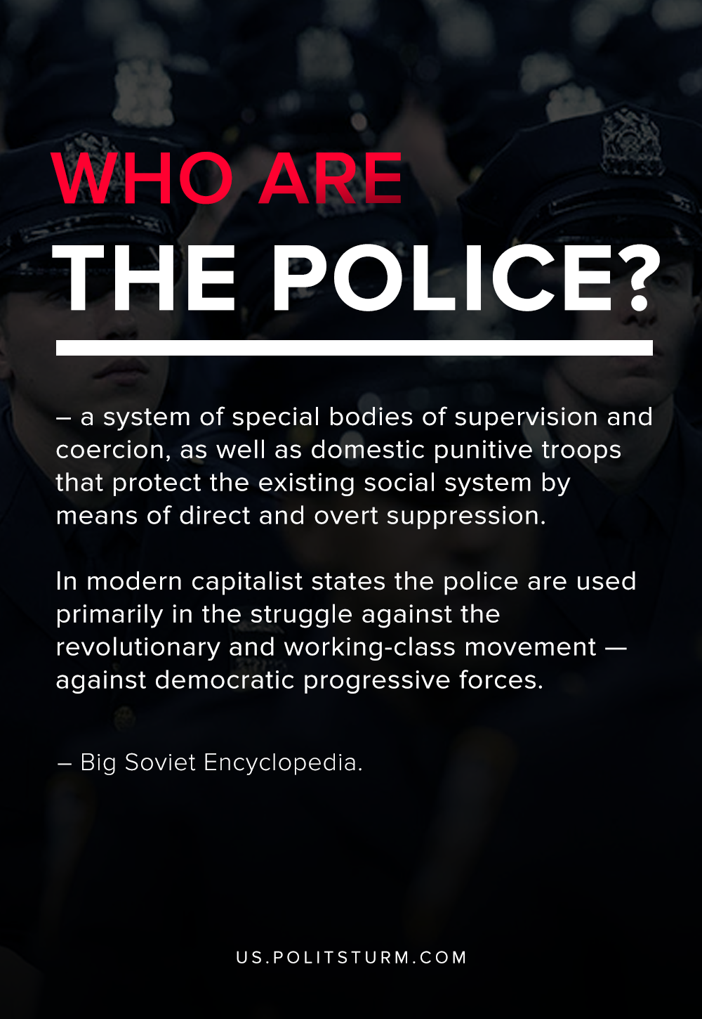

Original article
2020-07-11

In modern capitalist states the police are used primarily in the struggle against the revolutionary and working-class movement — against democratic progressive forces.

Original article

