What's Happening in Colombia? Healthcare Reform Review
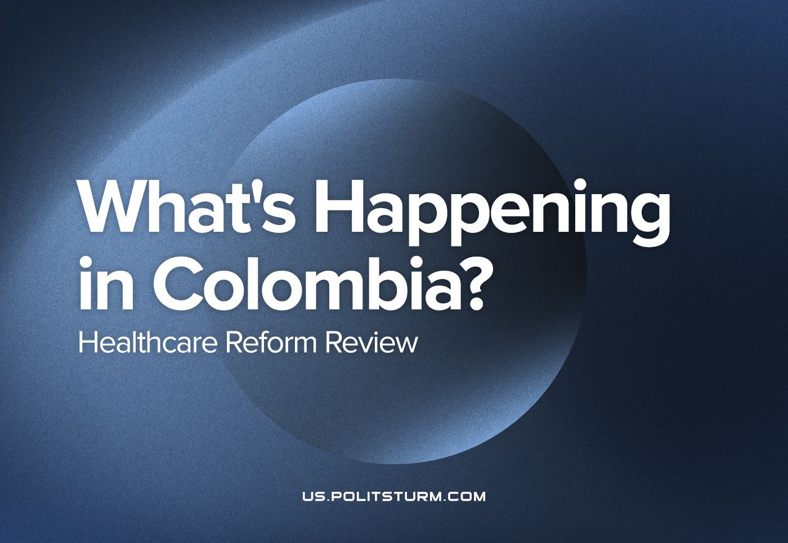

Original article
2023-03-29
9 min read

The presidential elections that took place last year in Colombia gave power to a project relatively independent from the “traditional" Colombian politics, i.e. not affiliated with the parties of the landowners, drug lords or big financial capitalists. Social democrats and right-wing socialists all over the world declared the beginning of a totally new and progressive chapter for Colombia – but is this new government, and is it really as significant as they believe?
That 2022 election, as most recent political events in Colombia, was a consequence of the civil war that this country suffered for the last 60 years (which in time follows the path of an almost uninterrupted sequence of civil wars starting after the Independence) and within this context the main characters of this and the last presidential elections emerged.
On one side is Álvaro Uribe – the son of a landowner and close ally of Fabio Ochoa Restrepo, partner of Pablo Escobar and founder of the Medellín Cartel. He has represented the interests of landowners, drug-lords and financial capitalists for all of his political career. In the 80’s, as director of the Civil Aviation Authority, he gave licenses for several planes and improvised runways to drug-smugglers; in 1991 he presented the current Law of Healthcare and Social Security as a Senator; later, for some time, he legalized the death squads already organized by drug-lords and landowners. Finally, as president he established a reactionary government with the open support of big capital, the US and the huge majorities of the traditional parties, imposing a forced consensus in the society to the point of sending an implicit death threat to the director of Human Rights Watch for being a 'guerrilla fighter in civilian clothes', like any other critic of his policies with even fewer protections and killing more than 6000 innocent young men to present them as guerrilla casualties.
On the other side was Gustavo Petro. He started as a member of one of the many Colombian guerrillas of the 70’s and 80’s (the M-19, a radical liberal urban guerrilla). Allowed by peace negotiations between his organization and the state, Petro was elected to some official positions in a small town neighboring the Colombian capital city of Bogotá. After the surrender of M-19 in 1990, he was elected to Congress in 1991, which represented a major jump into national politics through his outspoken opposition to the Uribe government and constant denouncing of the President's illegality, corruption and personal ties to the drug-lords and death-squads. Petro was also elected as Mayor of Bogotá in 2011, in which office he led a reformist government, similar to previous examples but more disorganized, before being impeached. He returned to office on a wave of popular support due to the public rebuff of his removal.
Error loading image
Within the context of the social unrest of the last many years and rising people’s struggle against the mainstream liberal policies (such as the strict application of the recommendations from international financial institutions) of "Uribism" and his opposition within traditional parties, both agreed on reinforcing mass impoverishment, financial aids for big companies and de-industrialization in the name of free market by means of violence. This is where Petro rose as the most visible representative of the legal left-wing. Because of his previous résumé as an original critic of Uribe that didn’t ally with that bloc even for limited goals (while some others joined forces with Uribism to support small proprietors and oppose the “democratic” mainstream liberal government of Juan Manuel Santos [1]) the one who lead the denounce of corruption among an old left-wing alliance [2].
Even though he was able to be somewhat coherent in opposition against the most brutal expression of Colombian bourgeoisie, he had shown opportunistic and counter-revolutionary trends; he called for alliances several times with corrupt representatives of the traditional bourgeoisie [3] (even former supporters of Uribe) and even has some as closer collaborators [4]. He still openly calls for the development of capitalism in Colombia and tried to deny the capitalist character of the Colombian economy [5].
It is in this context in which the Healthcare reform has been proposed.
The current health system separates users into two categories [6]:
- Subsidized regime users: Most of them are unemployed or informal workers, they can choose between state and some private Health Promoting Companies (EPSs) which offer healthcare in this regime. In subsidized regime all of the health costs are covered by the state but the EPSs act as intermediaries, providing (more frequently denying) customer-facing attention for general practitioners’ and basic dentist’s appointments, specialized doctors appointments and medical treatments within a network of either their own or partnered infrastructure and collecting the costs of those services from the state health budget.
- Contributory regime users: More frequently formal workers and their families, they also can choose between state and private EPSs but in their case there are more options. They monthly pay those services with wage-based payments (by the law 8% of the wage is collected for social security –half for healthcare and half for pension funding—and the employer pays other part corresponding to 12% of the salary, but in the end both payments are produced by the worker), in this case private EPSs should fund their services only by the funds generated trough those payments. Additionally, the worker must pay a regulatory fee for each individual service (between $0.5 and $1 USD for a minimum monthly wage of approximately $250 USD) in order to receive it, that generates unnecessary steps for the worker and could end in service denial when they are short of cash.
Additional resources for the state health budget are collected from sources like taxes on gambling and part of the contributory regime payments have the state health budget as the exclusive destination. Some severe problems in this system have been exposed for years, like the use of state health funds to finance death squads [7], the register of fake patients and fake high-complexity treatments from EPSs in order to get free funds [8], the use of private health funds to finance luxuries and risky investments [9] and constant denial of services, even those included in the Mandatory Health Plan (POS) [10].
The draft law for the Health System reform that the Petro Government proposed to Congress aims to remove the intermediary role of the EPSs and limit them to Primary Healthcare Centers (CAPS) management, registry of users and services and system auditing (which is intended to be open to general population) [11, Art. 53]. Apart from that some proposed changes or interesting points of the project are:
- The participation of general population (both as citizens and as organizations) in the management and political regulation of the system [11, Arts. 3, 10 and 108].
- The consideration of women and LGBTQ population in order to guarantee respect and equality for them in the system [11, Art. 3].
- The preventive character of the new healthcare system by the responsibility of the State on action upon the social and environmental determinants of health [11, Art. 5].
- The conformation of a National Health Council and similarly organized Territorial Health Councils with explicit presence of worker and peasant organizations delegates (8 explicitly from unions and peasant organizations and 13 from general population against 10 from Government and State and 4 explicitly from the bourgeoisie, and along 5 from the Academy) and with the purposes of generating reports of the health system and negotiating initiatives on healthcare policy [11, Arts. 10 and 13].
- The removal of control fees and access barriers for health services, medications or urgency attention [11, Art. 26].
- Universal healthcare for both nationals and foreigners, for immigrants and tourists the covering is intended to be given trough insurance [11, Art. 51].
- The creation of the Public Unique Integrated System of Health Information (SPUIIS) under responsibility of the Health and Social Protection Ministry with the purpose of allowing accountability and decision making in all of the levels of the health administration [11, Arts. 102].
- Price control over pharmaceuticals and relevant technologies in the context of market competition as part of the national policy [11, Art. 123].
Most of the public debate has centered over the removal of EPSs as administrators of public funds, the mainstream press (owned by financial capitalists and foreign press groups) is pressing on that by equivocating it with the complete removal of primary health services offers, by explaining private corruption as “bad apples” in the EPS and repetition of their dogma on inefficiency and corruption in state owned companies (even saying that state companies are socialist) while some unions and democratic organizations called for the support of the reform and other government initiatives. Traditional politics of the bourgeoisie proposed counter-reforms which only increased funds for the current system. On this, we must remember:
“Unlike the anarchists, the Marxists recognise struggle for reforms, i.e., for measures that improve the conditions of the working people without destroying the power of the ruling class. At the same time, however, the Marxists wage a most resolute struggle against the reformists, who, directly or indirectly, restrict the aims and activities of the working class to the winning of reforms. Reformism is bourgeois deception of the workers, who, despite individual improvements, will always remain wage-slaves, as long as there is the domination of capital.
The liberal bourgeoisie grant reforms with one hand, and with the other always take them back, reduce them to nought, use them to enslave the workers, to divide them into separate groups and perpetuate wage-slavery. For that reason reformism, even when quite sincere, in practice becomes a weapon by means of which the bourgeoisie corrupt and weaken the workers. The experience of all countries shows that the workers who put their trust in the reformists are always fooled.”
– V.I. Lenin, Marxism and Reformism, 1913.
Our agitation's focus is not only the defects of the past system in Colombia, but also critically exposing the temporary character of the advantages of the proposed reforms, based in both the current strong opposition from that class sector which benefits the most from capitalism (which is trying to sink the reform despite the truth that it doesn’t threat the foundations of their economic system), which will retain it’s power after the expected reform approval, and in the development of any service or good production under capitalism.
Markets will be the supreme judge of all services and will benefit those most profitable, dividing the service between almost-luxury health providers demanding prohibitive costs for the workers and mediocre-quality cheap providers for the masses.
Another factor worth our consideration is the corruption that the new government is beginning to show plainly. In a liberal republic, for a reform to be approved by the parliament it needs to benefit the majority of the capitalists’ representatives more than the current laws do. That means that Petro's reform needs to increase the profits of the congressmen and their partners, or be supported through bribes paid to them, no matter if those are given in the form of cash (infrequently) or in the form of positions in the government, the regulatory institutions and the management of the new system for them and their allies.
In the case of this government, corruption manifests in the presence of traditional politicians in the cabinet, diplomacy and its closer parliament allies, as well as in the future opinion changes of some parliament representatives towards the reform, the direction of that change being decided by the offerer of the biggest bribe.
Any progressive change in capitalism is reached by constant and difficult efforts from working peoples and is easily denied by the exploiters just as soon as the struggle subsides. The only way to get long-standing improvements in our life is by materializing our interests in the form of a socialist state, no matter how democratic or “socially-conscious” the representatives of the current one try to appear.
We must not forget that the modern social-democracy appears as a bourgeois trend among workers to disrupt their struggle under the banner of class-collaboration and “social peace” which is essentially the program of fascism but carried out under legal and “democratic” means. Social democracy has even collaborated effectively with fascism (as with the leading SDP of the Weimar Republic) or became a fascist organization (as Argentina's Perón began as a reformist minister of a moderate liberal military government, then became a close Franco ally and organizer of the Anticommunist Alliance, all of that within a process which undermined the revolutionary union movement by means of supporting yellow Peronist unions which remain as the majority still).
“Secondly, it is not true that the decisive battles have already been fought, that the proletariat was defeated in these battles, and that bourgeois rule has been consolidated as a consequence. There have been no decisive battles as yet, if only for the reason that there have not been any mass, genuinely Bolshevik parties, capable of leading the proletariat to dictatorship. Without such parties, decisive battles for dictatorship are impossible under the conditions of imperialism. The decisive battles in the West still lie ahead. There have been only the first serious attacks, which were repulsed by the bourgeoisie; the first serious trial of strength, which showed that the proletariat is not yet strong enough to overthrow the bourgeoisie, but that the bourgeoisie is already unable to discount the proletariat. And precisely because the bourgeoisie is alreadyunable to force the working class to its knees, it was compelled to renounce frontal attacks, to make a detour, to agree to a compromise, to resort to ‘democratic pacifism.”
– J. Stalin, Concerning the International situation, 1924.
We must defend the independence of our class organizations from bourgeois reformists, and not submit to calls for unprincipled unity with such 'progressive' capitalist representatives, because:
“The stronger reformist influence is among the workers the weaker they are, the greater their dependence on the bourgeoisie, and the easier it is for the bourgeoisie to nullify reforms by various subterfuges. The more independent the working-class movement, the deeper and broader its aims, and the freer it is from reformist narrowness the easier it is for the workers to retain and utilise improvements.” – Vladimir Lenin, op. cit.
Sources:
[1] https://archivo.kaosenlared.net/colombia-la-quiebra-hist-rica-del-moir/
[2] https://www.semana.com/direccion-del-polo-llama-rodear-moreno-petro-ratifica/123743-3/
[3] https://www.elcolombiano.com/colombia/alianzas-con-cuestionados-clanes-politicos-enlodan-campana-de-petro-EF17568693
[4] https://www.lasillavacia.com/historias/silla-nacional/con-benedetti-petro-recibe-en-sus-huestes-un-simbolo-de-lo-que-critica/
[5] https://cnnespanol.cnn.com/2022/06/19/petro-discurso-capitalismo-colombia-elecciones-orix/
[6] https://www.scielosp.org/pdf/spm/2011.v53suppl2/s144-s155/es#:~:text=El%20sistema%20de%20salud%20colombiano,el%20r%C3%A9gimen%20subsidiado%20(RS).
[7] https://www.eltiempo.com/archivo/documento/CMS-16172000
[8] https://www.semana.com/nacion/articulo/fiscalia-investigara-carteles-de-enfermos-mentales-y-hemofilia/510814/
[9] https://www.fiscalia.gov.co/colombia/noticias/fiscalia-logro-condena-de-10-anos-de-carcel-por-actos-de-corrupcion-contra-carlos-palacino-expresidente-de-saludcoop/
[10] https://defensoria.gov.co/en/-/-eps-no-prestan-servicios-as%C3%AD-est%C3%A9n-en-el-pos-defensor-del-pueblo
[11] https://www.minsalud.gov.co/sites/rid/Lists/BibliotecaDigital/RIDE/DE/proyecto-ley-reforma-salud-msps.pdf

Original article

