What Is Happening in Russia: Protests against Rubbish Dumps in Moscow Region
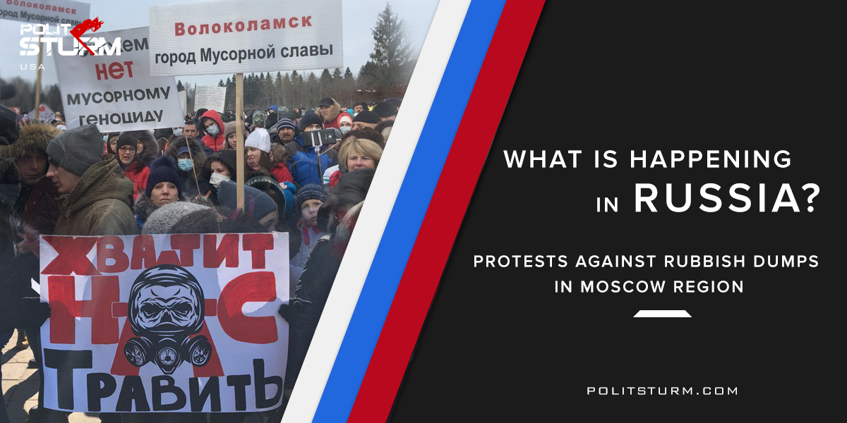

Original article
2018-05-21
5 min read

In the pursuit of profit capitalism damages not only human lives, but the soil, air and water. The problem of air, water, soil pollution in the world has always been important. Recent events in Russia only made this clearer. Moscow – the famous capital of Russia – has a very large population of over 10 million people. And, of course, the population of the city produces a lot of trash. It could be recycled or at least buried without harm to nature or people.
But Russian businessmen don’t care about «second-rate people» – us, workers. Profit, profit and more profit – this is what they want. «Why do you worry about these people? Well, thirty million can die out. They did not fit into the market. » – said «famous» Russian capitalist Anatoly Chubais in 90’s. Modern businessmen seem to follow this «advice». Instead of recycling rubbish, they just transport it to quickly growing rubbish dumps in the Moscow region.
Therefore, people take to the streets to prevent an environmental disaster in different areas of the Moscow region. Protesters are blocking roads, demanding the closure waste landfills and life-threatening facilities since the beginning of the year.
The problem became clear after events in Volokolamsk. On March 2, 2018, there was a release of poisonous gas from the Yadrovo landfill. More than 50 children went to the hospital with complaints of nausea and dizziness. Several children were hospitalized with the suspicion of poisoning. Several thousand people went to a spontaneous protest. The governor of the Moscow region came to the hospital of Volokolamsk, but didn’t talk to the people. Federal television channels almost completely ignored the events in Volokolamsk.
On April 13, law enforcement officers conducted searches on the mayor of Volokolamsk, as well as in the city administration. Petr Lazarev, who is the mayor of Volokolamsk, connects this with the fact that the administration of the settlement has given permission to hold rallies against the Yadrovo landfill. He also received threats from officials and criminal authorities demanding to stop allowing rallies.
After numerous rallies Dutch experts were invited to the site with modern equipment for pumping out the poison but the odor is still in the air. The governor of the Moscow region promised local residents to close the landfill on June 15.
This case is not the only one. In Kolomna citizens protest against the work of the landfill for solid household waste. The environmental situation began to deteriorate in 2017. On February 11, 2018, more than 3,000 people went to the streets demanding the closure of the landfill and also to prevent the construction of new ones. The people began to block the road to the garbage trucks for several days. People complain that at night a strong odor emanates from the testing range, which spreads in a proximity of several kilometers.
At the same time the administration declares that «there is no bad smell». Then it became known that the authorities had prepared a plan for the construction of a new landfill, which would be five times bigger than the existing one. Protests near the landfill have been going on for several months.
In the Klin district the situation is similar: on Tuesday, March 27, the picket was attended by residents protesting against the «Aleksinsky Quarry» landfill. Citizens complain that the air from the landfill “cuts the eyes, it is impossible to breathe at all even in a room with tightly closed windows”, and also feel nausea and a sharp headache in the evenings. Since 2013 it began to take waste from other regions.
The situation in Tarusa, another protest city, is also heating up. In February of 2018 a garbage processing plant began to operate here. It is unknown as to who owns it. The residents experience a persistent unpleasant smell near the plant. At the end of March 2018 the city passed the second action against the plant, where local activists gathered together with the head of Tarusa. More than 800 people demanded the closure of the plant, to which the city authorities responded that they cannot close the territory, because it’s private property.
Reports about the unfavorable situation in Zvenigorod also began to be received. The city, surrounded by greenery, lakes and monuments, was littered by spontaneous dumps. People are still less active, but as problems grow, they try to find a way out of the current situation with the garbage. “At night the city reeks, it all depends on the direction of the winds. Local residents began to complain of exacerbation of asthma – from smoke and rotting debris. “- says local resident Tatiana.
The fact complicating the situation is that the landfill is 800 meters from the Moskva River, which feeds the inhabitants of the capital of Russia. All landfill chemistry seeps into the soil and contaminates Moscow and the region.
Another activist says: “Mayor Smirnov does not live in the city. He comes to work from Rublevka (a rich district of Moscow), where he has a house. He is not interested in poking in shit, he is a rich man. He may come to open something, a shopping center for example. Cutting the ribbon – yes. Doing something with the garbage – no. ”
On April 14th a rally against the landfill “Forest” was held at Serpukhov near Moscow. It was pre-arranged with the head of the district Shestun Alexander, who demanded the closure of the landfill during his speech. Even before the meeting he began to receive threats of dismissal and other illegal and violent actions from high-ranking officials and representatives of the FSB, of which he managed to keep recordings. The situation became so dire that Shestun made an appeal to the President, which he published on his YouTube channel.
Bureaucracy, corruption, arbitrariness of power and the absence of any attention to the needs of the people – this is happening not only in the Moscow region, but throughout Russia. We have one clue – the power of capital, pumping out all the juices from the country.
By the end of April it became known that the selection of companies-operators for the collection of household waste had been completed. According to the results of the contest, the «RT-Invest» company, whose co-owner is «Rostech», will remove 60% of garbage in the Moscow Region.
«RT-Invest» is a subsidiary of the state corporation «Rostech». But the state-owned corporation now owns only about a quarter of its share. The rest is owned by «Tsaritsyn Capital», which, in turn, is 100 percent controlled by Andrei Shipelov. But Shipelov is the general director of «RT-Invest» – so he manages the joint venture of himself with the «Rostech» state corporation.
However, «RT-Invest» became famous due to the fact that this structure indirectly participates (through «RT-Transport Systems LLC», 50% of which is owned by Igor Rothenberg – one of the richest men in Russia) in the scandalous system road payments, collected from the heavy-weight trucks “Platon”, which caused mass protests of entrepreneurs engaged in cargo transportation. One of the main reasons why Krasnodar Region was chosen as one of the pilot regions for their initiative is that the Kuban is a region with low civic activity of the population and highly repressive activity of the law enforcement bodies.
Facing bitter resistance of citizens in Moscow and Tatarstan, the structure of «Rostech» will try its luck in the south of Russia – the first plant is planned to be built in Sochi. «RT-Invest» also announced plans to build four incineration plants in the Moscow region, each of them will cost 31 billion rubles. In the Noginsk cluster garbage will be collected by «Charter» company, which belongs to Igor Chaika – the son of General Prosecutor of Russia Yuri Chaika.
Officials cover their relatives and allow them to rob the rich and at the same time poor Mother Russia. Russian officials like to talk about “patriotism” and “a national rebirth” but they have American citizenship and send their children to the West. Let the Western mass-media talk about the “red threat”, “evil empire”, “Russian hackers” and “Communist Putin” – you can see, there is capitalism in Russia, and it is not very different from the American one.
Capital is transnational. There is a united organization of the imperialists of all countries against the working people. The enemy of the Russians is Russian capitalist. The enemy of the American people is American capitalist. Only through joint efforts will we be able to end exploitation and oppression.
http://www.ewnc.org/node/25448
https://dailystorm.ru/vlast/ekocid-po-russki-chem-travyat-rossiyan-poka-te-ne-znayut
https://www.bfm.ru/news/380160
https://tsargrad.tv/articles/zvenigorodskaja-svalka-gorod-tonet-v-musore_132825
https://meduza.io/feature/2018/03/27/musornye-bunty-kolomna-tarusa-klin-tuchkovo-voskresensk-naro-fominsk
https://www.novostroy-m.ru/statyi/kak_ne_kupit_kvartiru

Original article

