Western Europe Faces Worst Heatwave Since 1757
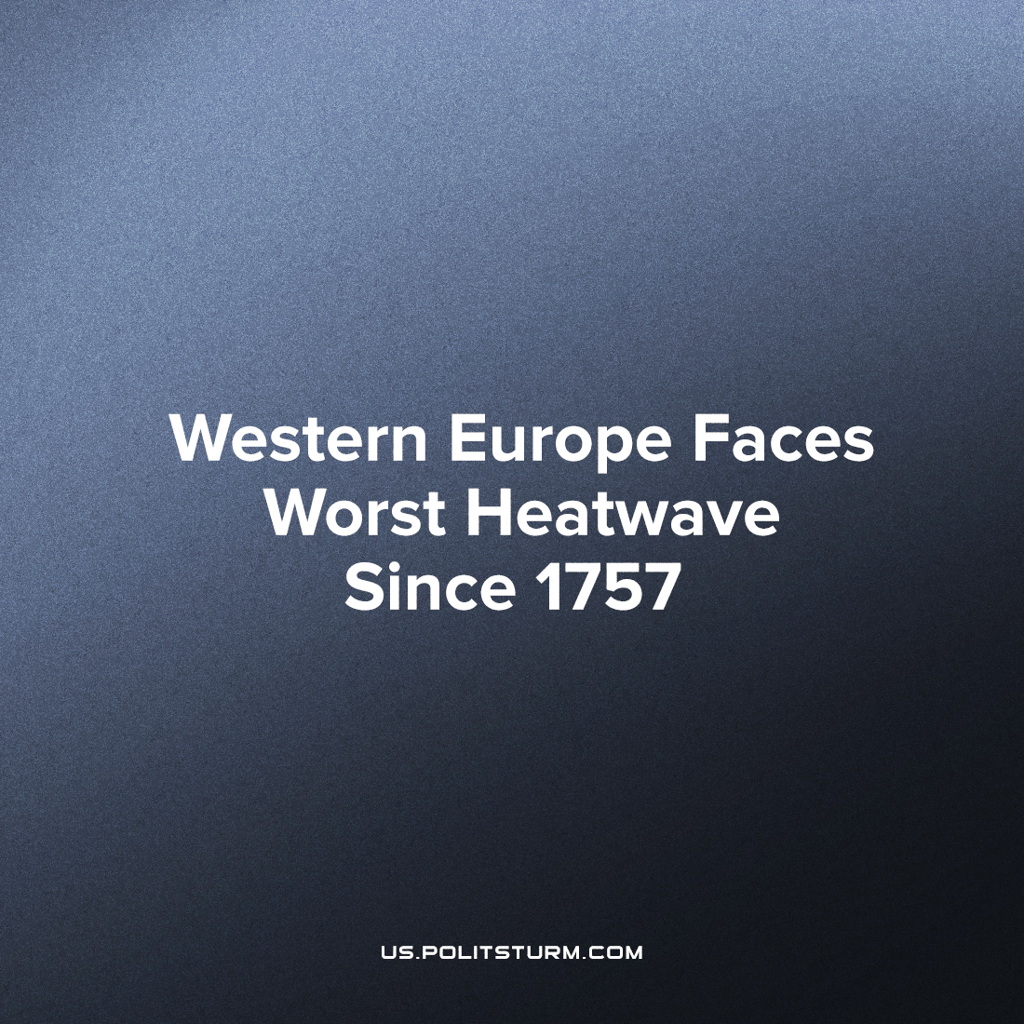

Original article
2022-07-17
4 min read

During the upcoming week temperatures across Western Europe are likely to be amongst the highest ever recorded, with much of the South of England and the North and West of France to reach or exceed 40°C (104°F), and temperatures reaching as high as 49°C (120°F) are possible in parts of Spain according to some projections.
Most Western European cities, industry, and infrastructure are built for temperate climates and are expected to face significant problems during the heatwave. Railways are susceptible to warping or buckling, asphalt roads are vulnerable to melting, power generation output will decrease, the threat of wildfires increases, crop yield will decrease, water shortages are possible, and incidences of heat-related illness will mount, to list a few.
The 2003 European heatwave caused over 72,000 excess deaths (almost 15,000 in Paris alone) and an estimated 10% reduction in wheat production due to crop failure across Europe. This heatwave is likely to be more severe and is happening at a time of a global wheat shortage.
Events like these, which used to be freak occurrences, are becoming increasingly common. This is due to the ongoing climate crisis caused by the phenomenon of global warming which is a product of modern capitalist society. In Capital, Marx spoke of the capitalists’ unquenchable “were-wolf hunger for surplus-labour” and consequently the extraction of surplus-value which corresponds to an ever yet larger accumulation of capital. This process is inevitable and self-perpetuated by the fact that capitalists do not exist in a vacuum and are forced into competition with each other.
“Conceptually, competition is nothing other than the inner nature of capital, its essential character, appearing in and realized as the reciprocal interaction of many capitals with one another, the inner tendency as external necessity.) (Capital exists and can only exist as many capitals, and its self-determination therefore appears as their reciprocal interaction with one another.)” – Marx, The Grundrisse Notebook IV
“Modern bourgeois society, with its relations of production, of exchange and of property, a society that has conjured up such gigantic means of production and of exchange, is like the sorcerer who is no longer able to control the powers of the nether world whom he has called up by his spells.” – Marx and Engels, The Communist Manifesto.
“…all progress in capitalistic agriculture is a progress in the art, not only of robbing the labourer, but of robbing the soil; all progress in increasing the fertility of the soil for a given time, is a progress towards ruining the lasting sources of that fertility. The more a country starts its development on the foundation of modern industry, like the United States, for example, the more rapid is this process of destruction. Capitalist production, therefore, develops technology, and the combining together of various processes into a social whole, only by sapping the original sources of all wealth — the soil and the labourer.” – Marx, Capital Volume One Chapter 15
Due to this, fundamentally, no-one controls capitalism as a system. Development and growth are ultimately not governed by the decisions of individual capitalists, but by the law of value – the insatiable hunger for greater profit. It is a moribund mode of production that is destroying its two sources of wealth (nature and human beings) in order to preserve itself. The scale of the necessary changes and timescale for transformation required to combat the climate crisis is impossible under capitalism yet is not unprecedented in history. Both in the construction of socialism, with the electrification of the country, industrialisation, literacy campaigns and preparing for the fascist invasion as well as in the reconstruction effort afterwards, the Soviet Union was able to achieve an equivalent in scale societal transformation to what is required over a very short duration of time. There were many factors behind this, but chief among them was the planned economy. As a result, development was not guided by profitability, but by the needs and wants of the mass of working people.
Opportunists, anti-communists, and bourgeois eco-activists might point to environmental degradation that occurred under socialism as a refutation of this. While this certainly occurred, it was principally during the period the communist movement was in decline and dominated by revisionism and opportunism. Even during this period, the Soviet Union was far less antagonistic to its environment then modern capitalist states. Recycling was a systemic practice, and the greening of cities was common practice within urban planning. The planting of greenery in Soviet cities was an integral part in the field of Soviet urban planning, which stemmed from the basic economic law of socialism—the maximum satisfaction of the ever-growing material and cultural needs of the whole of society.
The first laws on the protection of nature were signed in 1921 by Lenin, on the protection of natural monuments, gardens, and parks. Lenin was acutely aware of the damage capitalism does to the natural world and had said (as reported in Maxim Gorky’s memoirs), “You could write a novel for the workers on the topic of how the predators of capitalism robbed the earth, wasting all the oil, all the iron, wood, all coal”. Even during the height of the industrialisation and socialist transformation, according to the historian Stephan Brain, “Environmentalism survived and even thrived in Stalin’s Soviet Union, establishing levels of protection unparalleled anywhere in the world”. He goes on to say:
“…forest protection driven by hydrological considerations is forest protection nonetheless. And intriguingly, although forest protection in the Stalin era was driven by pragmatic rather than preservationist concerns, Stalin’s policies withdrew millions of hectares from economic exploitation and ordered that they be left more or less untouched, in keeping with the supposition that complex, wild forests regulated water flows and decreased silt loads more effectively than managed forests. As a result, one could say that Soviet forest protection was not only conservationist, but de facto preservationist as well.” Stalin’s Environmentalism, Stephen Brain
Consequently, the only way out for humanity of the climate crises foisted upon it by capitalism, is socialism and a green 5 year plan, to reorganize and reconstruct the economy on a thoroughly sustainable and socialist basis. With modern forces of production, computer technology, and internet-based communication networks, the potential of socialist economic planning is tenfold greater than it was for the socialist bloc.
Heatwaves in Europe similar to the coming one this week are relatively minor compared to what is in store for us should we fail, and that is not even considering the areas and regions of our planet that will be affected far worse than Europe, especially South Asia and Sub-Saharan Africa.
Sources:
https://www.accuweather.com/en/weather-forecasts/europe-heat-wave-could-be-worst-in-over-200-years/1216701
https://assets.publishing.service.gov.uk/government/uploads/system/uploads/attachment_data/file/1091186/Heatwave_Plan_for_Engand_2022_July_2022.pdf
https://reliefweb.int/sites/reliefweb.int/files/resources/Human%20Cost%20of%20Disasters%202000-2019%20Report%20-%20UN%20Office%20for%20Disaster%20Risk%20Reduction.pdf
https://www.jstor.org/stable/20621169
http://tehne.com/library/ozelenenie-sovetskih-gorodov-posobie-po-proektirovaniyu-m-1954
http://september.media/archives/2934

Original article

