Victory Day – 2021
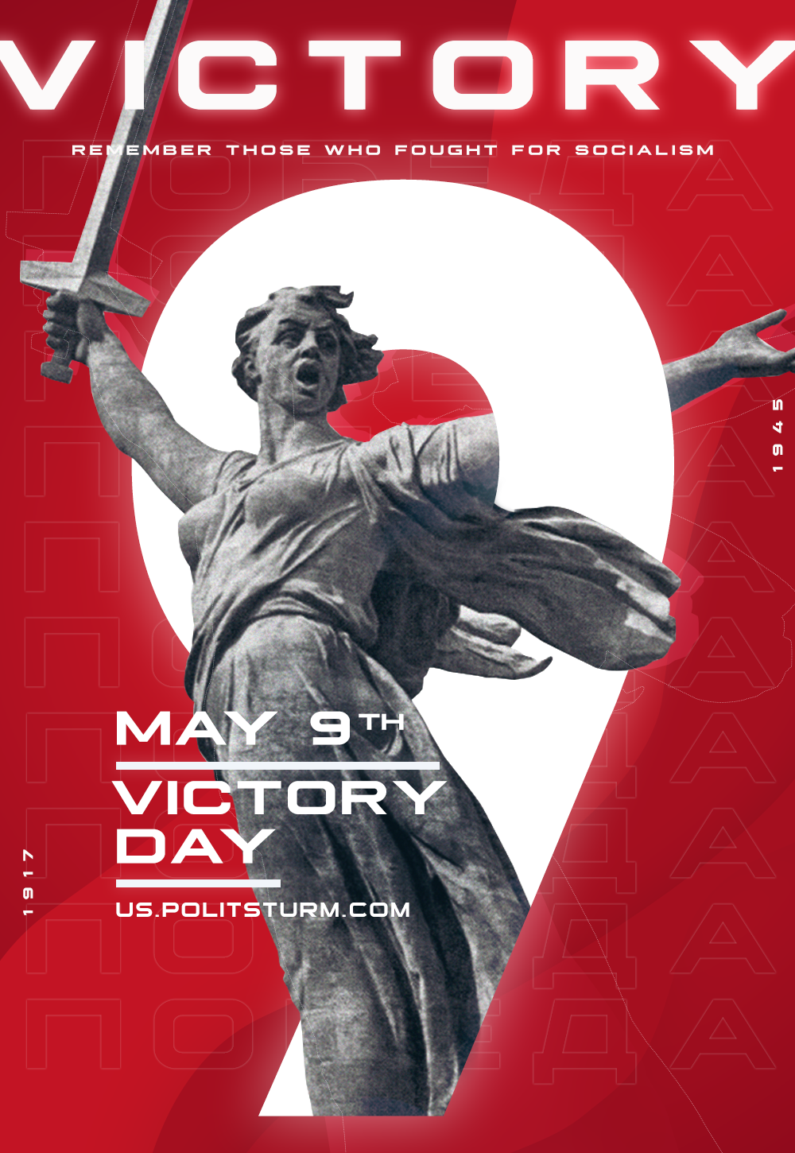

Original article
2021-05-09
1 min read
The Victory Banner, raised on the walls of the German capital by the Soviet soldiers, depicts a hammer and sickle – a symbol of the proletarian state and the struggle for a future without capital. However, it’s the capitalism that gave birth to fascism. Fighting against fascism, the Soviet people and all anti-fascists fought for the victory of communism.
Today there is no proletarian state to defend the people from the bloody wars, and the fascist threat is on the rise. We can not expect mercy from capitalists. The only way to liberate humanity from the dangers of fascism and new wars is to unite the working masses in one strong organization to fight the dominance of capital.

Original article

