Verizon Fights Against Unionization Efforts in Washington
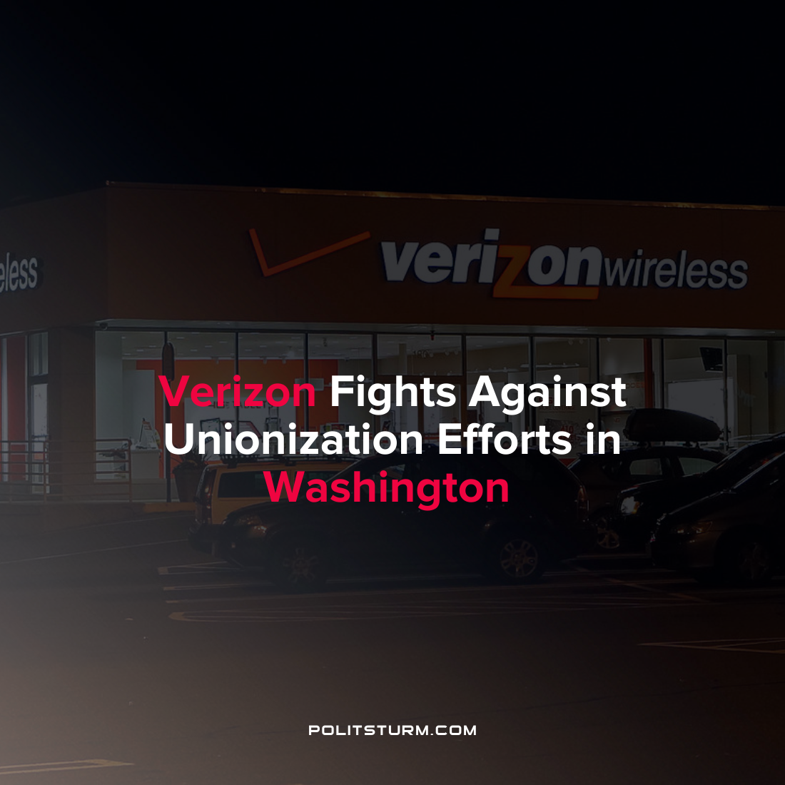

Original article
2022-03-19
1 min read

According to an article published by Jacobin, Verizon is taking strong union-busting efforts as Verizon retail workers in the Pacific Northwest are attempting to form a union. Workers at the Lynnwood and Everett Washington locations sent a letter to the CEO Hans Vestberg requesting that the company voluntarily recognize the formation of a union. Workers were demanding higher rates of pay, increased staffing levels, and improvements to their work/life balance.
In response, the company has been sending executives and labor relations managers to the retail locations which are considering unionization.
“There was no reply to our email — except for they immediately flew in union busters, so I know they got the email”, said employee Austin Hitch who was active in the unionization efforts.
Verizon has a history of strong anti-union efforts in the recent past. In 2014, Verizon closed a store that was attempting to unionize in Everett, Massachusetts.
These actions by Verizon in response to unionization efforts are predictable as executives are responsible for maximizing profits. According to the Bureau of Labor Statistics, unionized workers in the U.S. have median weekly earnings of $1,169 compared to $975 for non-unionized workers. Suppressing unions benefits the capitalist class with lower labor costs and other conditions which maximize profits. The union-busting efforts of Verizon is another modern example of the class struggle as the capitalists fight to defend their own interest, namely the maximization of profits through the exploitation of labor. It is imperative that workers also struggle for their own interests by understanding and applying Marxist-Leninist theory.
Source: 1 2

Original article

