Venture Capitalists Invest In Worship Apps To Sell Data
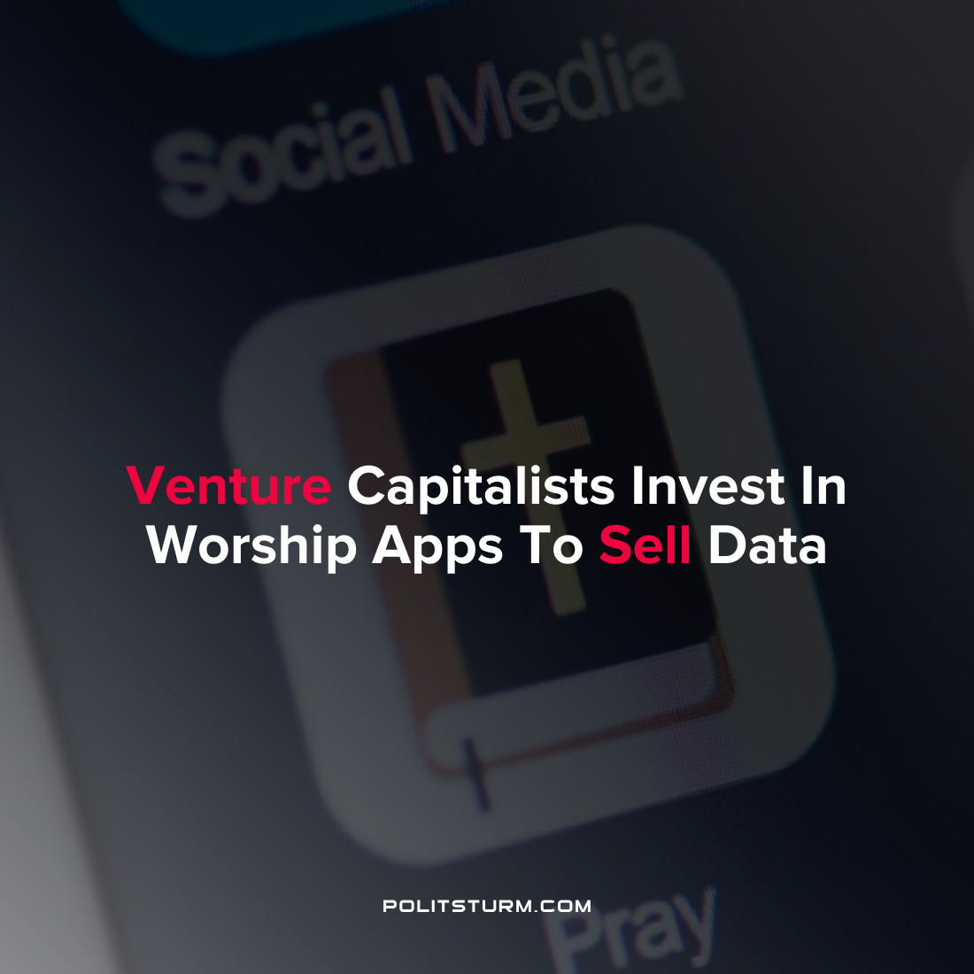

Original article
2022-02-09
1 min read

As people have turned to religious apps in the wake of the COVID-19 pandemic limiting in-person gatherings, it has opened a new avenue for venture capitalists to profit. Applications and sites such as Pray.com have provided a way for capitalists to directly profit from the data collected as religious individuals post their prayers in an electronic format. The company’s privacy policy allows them to collect data and share it with data analytic companies such as AWS, Google Analytics, and Twilio.
Venture capitalists have aggressively pursued funding applications such as Pray.com, Hallow, and Glorify lured by the potential of profiting from the user base.
Capitalist Katherine Boyle described the situation as one where, “A holy trinity is in place: isolated people hungry for attachment, religions desperate for growth in an online world, and technology investors searching for the consumer niches yet to digitize”.
Religion has been described as the “opiate of the masses”, and the capitalist class is willing and able to exploit the religious for profit whenever it is possible. This can be achieved indirectly by the promotion of idealist nonsense and directly by profiting from the sale of data and tithing. Religion is a tool of the ruling class and is necessary from the continued exploitation of man-by-man under capitalism just as it was under slavery and feudalism. The commercialization of prayers and other religious practices is just another example of the ruling class using religion to exploit and deceive the masses for their own purposes.
Source: 1 2

Original article

