Vance claims that the Trump era marks the end of US Meddling
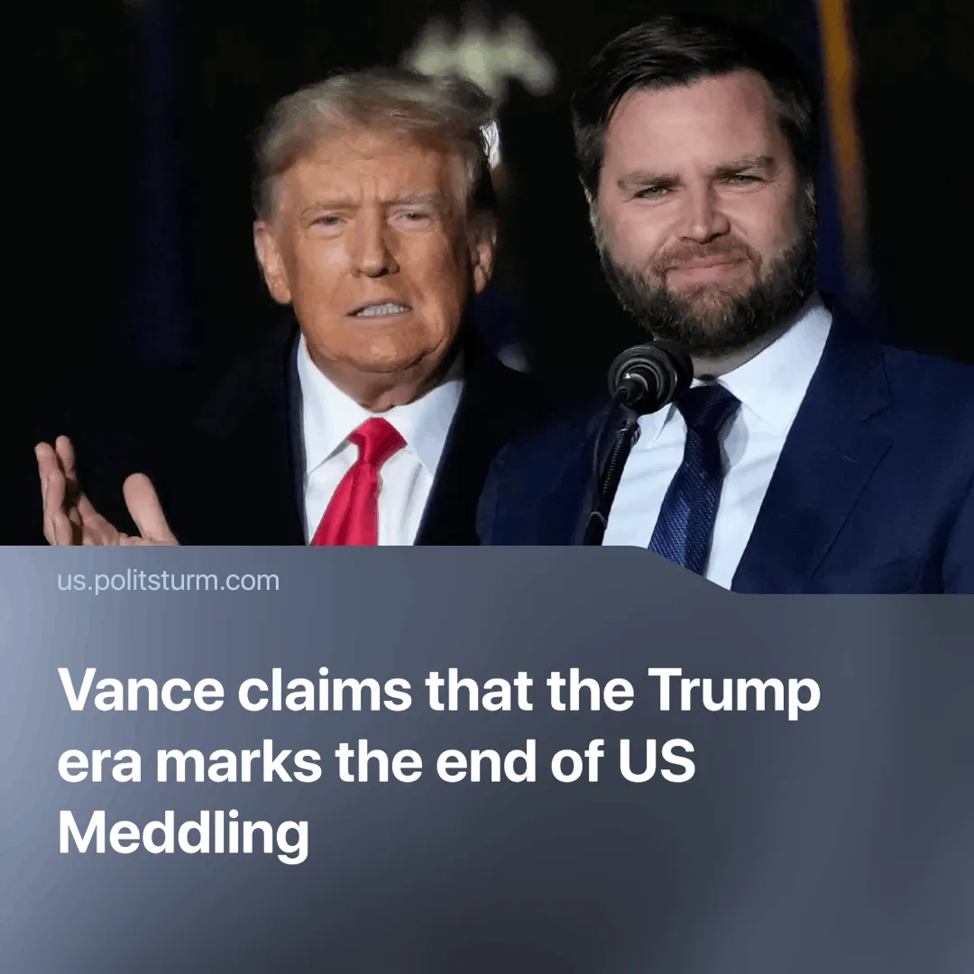

Original article
2025-05-28
2 min read

JD Vance claims the U.S. has stopped "meddling in foreign countries." But since Trump’s inauguration, America has repeatedly interfered abroad.
On May 21, 2024, speaking to Naval Academy graduates, Vice President Vance argued that the second Trump administration had broken with decades of failed U.S. foreign policy, accusing previous leaders of trading “hard power for soft power” and dragging the country into unnecessary wars. He stated,
Quote: “The Trump era marked the end of America meddling in foreign countries. For the first time in a generation, we stopped toppling governments and starting wars that had nothing to do with us.”
Context. Vance’s remark fits into a broader narrative aimed at portraying Trump’s foreign policy as peaceful, non-interventionist and focused on "America First." He linked the turn to soft power—diplomacy, aid, and global prestige—to the post-Soviet era, when U.S. leaders, confident they had no rivals, let military and industrial strength decline.
In reality, “America First” has meant continued meddling abroad, simply carried out through hawkish actions and rhetoric,
► From March to May 2025, the United States carried out a major military campaign against the Houthis, including extensive air and naval strikes. Known as “Operation Rough Rider”, it marked the largest U.S. military action in the Middle East during Trump’s second term so far.
► Just weeks later, Washington signed a new security deal with Panama, granting U.S. troops access to the Panama Canal zone. The move aimed to reassert US control over a key global trade route amid growing Chinese influence in Latin America.
► Trump’s tariffs have been used as tools of economic blackmail. Mexico and Canada, whose economies rely on the U.S. for nearly 80% of exports, were threatened with 25% duties unless they accepted political concessions, such as Mexico deploying 10,000 troops to its southern border. Both governments complied and were temporarily exempted from the “liberation day” tariffs.
► The administration has backed pro-U.S. opposition movements abroad, such as Venezuela’s right-wing María Corina Machado, while threatening to tighten sanctions on the elected government. It has also politically aligned with European far-right parties like Germany’s Alternative für Deutschland.
► Trump has reignited annexationist ambitions to seize Greenland, possibly through conflict and publicly calling for Canada to become the “51st state”, stating that use of military force “could happen”. His administration also designated several Mexican cartels as foreign terrorist organisations—a legal move widely seen as laying the groundwork for unilateral military action across the southern border.

Original article

