US Sends Trucks of Syrian Oil, Wheat to its Bases in Iraq
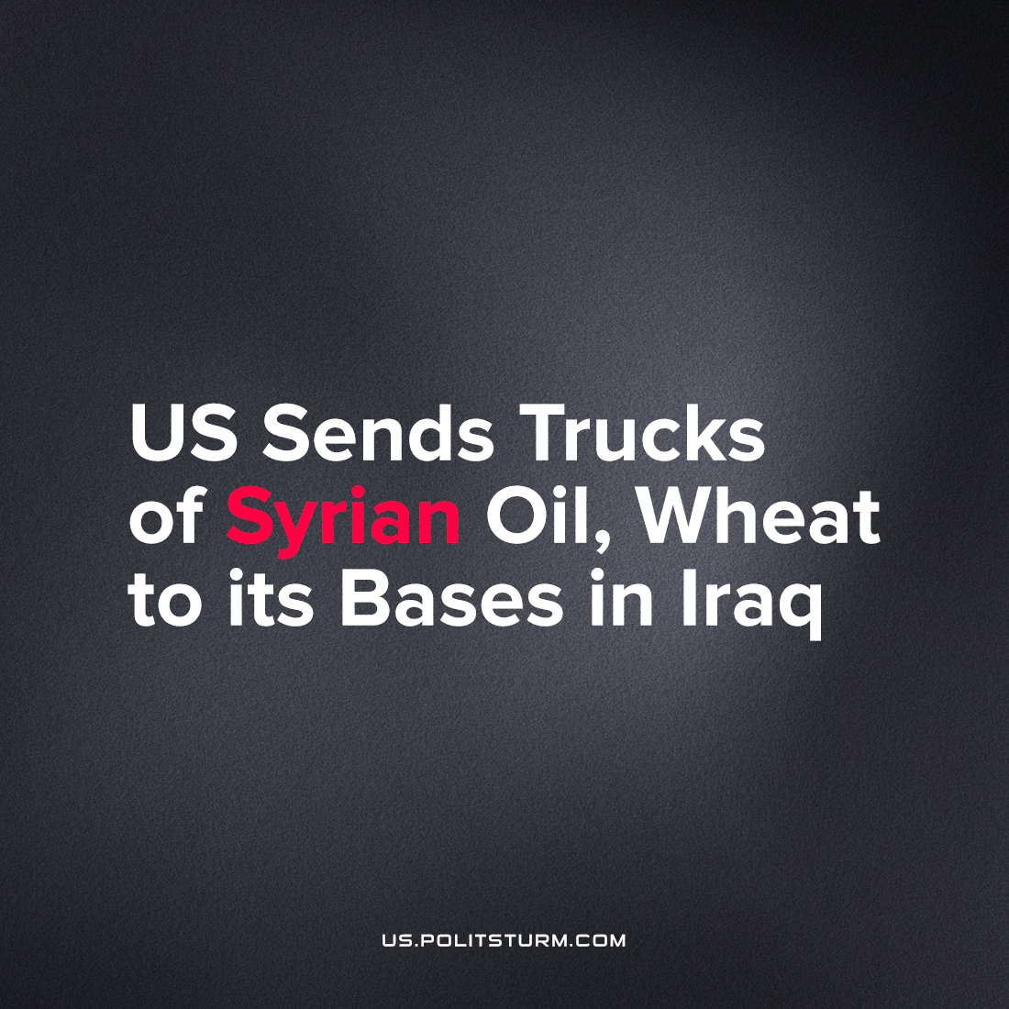

Original article
2022-11-18
2 min read

According to Syria’s official news station SANA, Saturday, Nov. 12th, American military forces took possession of oil tankers filled with Syrian crude oil, and wheat. With the help of local mercenaries, they have reportedly transported 74 tankers of oil, 30 via the Al-Waleed border crossing, and 44 more tankers of oil from Al-Swaidiya fields using the Mahmoudiya crossing, said to be heading to US military bases in Iraq, where they can put on the market or utilized in local production. According to reports, US-backed Kurdish militants also took 20 truck-loads of wheat to northern Iraq through the Semalka crossing over the Tigris river.
This is not the first time we hear of the US robbing the Syrian people of their very much needed natural resources. Just last week it was reported that US forces shipped 43 tanker trucks of stolen Syrian oil [1] to northern Iraq. Damascus has repeatedly condemned America’s food, oil, and other natural resource looting activities. These actions have robbed Syria of nearly 90% of their oil, and most of the rich farming land accessible to the Syrian people.
Losses in domestic wheat production such as this have forced Syria to pay the crisis-inflated prices for limited shipments of Ukrainian grain, narrowing the market for even poorer countries. In August, a shipment of Ukrainian wheat bound for Lebanon was re-sold to Syria while at sea.
The US has kept approximately 800-900 troops in Syria [2] from its 2017 intervention into the Syrian Civil War. These US troops have been tasked with gaining and keeping control of Syrian energy fields, as well as to block Damascus from regaining control of their borders. On top of the looting and stealing of resources, the US and European allies have imposed devastating sanctions with the goal of crushing the Syrian economy and blocking the import of much needed goods including medical supplies.
These unjustifiable actions of the US are just another example of American capitalists forcefully imposing their imperial division of the world’s territory to secure oil and other resources for their own gains. With big oil companies spending at record highs on lobbying, 12.4 million dollars in the first quarter of 2022 alone [3], and the spike in gas prices hitting America this year, it is to no surprise that US forces – representing the interests of the American petroleum syndicate – would apply its power over the resource-rich territory, due to its accessibility to its major logistics centers in the region.
Sources: 1, 2, 3

Original article

