U.S. Increases Pressure on Russia After Signing Mineral Deal With Ukraine
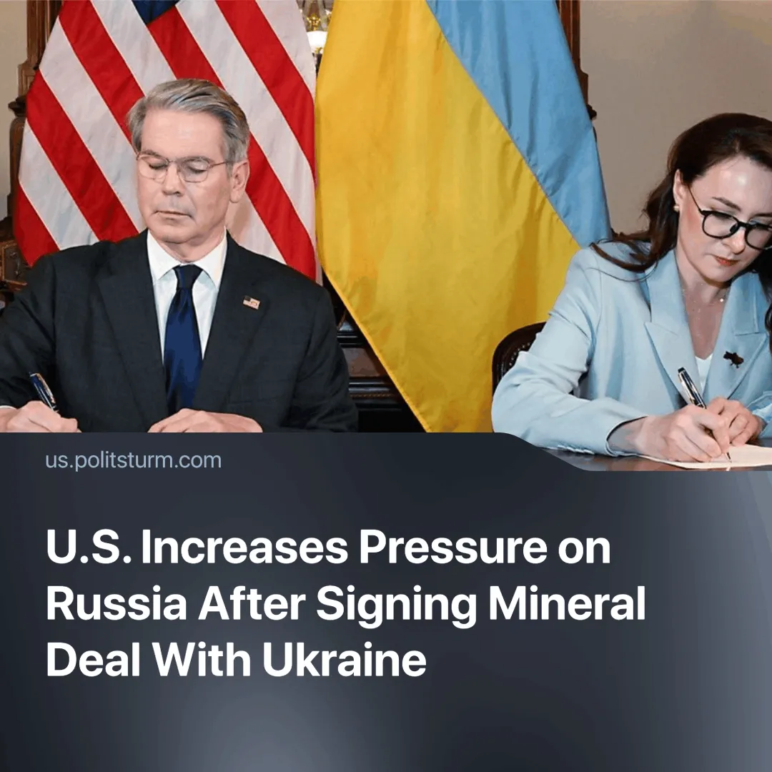

Original article
2025-05-02
1 min read

The U.S. and Ukraine have officially signed a minerals agreement after months of delays. Following the signing, the White House has sharply increased its attacks on the Russian Federation.
► We recently reported on the U.S. increasing pressure for a Ukraine-Russia peace deal, as well as the public failure to sign the minerals agreement during the February Trump-Zelenskyy meeting at the White House.
Details. The agreement was signed in Washington on April 30 by U.S. Treasury Secretary Scott Bessent and Ukrainian First Deputy Prime Minister Yulia Svyrydenko. It establishes a 50-50 U.S.-Ukraine Reconstruction Investment Fund to finance critical minerals extraction and infrastructure.
► The White House has stated that “this partnership sends a strong message to Russia – the United States has skin in the game and is committed to Ukraine’s long-term success,” as well as reversing Trump’s previous statements suggesting that Ukraine had started the conflict.
► The agreement includes 55 materials, including lithium, titanium, and uranium. This will reduce America’s dependence on China for these minerals, allowing it to prepare for potential conflict.
► The agreement still requires ratification by Ukraine’s parliament. According to Ukrainian officials, the first projects could begin by mid-summer.
► Treasury Secretary Scott Bessent called the agreement a “historic economic partnership.” A White House fact sheet stated: “This partnership represents the United States taking an economic stake in securing a free, peaceful, and sovereign future for Ukraine.”
How did other countries react? Ukraine’s Prime Minister Denys Shmyhal called the deal “good, equal, and beneficial.”
► Former Russian President Dmitry Medvedev called the deal a defeat for Ukraine, saying, “Trump has finally broken the Kiev regime into paying for American aid with minerals… Now they will have to pay for military supplies with the national wealth of a disappearing country."
► EU officials have yet to make any comments on the signing.
► China has not officially commented, however, the deal threatens China’s strategic position in critical minerals.
Context. The signing of the deal comes immediately after Ukraine’s defeat in the Kursk region and the public confirmation of DPRK troop involvement. This is no coincidence — Trump is determined to avoid a repeat of the U.S. defeat in Afghanistan.

Original article

