U.S. Gives Ukraine Millions of Rounds of Ammunition It Seized from Iranian Ship
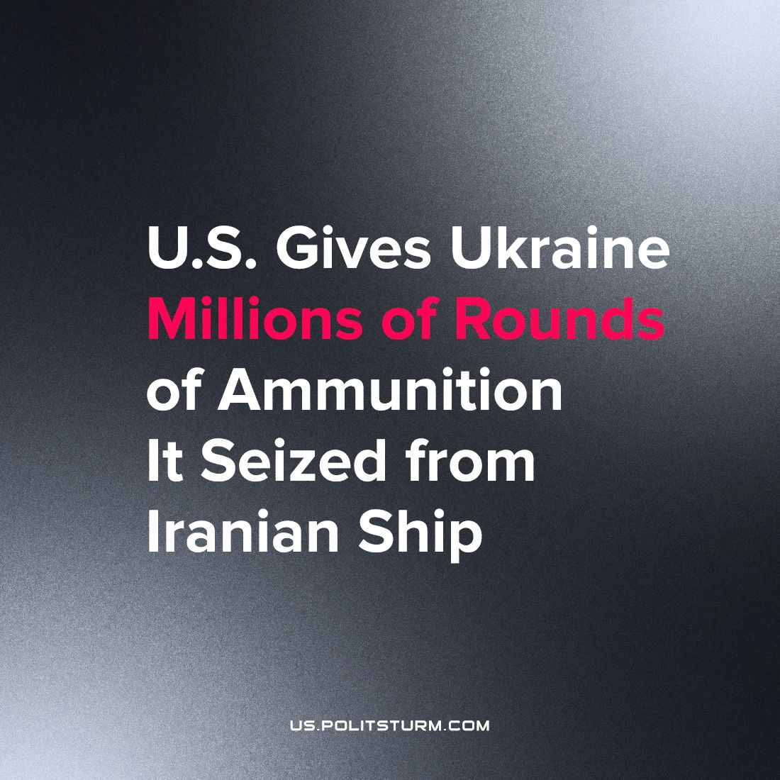

Original article
2023-10-09
1 min read

Officials at the Pentagon have confirmed that the transfer of 1.1 million rounds of 7.62mm small arms ammunition to Ukraine took place on Monday this week. The Iranian ship in question was captured during a shipment of ammunition to Yemen.
The latest move by the U.S. imperialists is a continuation of American weapons sales to Ukraine. According to the U.S. Department of State, the United States began to invest in 2014 in Ukrainian defense and, “has provided more than $46.7 billion in security assistance for training and equipment to help Ukraine preserve its territorial integrity, secure its borders, and improve interoperability with NATO”. A few examples of the Assets given by the U.S. include 31 Abrams Tanks, 45 T-72B tanks, and more than 100,000 sets of body armor and helmets.
This staggering amount of weapons shipped to Ukraine is an extension of U.S. imperialism and its attempts to gain power and influence in Ukraine. It is in the interest of all workers to oppose imperialism on all sides, whether it’s American, Russian, Chinese, etc. Overcoming this horrid system of exploitation can be done on a scientific basis, which is only provided by the Marxist-Leninist theory.
Source:
https://news.sky.com/story/us-hands-ukraine-more-than-a-million-rounds-of-ammunition-it-seized-from-iranian-ship-12976972
https://www.state.gov/u-s-security-cooperation-with-ukraine/

Original article

