US Defense Press Secretary: "Small Teams" of American Troops in Ukraine
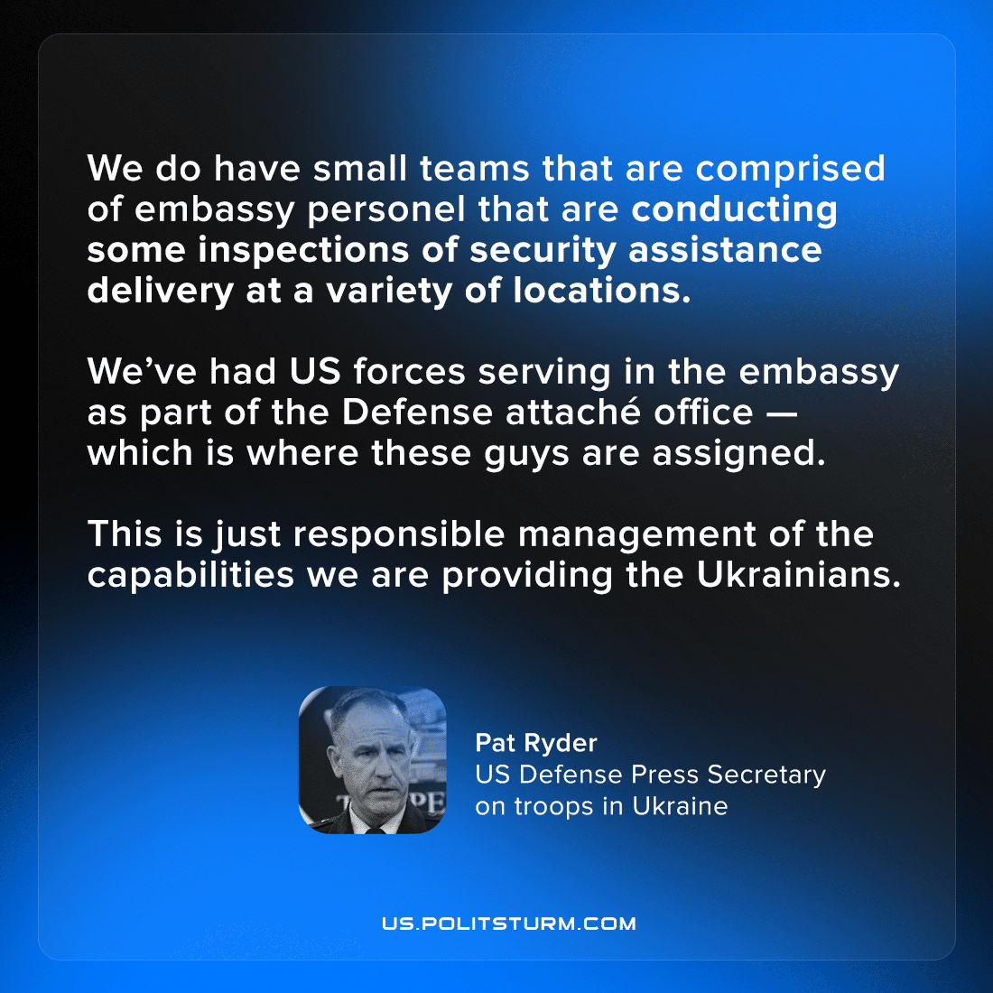

Original article
2022-11-06
3 min read

On the 3rd of November, Pentagon official General Pat Ryder, USAF, carefully confirmed the presence of US ground troops in Ukraine [1].
He explained that the US presence was limited to only “small teams”, who are venturing outside of the US embassy to “track US provided capabilities and prevent illicit spread [of arms] throughout Eastern Europe”. Ryder was very emphatic that US ground troops would be “far away from any type of frontline actions”, and that the US is “relying on the Ukrainians” to do the bulk of the fighting – categorically stating that there are “no US forces conducting combat operations in Ukraine”.
This admission of a broadened role of defense attachés off embassy grounds, however, is only a half-truth, emphasised to cover for the later outright lie. According to the Intercept [2], reporting in July on information from “several current and former intelligence officials” there already exists a large presence of US special forces troops and CIA operatives deployed to Ukraine under a covert Presidential finding. In addition, special forces from US allies, such as Britain, France, Canada, and Lithuania have been active since at least June [3]. It is possible that such forces were involved in what Press Secretary Ryder discusses of tracking high-grade military equipment, and that it was necessary for military personnel structures based in the embassy to expand to support this mission.
The presence of NATO troops has been going on more or less openly since the 2014 coup in Ukraine that firmly transferred it from the Russia “sphere of influence” to the Western one. Ever since the escalation of hostilities in Ukraine in February, there has been clear and close intelligence sharing between Ukraine and its Western “partners” as well as $20 billion dollars’ worth of US taxpayer money given as military aid by the US as well as similar but smaller packages of military aid given by US allies. Press Secretary Ryder was so emphatic about the non-combatant status of US military personel in order to reassure the public against thoughts of world war, worries which may undermine the electoral position of capitalist politicians such as President Biden. But US officials have sometimes said things more openly, like Democratic Senator Seth Moulton who declared as early as May that:

“We’re not just at war to support the Ukrainians. We’re fundamentally at war, although somewhat through a proxy, with Russia, and it’s important that we win.” [4]
General Pat Ryder’s announcement of the presence of US troops happened weeks after multiple reports of NATO arms being found in the hands of criminal gangs[5], recently in Finland, Sweden, Denmark, and the Netherlands with at least one of the biker gangs, caught with assault rifles, having an established connection to the far-right. Corruption and poverty are widespread in Ukraine, and it is unsurprising that some enterprising individuals in the Ukrainian Armed Forces would sell their donated NATO weapons and equipment to the highest bidder. As a result, the stated purpose of the US troops in Ukraine is to guard US embassy bureaucrats that are ensuring that these arms are being trafficked properly. Never-mind the history of examples, such as Iran-Contra, of the tangled web of CIA involvement with arms, networks of organised crime, and allied right-wing paramilitaries.
The modern Ukrainian state is not a particularly developed or strong one and as a result the US state enforces the increasing dominance of American capital, in this case through intensifying involvement directly in the military sphere and indirectly through the “responsible management” of its coalition’s military aid.
Russians and Ukrainians, who had lived in peace for decades under socialism are forced to act out the competing interests of Russian and American capital – demonstrating that a permanent peace under capitalism, especially in the era of Imperialism, is an impossibility. As the world is already fully divided, it can only be redivided, and war has always been the capitalists’ most effective tool for the redivision of the world. They have nowhere to lead us but to each other’s throats. Only socialism, where the monopolists and owning classes in general in whose interest this war is being waged have been expropriated, can ensure a permanent peace, and roll back the churning tide of fascisation.
Sources:
[1] https://www.youtube.com/watch?v=PY-zS6VvUNc&t=783s
[2] https://theintercept.com/2022/10/05/russia-ukraine-putin-cia/
[3] https://archive.ph/X6JQb
[4] https://twitter.com/ryangrim/status/1523047697451786240
[5] https://news.yahoo.com/weapons-meant-ukraine-hands-finnish-164400692.html

Original article

