UPS Reaches Deal with Teamsters Union
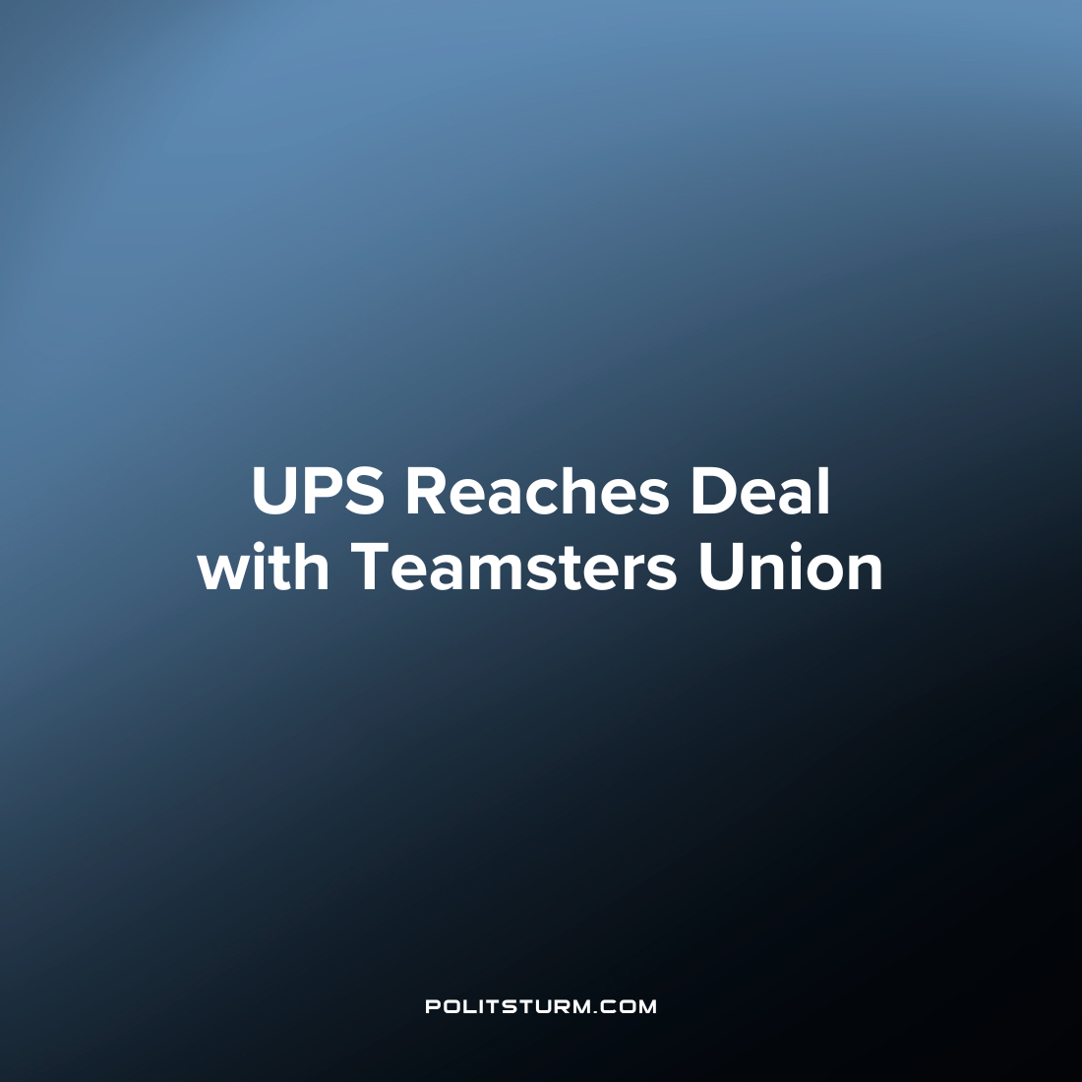

Original article
2023-07-31
1 min read

UPS and its 340,000-person union have reached a tentative contract, potentially avoiding a strike that could have disrupted package deliveries across the US. After contentious negotiations, the two parties agreed on various issues, but pay for part-time workers remained a major point of contention. Under the tentative agreement, full- and part-time union workers will receive increased wages by $2.75 per hour in 2023 and $7.50 per hour by the end of the five-year contract. The deal also includes higher starting pay for part-time workers, going from $16.20 per hour to $21 per hour.
The agreement comes after fears of a UPS strike, which could have had significant consequences due to the company's crucial role in shipping with around 24 million packages shipped daily, equivalent to approximately 6% of the nation's GDP.
“UPS came dangerously close to putting itself on strike, but we kept firm on our demands. In my more than 40 years in Louisville representing members at Worldport — the largest UPS hub in the country — I have never seen a national contract that levels the playing field for workers so dramatically as this one. The agreement puts more money in our members’ pockets and establishes a full range of new protections for them on the job,” said Teamsters General Secretary-Treasurer Fred Zuckerman.
The victory of the union to secure concessions from UPS is a win for organized labor and will go a long way in improving the wages and some aspects of the working conditions for the workers. However, such victories under capitalism are always bound within the constraints of the capitalist system. The capitalists will always maximize their profits and do whatever in their power to drive down the conditions of labor to the minimum possible level to achieve this end. It is necessary not only for workers to organize, but to do so under the principles of Marxist-Leninist theory to achieve the best possible results for the working class.
Source: 1

Original article

