Elections for President and Congress are Upcoming in Mexico
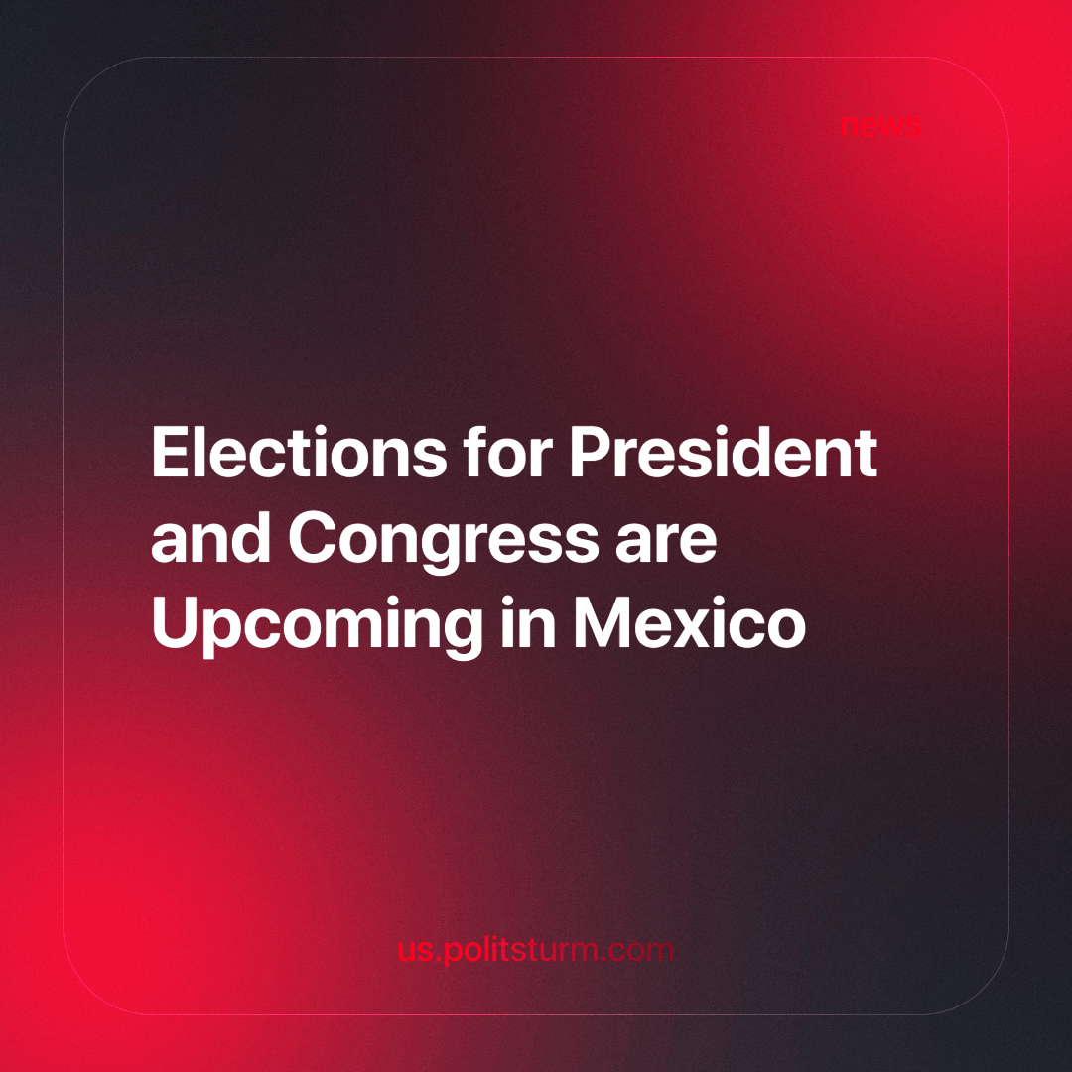

Original article
2024-04-09
4 min read

On June 2nd, Mexicans will vote for presidential candidates, Congress members, and local authorities for the next six-year period [1]. This upcoming election looks different from the previous ones in the eyes of most of the world because the traditional parties are joining forces to recover the presidential seat after losing their almost 90 years of undisputed hegemony in 2018. The person who represents this change in the name of the ruling party is President Andrés Manuel López Obrador (AMLO), a modern inspiration for many right-wing social-democrats. Besides this, Mexico changed very little under López’s government, and we will show the real character of him and his party.
López Obrador originally comes from the leftist sections of the Institutional Revolutionary Party (PRI), the liberal party that has occupied the wide majority of state positions since 1930 thanks to a rhetoric of peaceful reforms [2]. He ran for president several times under several parties and coalitions, first as the candidate of the leftist split of the PRI (the Democratic Revolution Party—PRD) in 2006 and then with his own party (Movement for National Regeneration—MORENA, a split of the PRD) in 2012 and 2018. After the 2006 and 2012 elections, he denounced fraud, which gave him some relevance among the rest of the reformist politicians in Mexico.
The government of López Obrador, as with many other reformist governments in Latin America, was merely a change of color in the rule of monopolist capital. His proposal of the “Fourth Transformation” ended up being a set of infrastructure projects for the export of raw materials and some reforms that offer tiny improvements for the workers with the sole purpose of gaining their loyalty [3]. Even more, in the last six years, Mexican monopolies have sped up their race against their Brazilian counterparts in the regional imperialist competition [4].
But the fact that better reflects the real attitude of López Obrador in regards to the workers is the covering up of the complicity of the Mexican Army in the torture, killing, and disappearance of the 43 students of the Ayotzinapa Rural Teachers' College. He promised transparency to the victims’ parents in 2018 about the events of the massacre, but when the Truth Commission started to investigate the involvement of military officers in it (and their consequential partnership with heroin smugglers), the state authorities blocked their access to the requested documents.
AMLO justified the denial of access to the documents, affirming that the Army is a “fundamental institution for the Mexican state” [5]. Clearly, the armed bodies are not only fundamental but also the central body of the state, the executioners of the necessary violence for the oppression of the working classes. Through this event, it’s evident that even the most praised reformists are willing to support state violence, to cover up the atrocities of armed bodies, and to hide the complicity between their capitalist sponsors and organized crime.
Returning to the elections, we will briefly summarize the profiles of the main candidates. To begin with, Claudia Sheinbaum is the candidate for the pro-government coalition. She is the former mayor of the Mexican capital city, and the polls give her about a 60% approval rate.
Secondly, the main opposition candidate is Xóchitl Gálvez, with a 25% polled approval rate, who is a former senator for the conservative National Action Party (PAN, the traditional opposition of the PRI since 1939) who campaigned against AMLO’s reforms by calling them a threat to Mexican democracy. Gálvez’s proposal is focused on security (for the business owners), specifically advocating for the militarization of the country and the building of more prisons. The coalition behind Gálvez unites the traditionally opposed PAN and PRI, along with the leftist split of the second, the PRD.
The third candidate is Jorge Álvarez Máynez, with about 6% approval. He runs for a reformist party that has held an ambiguous position towards the government and possibly launched him in order to get enough votes to keep their funding from the state [6].
As we can see, Mexican politics is not very different from that of other dependent and semi-dependent countries. After the Mexican Revolution, the main branches of the bourgeoisie reached an agreement to rule the country through a single liberal party that formally adopted the demands of the poor peasantry while actually implementing whatever the capitalists agreed on behind the ballot boxes.
Meanwhile, in the rest of Latin America, the corresponding branches of capital, without the risk of a revolution, fought wars between each other and then reached agreements to divide and rotate the state positions between a liberal and a conservative party. Later, in the last years of the last century, many radical reformists and revisionists saw this form of legal politics as the main obstacle to their political programs and called for “democratizing” national politics.
Now, with the arrival of these “new forms of politics”, we witness how a change in the name of the ruling party is far from even leveling the workers’ living conditions up to the standards of industrial countries. The lesson we, the working people, must learn from this is that the decomposition of traditional bourgeois politics must be denounced and broken not in favor of another “progressive” government or the participation of small parties in parliament, but for the change of the economic basis of society, for a socialist state.
Evidently, this new society wouldn’t emerge on its own – spontaneously or growing out of capitalism, as this didn’t happen already, but only with the conscious efforts of the most advanced elements of the working class, educating and helping to organize the rest of their class to reject the empty promises of the reformists and to achieve their historical goal.
Sources:
[1] https://apnews.com/article/mexico-elections-2024-what-to-know-d104184b02bf5bcf9e08f570a5ba37e2
[2] https://www.sinembargo.mx/28-07-2018/3449193
[3] https://elmachete.mx/index.php/2024/02/14/reformas-de-amlo-mas-beneficios-para-la-burguesia/
[4] https://elmachete.mx/index.php/2022/09/18/avanza-el-poder-de-los-monopolios-con-amlo/
[5] https://www.hrw.org/news/2023/09/26/ayotzinapa-mexicos-army-and-lopez-obradors-silence
[6] https://www.as-coa.org/articles/explainer-whos-who-mexicos-2024-presidential-race

Original article

