Lenin on the Best Form of State for Capitalism
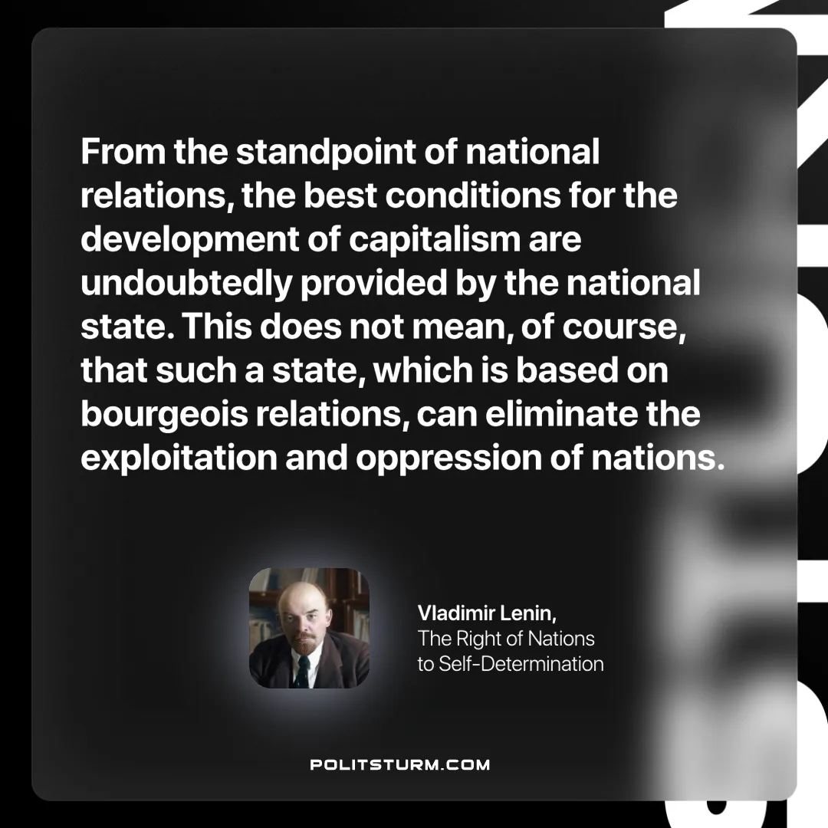

Original article
2024-11-14

“From the standpoint of national relations, the best conditions for the development of capitalism are undoubtedly provided by the national state. This does not mean, of course, that such a state, which is based on bourgeois relations, can eliminate the exploitation and oppression of nations.”
Vladimir Lenin, The Right of Nations to Self-Determination

Original article

