Engels on Growing Inequality of Benefits under Capitalism
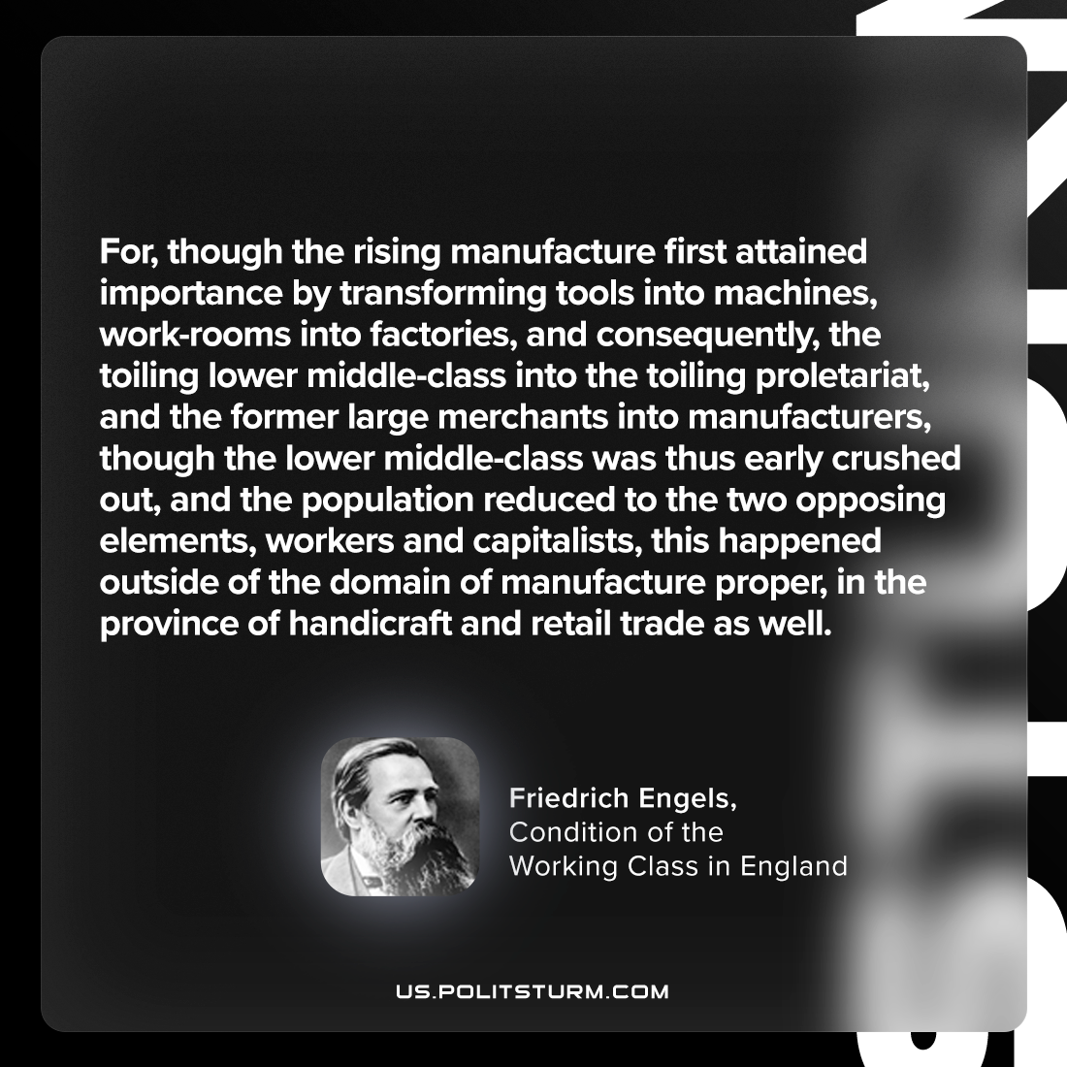

Original article
2024-03-31

“For, though the rising manufacture first attained importance by transforming tools into machines, work-rooms into factories, and consequently, the toiling lower middle-class into the toiling proletariat, and the former large merchants into manufacturers, though the lower middle-class was thus early crushed out, and the population reduced to the two opposing elements, workers and capitalists, this happened outside of the domain of manufacture proper, in the province of handicraft and retail trade as well.”
Friedrich Engels, The Condition of the Working Class in England

Original article

