Lenin on the Similarities Between Social-Chauvinism and Opportunism
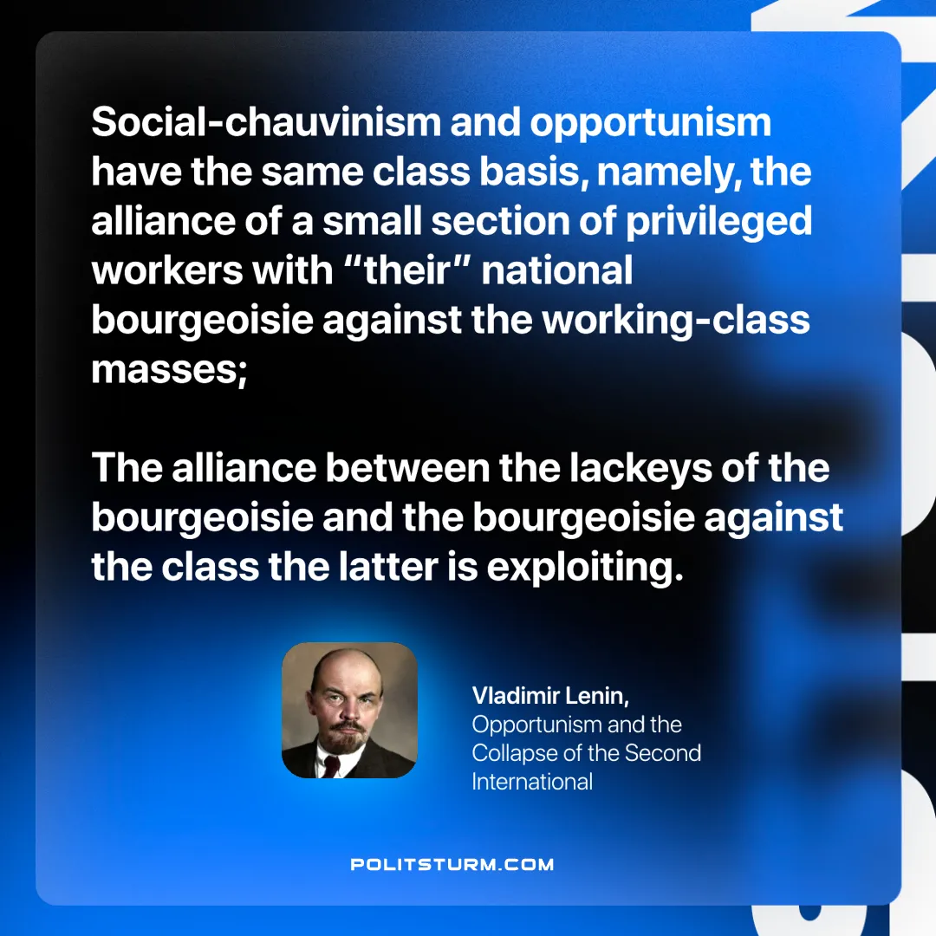

Original article
2025-05-13

“Social-chauvinism and opportunism have the same class basis, namely, the alliance of a small section of privileged workers with “their” national bourgeoisie against the working-class masses; the alliance between the lackeys of the bourgeoisie and the bourgeoisie against the class the latter is exploiting.”
Vladimir Lenin, Opportunism and the Collapse of the Second International

Original article

