Unpaid wages in Russia reached $4.1 Million
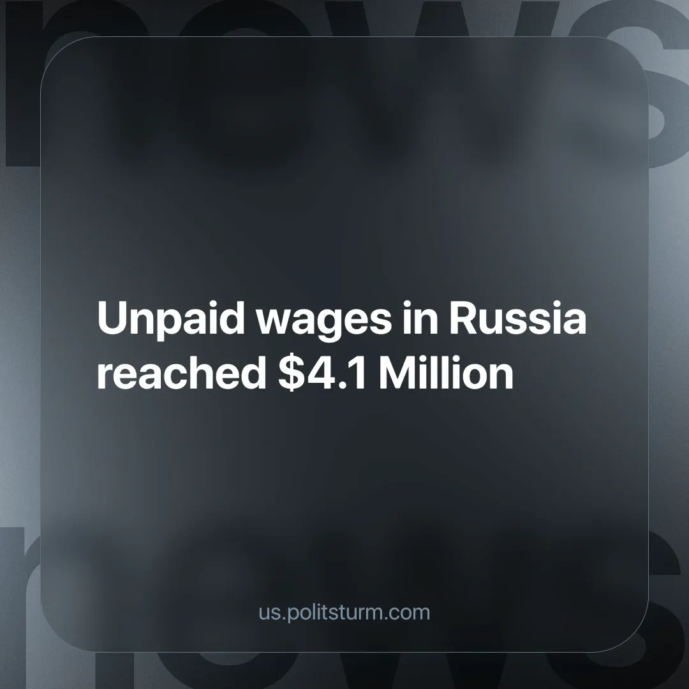

Original article
2024-11-25
4 min read

Rosstat reported an increase in total wage arrears in the country. Miners in the Kemerovo region faced this problem, and they went on a hunger strike.
As of October 1st, 2024, Russia's wage backlog amounts to $4.1 million. At the same time, more than half of this amount dates back to previous years. This situation persists in many sectors of the economy [1].
Rosstat also notes that as of October 1st, less than 1% of the employees in the surveyed organizations experienced wage delays [1]. While this figure may seem insignificant, it still represents thousands, potentially even hundreds of thousands, of struggling workers and even more members of their families.
Moving from the general to the specific, it is worth mentioning one of the examples of the unfair treatment of this 1% “minority” of workers. The miners of the Ina coal mine have not received their salaries from July to October. The company's debt to its 282 employees amounted to 46 million roubles, accounting for a tenth of the overall wage arrears according to Rosstat [2].
The workers have not gone to work for several months. This boycott is very much legal, sanctioned by Article 142 of the Labor Code of the Russian Federation, which implies the right to be absent from work in case of salary delays.
The case moved forward when 12 particularly active workers threatened the directors with a hunger strike. They announced their decision in one of the Kuzbass (a major coal-mining and industrial region in southwestern Siberia) social media communities, which immediately attracted the attention of the mine management and local authorities. Soon a video appeared in which the mine management asked the workers not to quit mining and promised that all debts would be paid by October 28.
The Investigative Committee has turned its attention to this situation and opened a criminal case. It can be assumed that the owners of the coal mine were afraid of punishment or public outcry. Some may even assume that management felt sympathy for the workers who chose to starve as a protest, but if that were the case, the wage arrears wouldn’t have occurred in the first place.
Chinese investors solved the problem by agreeing to invest 2.4 billion roubles in the company. This will be used to pay off wage arrears and resume mining of special premium long-flame coal, which is essential for a number of production facilities [3].
Negotiations on financing were successful, but there was a problem with the lack of allocated quotas for rail transportation of coal to land border crossings with China. Denis Nemykin, the owner of Inskaya Mine LLC, attributed this to the activities of his predecessor, which resulted in a loss of the necessary quotas.
The inability to sell coal to China forced the flow to western seaports at prices lower than the eastern ones, which is even below the cost of production. The owner began to increase monthly liabilities, including wages, in order to maintain profits and preserve markets in China [3].
Once again, entrepreneurs are shifting losses onto the shoulders of their workers. They do not care how can workers sustain themselves or support their poor families. The main incentive of their activity was and remains profit. In order to maintain cash flow, the owner sold coal at a loss, but at the cost of not paying the miners' salaries. All for the sake of potentially more profitable Chinese markets, for which the businessmen are willing to keep the workers on starvation rations for several months.
The example of the Kuzbass workers is just one of many. The pursuit of profit and self-interest is no longer hidden by businessmen but is openly demonstrated in the official news. We are told every day that the laws of the market work this way and that there is no possibility to change this system. But the working people know other laws of economic and social development.
The employer could not allow coal production to stop, as it was essential for their own well-being. The united struggle and the threat of stopping the mine forced the management to solve the financial problems. All businessmen will always help each other when they sense a threat from the workers.
The working people of Russia must remember once and for all that "effective managers" see and treat them merely as a workforce that can be disregarded for the sake of profit. As long as the main incentive of any enterprise is maximization of profit and minimization of costs, wage arrears, mine collapses, and heating and power grid shut-downs will continue to occur. Each of the above examples is a consequence of a rotten economic system dominated by private property — capitalism.
Only the establishment of socialism — a system prioritizing social equality and efficiency, can remedy the plight of the common people. Strictly following the theory of Marxism-Leninism, the workers must unite in their struggle, realize their common interests, and, under the leadership of an organized Communist Party, they will be able to succeed. Private property must be replaced by social property, and the results of labor must be administered by those who produce them, not by those who appropriate them. A socialist planned economy will allow people to invest their power not in the profits of a few oligarchs, but in improving their own lives and society as a whole.
The road to a new social order is not easy. It is not enough to defend your rights at work or each figure on your paycheck. Every such victory will be temporary. Corporations will cooperate only when it is in their interest, and when profits or markets are at stake. As soon as the owners regain solid ground, they will again take away wages, introduce new fines, or abolish the detested Article 142. It is impossible to secure a lasting improvement in one’s living conditions under capitalism. The only way out was and remains socialism. The struggle for socialism can succeed today by joining a unified communist organization with a very clear goal — the establishment of workers’ power. Join Politsturm!
Sources:
[1] RIA Novosti — “Rosstat reported an increase in total wage arrears in the country” — October 23, 2024.
[2] RBK — “The miners' hunger strike over wage debts lasted several hours” — October 22, 2024.
[3] Neftegaz.RU — “Chinese companies are ready to save the troubled Inskaya mine in Kuzbass” — October 27, 2024.
[4] Politsturm — “The deficit and devastation of the electric power industry.” — October 13, 2024.
[5] Politsturm — “Tragedy at the Amur mine: chronology and causes” — April 8, 2024.

Original article

