United Auto Workers Strike Today
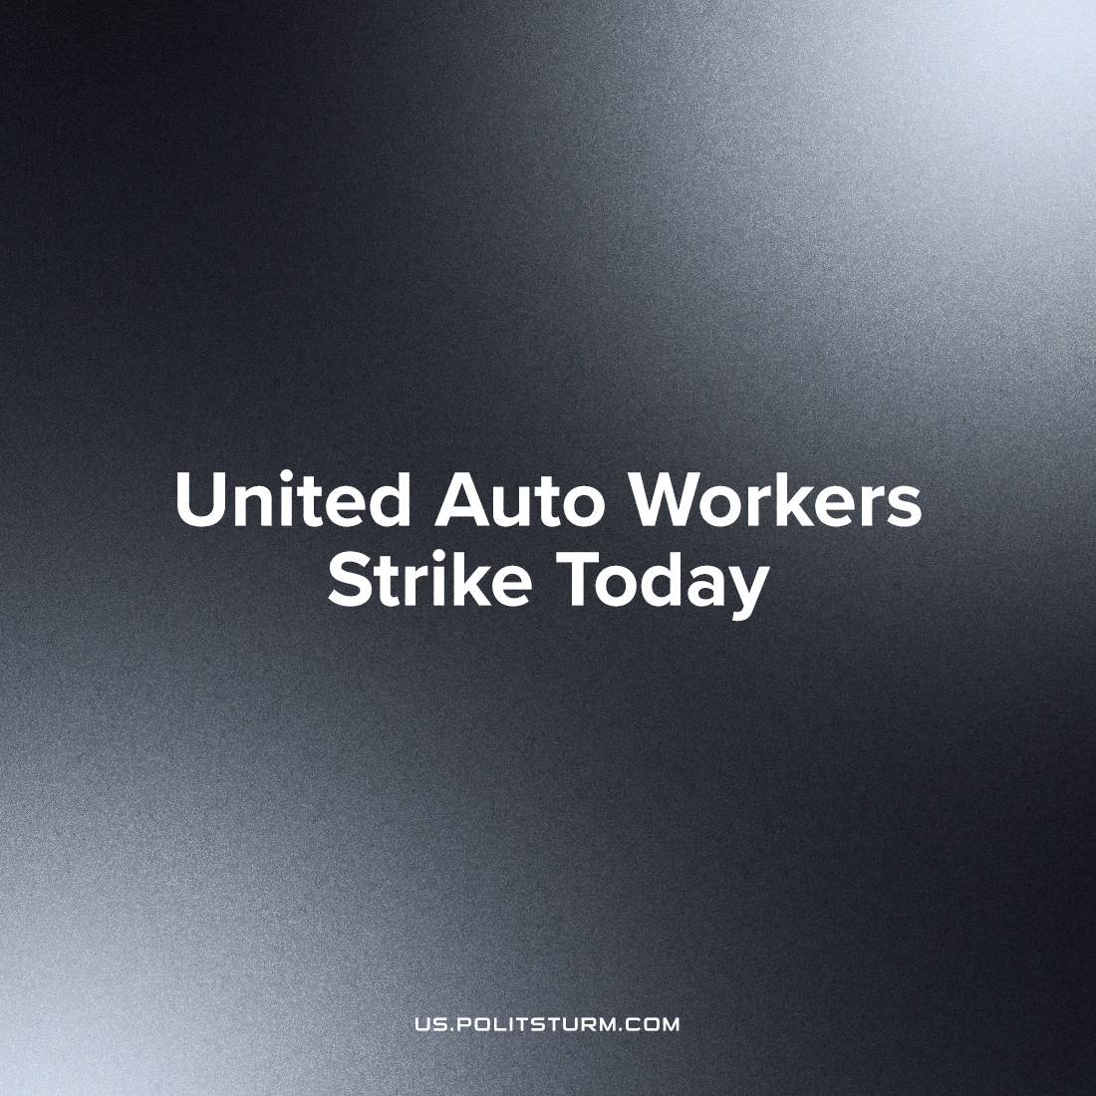

Original article
2023-09-15
1 min read

Today, the members United Autoworkers will go on strike, including work stoppages, due to the inability of the major automotive manufacturing corporations, like Ford, to agree to a negotiate a new contract in line with UAW demands. The strike is estimated to cost the auto-industry billions. There are a total 145,000 potential members of the strike action, but many are not expected to join in initial work stoppages.
4 years ago on this same day, 48,000 union members began their walk-off from worksites owned by General Motors. Back in 2019, GM halted health insurance payments for 55 thousand, placing the expense on UAW.
Today, polled Americans overwhelmingly support the strike, and financial attempts at corporate coercion have not dissuaded UAW from an even bigger action in the present market situation of labor strength. The current UAW strike fund is officially over 825 million dollars, and donations will likely increase as the strike begins.
Ford fears public support and publicity, and so has even pulled the list of factory locations from their website. Public support for labor unions has slowly risen for years, and increased strike action will likely elevate the public perception of labor as a source of strong resistance to elite corporate interests.
The UAW has the potential to win major demands like the abolition of the 'second-class' of temporary co-workers, reduction of weekly hours, only if it uses the full incredible strength available to it, including the will and potential support of the public. However it is likely the UAW will not win its full demand. Even if it did, by incredible odds, it will still not reverse the economic antagonisms constantly undermining the position of the working class inherently to capitalism.

Original article

