New Law Would Make Dock Workers Pay Bosses $2 Billion per Day for Striking
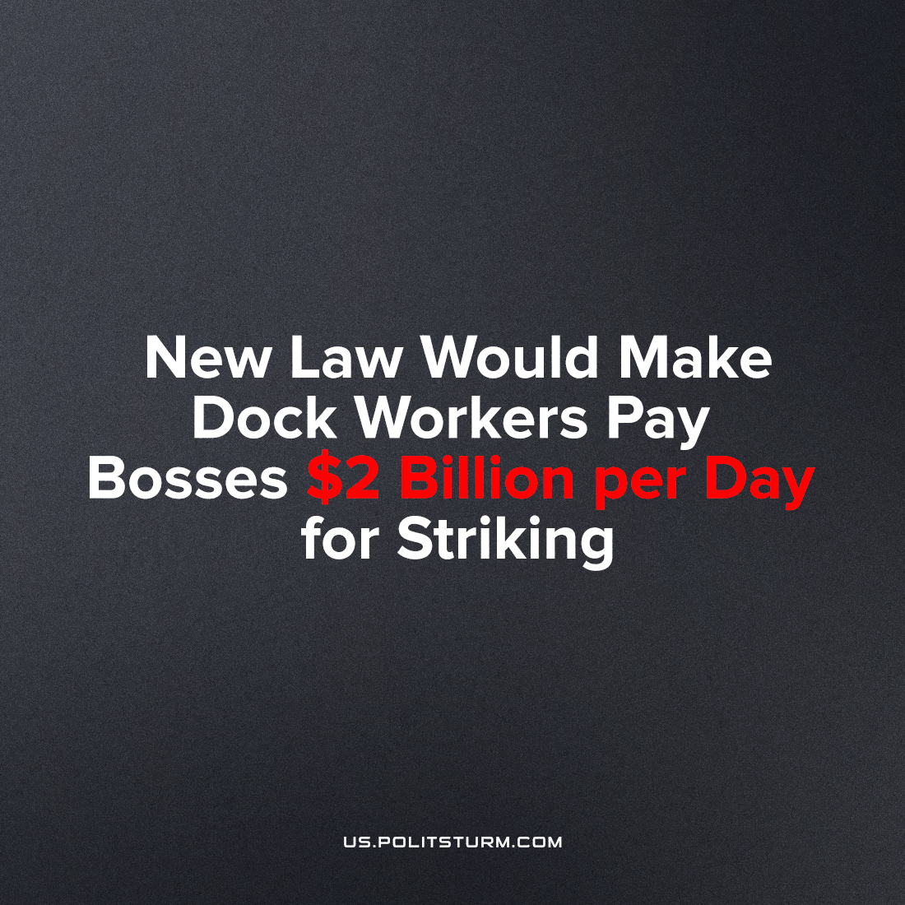

Original article
2023-06-28
2 min read

The Republican Party has introduced a bill in the U.S. Senate that imposes financial responsibility on the unions of dock and port workers for economic damages amounting to double the amount which their strike costs the company[1] . If the law is passed, trade unions will be forced to pay a fine of $2 billion for each day of protest. With such a fine, it will be impossible to carry out strikes - meaning the end of large labor actions.
The Loadstar states:
"The bill will amend the Law on National Labor Relations and the Law on Labor Relations. It is expected that the amendments will prevent delays and suspensions of ports due to the actions of port workers, including absenteeism and strikes. Such actions will be regarded as unfair labor practices,"
The U.S. Chamber of Commerce estimates that a mass strike on the west coast of the country costs about $1 billion a day. Therefore, the unions would hypothetically be forced to pay $2 billion a day.
This is happening against the background of the vote for a strike held in the ILWU branch: "99.24% of votes in favor of supporting a strike against the British Columbia Maritime Employers Association, if necessary". [2]
The bourgeois state will take any measures to protect the capitalists - this is only the latest attack in the judicial expression of class war. In a parallel attempt, the Supreme Court ruled that the Teamsters union could be sued in court for damages resulting from their strike - after they allowed cement to dry in its mixer.
Even when dockers want to improve working conditions within the framework of the law, they are opposed not only by the employer, but also by the entire state apparatus, including the White House with its 'most pro-union American President in history'. The fight of communists in labor will soon take on a new and essential character - making our participation necessary for the very existence of labor organizing in the country. The economic struggle is not enough to ensure the existence of unions; a workers' party is needed that will be able to unite the workers and implement all their interests. This can be fully achieved only under socialism - where the state will not be for capitalists, but for workers.
Sources: 1, 2

Original article

