Union Electric Steel Workers Strike
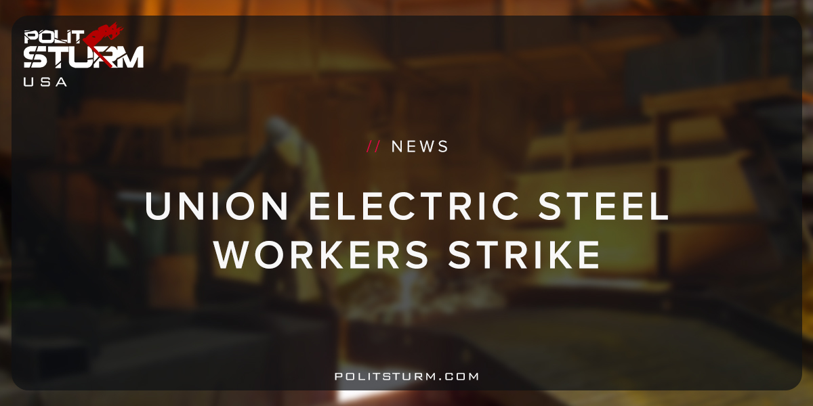

Original article
2018-06-16
1 min read

Union Electric Steel workers have gone on strike after the company would not even grant a wage raise of 3% per year. The company proposed a 9% increase spread out over 4 years, or 2.25% annually.
The workers were rightfully insulted because they know that orders and therefore revenues have increased. The workers know that they have increased productivity dramatically but the proposed wage increase is meager. It is quite apparent to workers that the profit is being siphoned to the capitalists, the owners and major shareholders.
Kyle Yarnell, an affected worker, called the proposal a “slap in the face. Kyle added, “We’ve met every quota they’ve had. They have three times as many orders on the books. We’ve done everything they’ve asked, increasing productivity and production.”
The company spokesperson argued that they were intent on finding an agreement that was “competitive”. The employer class is competing for ever higher profits, while the working class fights for better living and working conditions.
Solidarity must be expressed with the workers of Union Electric Steel who are able to see that the offer is an insult. The economic explanation given by workers such as Kyle Yarnell are valid and sound. The workers are producing more value, and are not receiving higher wages and better benefits.
https://www.nwitimes.com/business/lake-newsletter/update-union-electric-steel-workers-in-valpo-go-on-strike/article_94e566e7-bf14-51b8-9cf3-17529151854d.html

Original article

