Unemployment Claims Spike Amidst Crisis
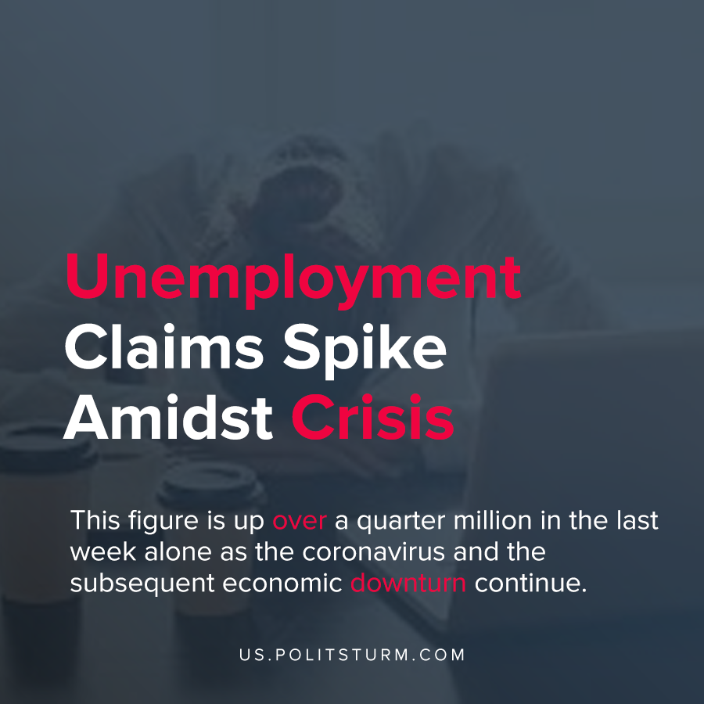

Original article
2020-12-12
1 min read

The number of initial non-seasonally adjusted unemployment claims increased by 947,504 for the week ending October, 5, 2020. This figure is up over a quarter million in the last week alone as the coronavirus and the subsequent economic downturn continue.
Initial claims occur when a worker becomes unemployed and submits a claim for unemployment benefits to the state.
Earlier in the year the U.S. experienced spikes in unemployment claims to over 6 million per week. The Coronavirus Aid, Relief and Economic Security Act (CARES) provided unemployment benefits between January 27, 2020 and December 31, 2020. As a result, millions of workers lose state benefits at the same time as initial claims are increasing.
The plight for the unemployed workers is very bleak with the approaching expiration of benefits and surging claims.
Workers have no right to a job under capitalist social relations and every crisis swells the reserve army of labor. During the crisis phase of each economic cycle, unemployment increases beyond its typical levels as capitalists lay off workers in an attempt to restore profitability or as businesses close. As long as capitalism exists, the scourge of unemployment will afflict the working class.
Sources: 1 , 2

Original article

