UN Reports on Ukraine’s Responsibility for 56 Civilian Deaths in Luhansk
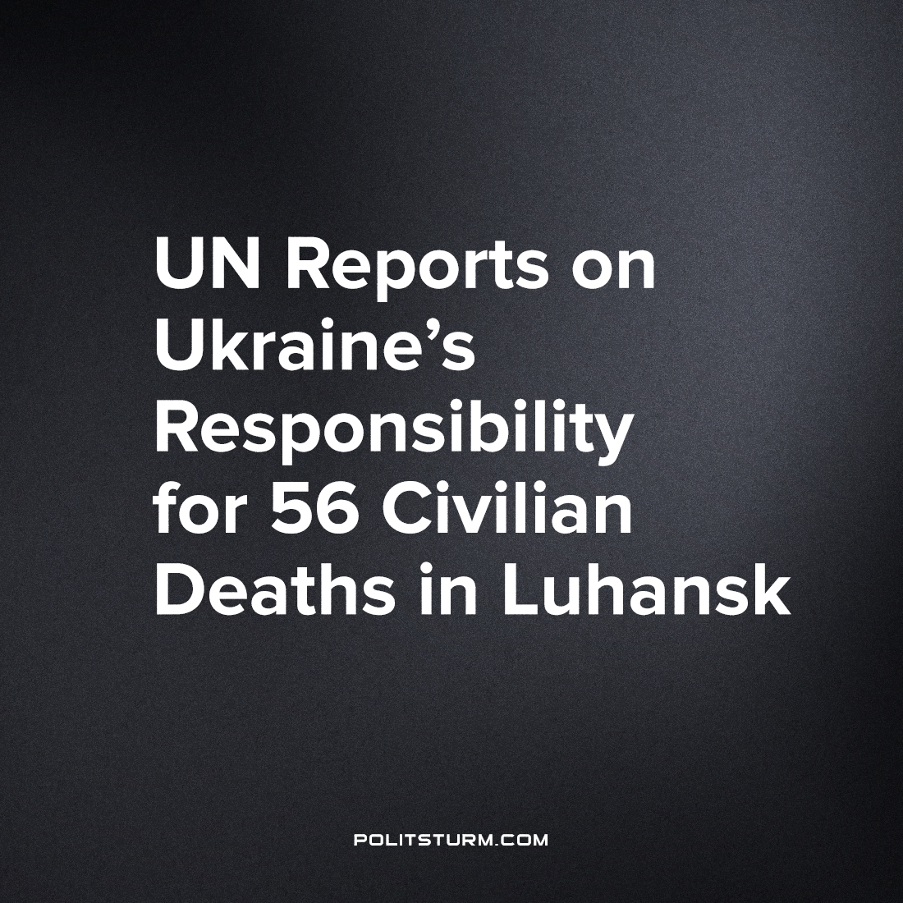

Original article
2022-07-15
3 min read

From the UN report “SITUATION OF HUMAN RIGHTS IN UKRAINE IN THE CONTEXT OF THE ARMED ATTACK BY THE RUSSIAN FEDERATION” (pages 8, 34-36):
“At the beginning of March 2022, when active hostilities drew nearer to the care home, its management repeatedly requested local authorities to evacuate the residents. This was reportedly impossible as Ukrainian armed forces were alleged to have mined the surrounding area and blocked roads.
On March 7th, soldiers from Ukrainian armed forces entered the care home, where older persons and residents with disabilities and staff were located, as it had strategic value due to its proximity to an important road.
On March 9th, soldiers from Russian-affiliated armed groups, who were approaching from the opposite direction, engaged in an exchange of fire with soldiers from Ukrainian armed forces, although it remains unclear which side opened fire first. During this first exchange of fire, no staff or patients of the care house were injured.
On March 11th, 71 patients with disabilities and 15 staff member, along with soldiers from Ukrainian armed forces, remained in the care home with no access to water or electricity. That morning, soldiers from Russian-affiliated armed groups attacked the care house with heavy weapons while patients and staff were still inside. A fire started and spread across the building while the fighting was ongoing. Some staff and patients fled the care home and ran into the forest, until they were met five kilometers away by Russian-affiliated armed groups, who provided them with assistance. According to various accounts, at least 22 patients survived the attack, but the exact number of persons killed remains unknown.
The consequences of the attack on a nursing home in Stara Krasnianka illustrate how fast propaganda reacts to developments on the ground, even if details might remain hidden by the fog of war. First reports in social media about the tragedy in Stara Krasnianka were mainly repeating the statement of Ukrainian officials even after a week had passed since the fighting.
A governor of the Lugansk region, Sergei Gaidai, stated in his Telegram channel on the 20th of March, that 56 were killed “clinically and deliberately” by “Russian occupants”, who “fired from a tank at close distance”. On the same day, similar information was given by the office of the Attorney General of Ukraine.
However, no mention was made of the fact that Ukrainian soldiers had entered the building before the fighting started.
It’s obvious that for the Ukrainian government it is important to save its initiative in the information war for the hearts and minds of people both in Ukraine and abroad. The last guarantees a permanent flux of billions of dollars in humanitarian and military assistance.
At the same time, during the whole conflict, the capitalist social media has permanently blamed Russian political and military authorities for indiscriminate shellings, which caused civilian casualties.
But shouldn’t the political and military leadership of Ukraine follow the norms of international humanitarian law in the same way? Of course, It should.
David Crane, a former Defence Department official and former Chief Prosecutor of the United Nations Tribunal for Sierra Leone spoke on the events in Stara Krasnianka. He stated that the Armed Forces of Ukraine violated the norms of international humanitarian law by not evacuating residents and staff of the nursing home.
We remind our readers that the use of civilians as human shields is prohibited by Article 28 of the IV Geneva Convention and Article 51(7) of Additional Protocol I.
The report of the UN High Commissioner for Human Rights does not conclude that the warring parties have committed a war crime. However, the UN report showed that the Armed Forces of Ukraine bear equal responsibility for the tragedy in Staraya Krasnyanka. A few days before the attack, AFU soldiers took up positions inside the nursing home, effectively turning the building into a target and the civilians inside it into human shields.

Original article

