UN Investigator Shocked by US Poverty: “This is Not a Sight That One Normally Sees” in the First World
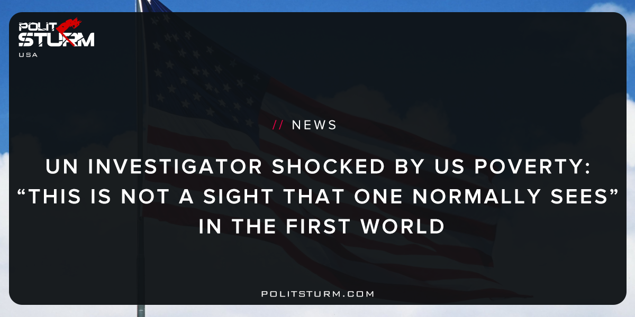

Original article
2017-12-21
7 min read

While Americans were focused on the special election between Roy Moore and Doug Jones, Philip Alston, the UN’s Special Rapporteur on Extreme Poverty and Human Rights was out touring areas of rural Alabama on his “poverty tour” where he was reportedly shocked at the level of poverty and environmental degradation he witnessed.
“Some might ask why a U.N. Special Rapporteur on extreme poverty and human rights would visit a country as rich as the United States. But despite great wealth in the U.S., there also exists great poverty and inequality,” Alston explains. “There are pretty extreme levels of poverty in the United States given the wealth of the country. And that does have significant human rights implications.”
Personally troubling were the cases of raw sewage that “flows from homes through exposed PVC pipes and into open trenches and pits” found in a community in Butler County.
Aaron Thigpen, a local activist from Fort Deposit, showed Alson his home where five extended family members, including two children, reside. “These two pipes are the raw sewage pipes coming from the house. And you’ve got your main water line here, and it may have a hole in it, so everyone gets sick all at once,” Thigpen explains while pointing out areas of raw sewage coming from exposures in the pipes. “It’s really bad when you’ve got a lot of kids around like there are here. They’re playing ball and the ball goes into the raw sewage, and they don’t know the importance of not handling sewage.”
“There is a human right for people to live decently, and that means the government has an obligation to provide people with the essentials of life, which include power, water and sewage service,” Alston maintains. “But if the government says, ‘oh no, we’re not going to do it,’ and leaves you to install very expensive septic tanks, that’s not how it should work.”
Another concern have been the reoccurances of poverty-related diseases, such as hookworm, normally at home in South-Asia and Sub Saharan Africa, discovered in Lowndes County, Alabama. The Zika virus, a disease spread through mosquitoes, is believed to have infected an estimated 12 million Americans.
“I think it’s very uncommon in the First World. This is not a sight that one normally sees. I’d have to say that I haven’t seen this,” says Alston.
Alabama is only one stop on a 15-day investigation also covering parts of California, Puerto Rico, Washington D.C. and West Virginia.
In West Virginia, Alston found that access to broadband access, a necessity in today’s economy, was relatively low (30% lacking access) when compared to the national average (10%). This number jumped to nearly 48% of West Virginians lacking access when counting rural areas.
In Puerto Rico, Alston concludes that the general consensus is that “many, probably most, Puerto Ricans believe deeply that they are presently colonized,” in reference to the island’s halfway position between colony and full-fledged state and the PROMESA austerity program signed into law under President Obama.
“Political rights and poverty are inextricably linked in Puerto Rico. If it were a state, Puerto Rico would be the poorest state in the Union. But Puerto Rico is not a state, it is a mere ‘territory,’ Alston writes in his official statement on the trip. “Puerto Ricans have no representative with full voting rights in Congress and, unless living stateside, cannot vote for the President of the United States. In a country that likes to see itself as the oldest democracy in the world and a staunch defender of political rights on the international stage, more than 3 million people who live on the island have no power in their own capital.”
Another colonized people, the indigenous communities of America, continue to see their culture destroyed, their people disempowered, and their way of life “criminalized”. The living conditions in Pine Ridge, Lakota, for example were described in the UN report as being “comparable to Haiti”. The annual income there hovers around $12,000 and infant mortality is more than three times the US national average. Alston was reported to have been told that nine individuals had committed suicide only in the last three months preceding his visit, one of which included a six year old. Another Native American tribe mentioned in the report, the Red Water Pond Navajo, are subject to predatory loans with rates of over 400%.
In the official UN statement on the trip, the Special Rapporteur gives some other shocking statistics concerning poverty and inequality in the United States:
- The “health gap” between the US and other developed countries continues to grow. Infant mortality rates in 2013 were the highest in the developed world and the US ranked 36th in the world for access to water and sanitation in 2013.
- Income equality is much higher than in European countries. With 25% of young Americans living in poverty, the youth poverty rate in the US is the highest of all OECD members.
- Despite all of these examples of severe economic stratification, the US continues to maintain and expand its budget for the military, already the size of the next seven military powers combined. Domestically, the US is home to the largest prison population in the world, equal to 5 times the OECD average.
Alston claims that despite being “one the world’s richest” countries, “neither its wealth nor its power nor its technology is being harnessed to address the situation in which 40 million people continue to live in poverty.” Instead he noted the way in which the poor are disempowered and disenfranchised in American society, such as the drug war, policies that “criminalize” the homeless, the setting of large bail-bonds, and the suspension of driver’s licenses for the inability to pay simple fines.
This, as a result, fundamentally undermines the democratic process; Alston explains:
“In the US there is overt disenfranchisement of vast numbers of felons, a rule which predominantly affects Black citizens since they are the ones whose conduct is often specifically targeted for criminalization. In addition, there are often requirement that persons who have paid their debt to society still cannot regain their right to vote until they paid off all outstanding fines and fees. Then there is covert disenfranchisement, which includes the dramatic gerrymandering of electoral districts to privilege particular groups of voters, the imposition of artificial and unnecessary voter ID requirements, the blatant manipulation of polling station locations, the relocating of DMVs to make it more difficult for certain groups to obtain IDs, and the general ramping up of obstacles to voting especially by those without resources. The net result is that people living in poverty, minorities, and other disfavored groups are being systematically deprived of their voting rights.”
The most damaging aspect to democracy, of course, that arises from this are the high rates of apathy among the poor, who come to see that voting is pointless as the people see no real change in their immediate conditions regardless of who is in office.
Politsturm: Professor Alston’s report is essentially capitalism in a nutshell; America is a rich country, yet it’s people are poor. The poverty rate currently stands at 12.5%, or 40 million people, according to the US Census Bureau, despite the economic “recovery” over the last decade. Minorities and immigrants are particularly at risk of being in poverty, however, as Alston mentions, there are “8 million more poor Whites than there are Blacks.” This is not simply the result of a bad economic climate or the policies of a certain party, but a structural constant, a permanent state of affairs under the capitalist mode of production.
How can such a rich country have such large levels of poverty? Simple. The capitalist economy is a naturally unequal system that creates massive disparities between rich and poor. Concessions in the form of the social welfare system have been slashed over the past few decades in order to make way for higher profitability; a market “competitiveness” that leaves the rest of us out to dry. While the New Deal era brought an unprecedented level of prosperity to the American middle class, history has shown that the rug can be pulled out from them at any given moment. Reforms then, are only useful to the ruling class insofar as they pacify the population from fighting for major systemic changes, e.g. social revolution, and once the problem has been taken care of, they can simply be rolled back.
As the UN attaché noted, the tactics of the neoliberals have been the constant barrage of attacks on those suffering from the worst of what capitalism has to offer. “Culture” has been the go-to wedge issue for capitalists to divide and conquer. When the unemployed are demonized as “lazy” or “welfare queens”, it is easy for the rest of the country to get around legislation that targets the most vulnerable. When minorities and immigrants are targeted because of their supposed ‘cultural incompatibility’ with the civilized world, whether it be by citing crime statistics, religious belief, or means of immigrating, it justifies the high incarceration rates, the police brutality, and the deportations. The point of these issues are to keep working people fighting amongst themselves while the rich continue taking more and more of the pie. However, we know culture not to be the problem, as the only culture we have is the one we have been given from the bourgeoisie through the system created over us.
If this report were made of one of the enemies of the American corporate state such as Iran, Venezuela, or North Korea, the elite would be full of condemnations, however, since these issues concern the state of their own country, the effects of their own policies, the report has been met with silence. Very few news outlets have even bothered to report on the United Nations investigation, instead choosing to cover the moves of America’s foreign “enemies” or the President’s latest scandal.
This report paints a grim picture about the state of the American working class. However, this should not be an excuse to despair but a call to arms. Working people need to understand that things under the current economic system are only going to get worse if they cannot organize and resist corporate interests. Links of solidarity need to be formed with workers of all backgrounds in order to struggle for the liberation of the proletariat as a whole. It is only when this class gains consciousness of itself that real change can be made possible.
Sources: 1, 2, 3, 4

Original article

