Ukrainian wheat going to well-fed nations in world hunger crisis
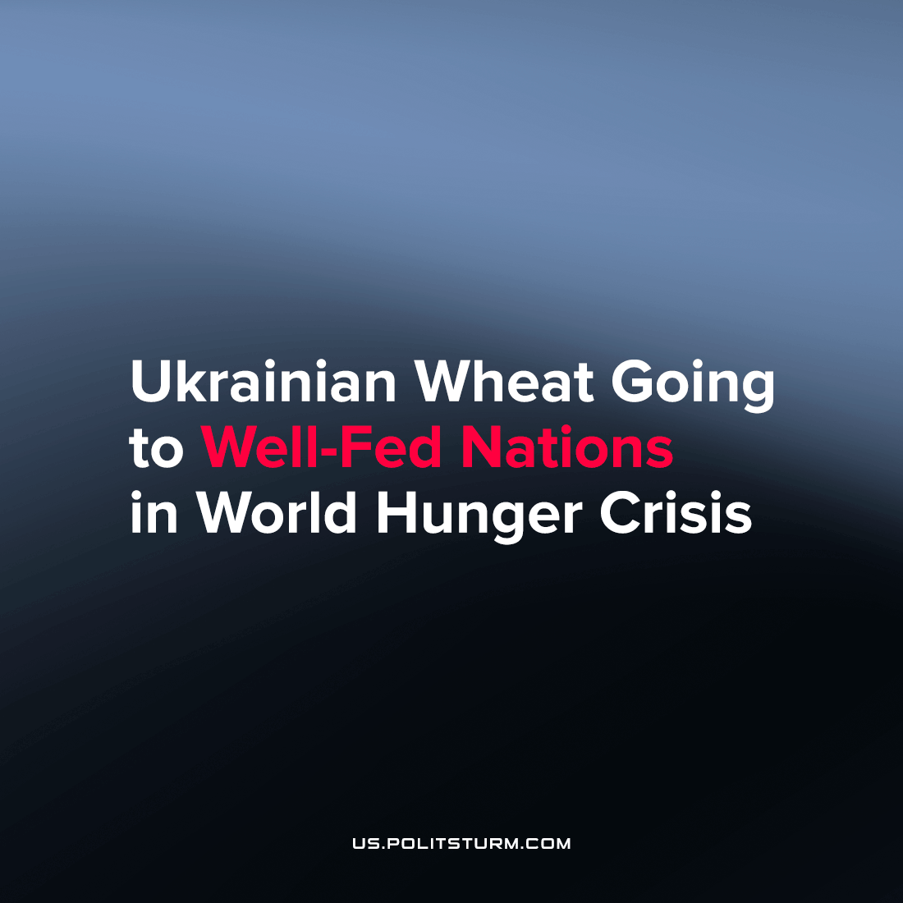

Original article
2022-08-31
3 min read

Of 24 ships that left Ukrainian ports to help starving countries in Africa, only one reached the announced destination.
Cargo ship Brave Commander departed on the 15th of August from Ukraine to Djibouti, an important imperial outpost on the Horn of Africa, carrying 23.3 kilotons of wheat for Ethiopia, one of the world’s hungriest countries. Here are the destinations of the other ships according to the UN and Marinetrafic.com:
🇹🇷Turkey – 12 ships
🇮🇹Italy – 2
🇮🇷Iran – 2
🇰🇷South Korea – 2
🇬🇧Great Britain – 1
🇮🇪Ireland – 1
🇨🇳China – 1
🇹🇩Romania – 1
🇸🇾Syria – 1
The first ship Rizon was on course to Lebanon carrying corn for chicken feed, but, after it was resold several times, it ended up in Syria. It’s noteworthy that the main cargo on these ships is grain for animal feed – feed corn (13 ships with 458 kilotons) and sunflower meal (2 ships with 50 kilotons). Only three ships with 35 kilotons carry wheat: except the above-mentioned Brave Commander, two others went to Turkey and Romania.
Western politicians cried for weeks about Russia’s blockade of Ukrainian ships in port, which they said deprived bread to starving Africans and doomed 15 million people to hunger.
As we can see, more than half of the Ukrainian ships are in a rush to help some of the most financially secure nations, where military and humanitarian support came from.
“The market, however, is not always efficient at sending the grain where it is needed” – complains NYT journalist Ruth Maclean, who has noticed a slight difference between rhetoric and practice by Western officials.
At the moment there are 0.56 million tons of grains exported, however, it is planned to export 20-22 million before the next harvest. Probably plenty of other ships will reach Africa, but current priorities are different.
Ukraine indeed supplies significant volumes of grain to Africa: in 2021 it was $2.1 billion (half of which went to Egypt) out of the country’s total grain exports of $10.7 billion, according to UN Comtrade data.
Countries where Ukraine exported grain in 2021, in billions of dollars:
🇨🇳China – 3.3
🇪🇺EU – 2.5
🇪🇬Egypt – 1.1
All other African countries – 1.0
🇮🇩Indonesia – 0.95
🇹🇷Turkey – 0.94
TOTAL – 10.27
2 billion, 792 million tons of grains will be collected across the world in 2022 according to the Food and Agriculture Organization (FAO) of the United Nations. Ukraine’s 20 million tons make up only 0.7% of this volume. At the same time, world grain stocks will grow to 856 million tons by the end of the season in 2022, and their consumption ratio will be at the level of 30%, which indicates a comfortable level of supply.
The situation of hunger is catastrophic in many African countries. Most of the undernourished are in the Congo (36 million people), Ethiopia, Tanzania, and Kenya. In terms of the share of the hungry among the population, these countries are Somalia (where hunger is at 60%) and the Central African Republic. Over the world, 828 million people suffered from hunger by 2021, according to the FAO estimate, which is 46 million people more than a year earlier.
What is the main reason for hunger? “The high cost of healthy diets, coupled with persistently high levels of poverty and income inequality, continues to place such diets out of reach for an estimated 3 billion people in all regions of the world,” says the latest FAO Food Security Report. The word “inequality” is mentioned more than 150 times in it, which speaks eloquently about the origins of hunger in the world. Inequality is a natural companion of capitalism, the colonial version of which in Africa has been enforced for many years by Western countries and corporations. Now, these same countries make the world’s supply-chain dance to their tune, at the great cost of human life.

Original article

