Ukraine Drone Attack Reveals a New Type of Warfare
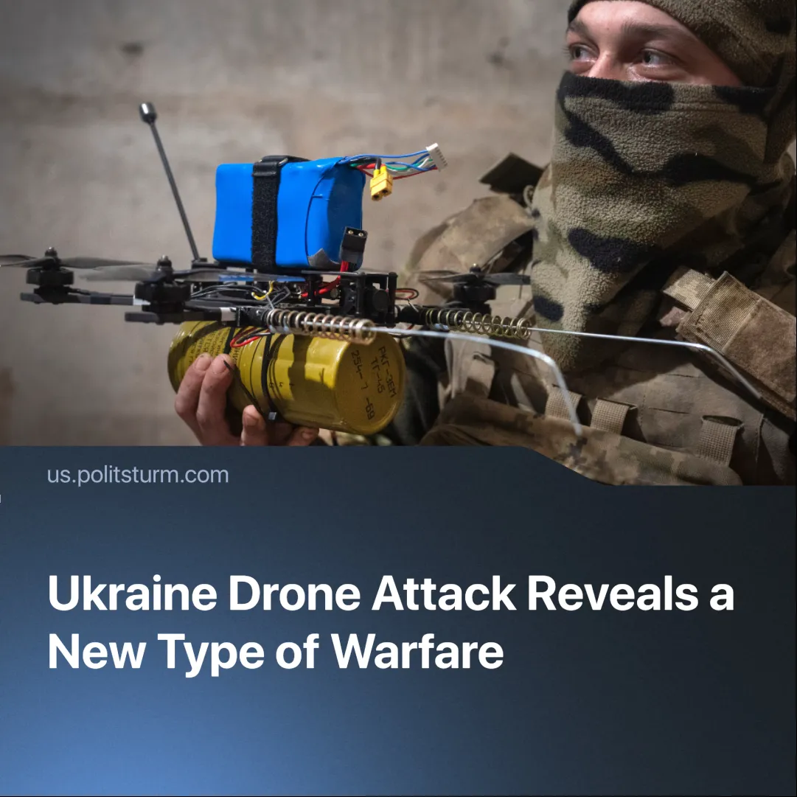

Original article
2025-06-07
2 min read

Ukraine’s largest coordinated drone strike has marked a turning point in warfare, drawing the attention of imperialist powers now racing to develop similar technologies.
Details. On June 1, the Security Service of Ukraine (SBU) orchestrated "Operation Spider's Web," deploying 117 FPV drones launched from trucks concealed within Russian regions. Targets included airbases in Murmansk, Ryazan, Irkutsk, Ivanovo, and Amur oblasts.
►For the first time, Ukrainian drones reached targets as far as Siberia, striking military facilities thousands of kilometres from the front lines.
► FPV drones sparked fires at the Murmansk and Irkutsk strategic aviation bases and damaged strategic bombers and hangars; Russia’s defence ministry says the fires were quickly contained and no casualties occurred.
► Ukraine reports striking 41 bombers and destroying 13, while BBC analysis of satellite imagery independently confirms 12 of those losses.
► The Russian Defence Ministry officially classified the strikes as acts of terrorism, emphasising the political significance of the scale and scope of the operation.
Context. Ukraine claims to produce 200,000 FPV drones per month, while Russia says it manufactures 4,000 per day. The widespread use of small, low-cost drones has become a defining feature of the war.
►The FPV drones are reported to have cost between $500-700, whilst the destroyed bombers would have cost tens of millions.
►The attacks coincided with direct Russia-Ukraine peace talks scheduled for the following day in Istanbul.
Important to know. Despite Russia’s multi-million-strong army and its vast security apparatus—including the police, FSB, and counter-intelligence services—Ukraine managed to strike targets thousands of kilometres behind the front lines at a fraction of the cost. The episode illustrates the emergence of a new type of asymmetric warfare, driven by inexpensive yet cutting-edge technology.
►Much like Baghdad’s “war of the cities” during the Iran-Iraq War, which aimed to break civilian morale when a large-scale ground offensive was impossible, deep-rear strikes now force Moscow to defend its own territory and erode public confidence. The timing also suggests an effort to pressure Russia ahead of the scheduled peace talks.
►All imperialist powers have been watching this conflict and learning. The United States has given defence contracts to companies like Anduril and Palantir to advance drone and smart ammunition technologies, further showing this shift in warfare.

Original article

