Ukraine, China and Militarization of Europe: NATO Summit Retrospective
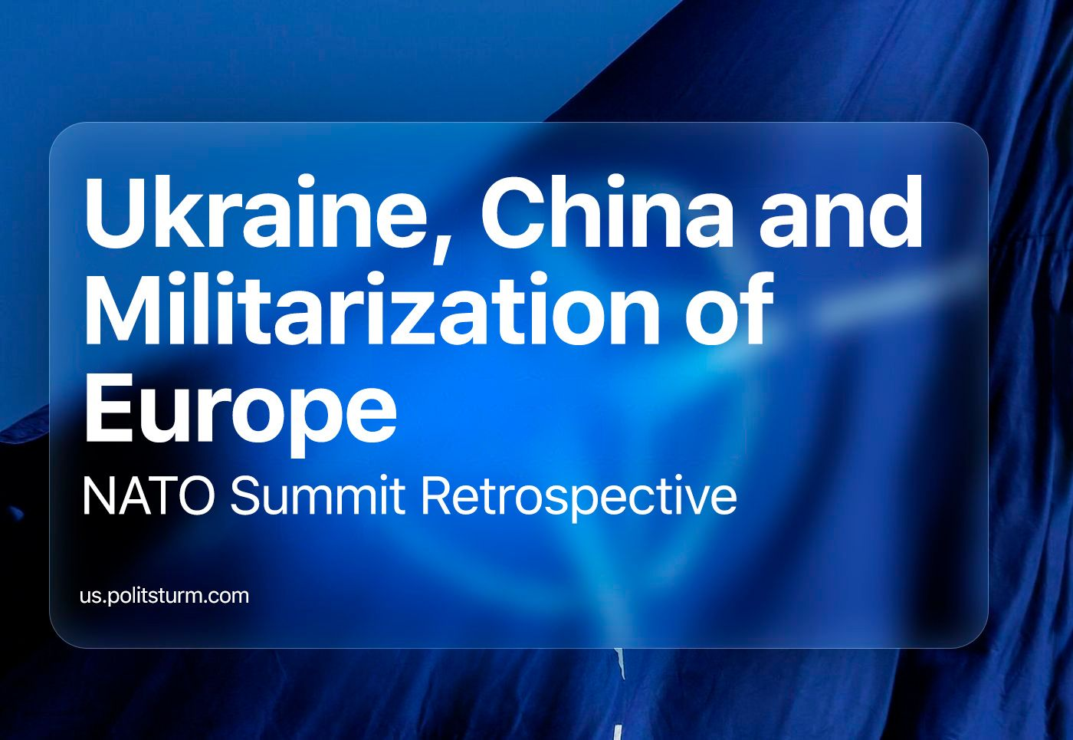

Original article
2023-10-04
21 min read

Another annual NATO summit was held in the Lithuanian capital Vilnius several months ago, on July 11-12. On the agenda of the alliance member states were the issues of Ukraine's membership in NATO, further militarisation of the bloc, the build-up of the so-called Rapid Reaction Force and the position on Russia and China.
The summit of the largest and most powerful imperialist alliance is an important event that plays a key role in the context of further aggravation of the international situation and relations between the major imperialist powers. What decisions were taken and how should communists evaluate them?

I. Ukraine's membership in NATO
The topic of Ukraine and the prospects of its membership in the alliance became the main topic of the two-day summit; the whole second day of the summit was devoted to it separately.
There were no unexpected decisions here and the alliance's decision was known even before the start of the summit: NATO Secretary General Jens Stoltenberg and German Chancellor Olaf Scholz openly stated that there would be no invitation of Ukraine to the alliance. Separately, the German chancellor said that even after the end of the conflict, Ukraine should not expect to be quickly admitted to the alliance because "there are clear criteria for accession".
In order to soften the negative background for supporters of the continuation of the conflict with Russia both in Ukraine and in Europe, a caveat was immediately made: the USA, the UK and EU countries will develop some "bilateral security guarantees" for Ukraine before Ukraine is admitted to the alliance. US President Joe Biden separately informed about the US plans to offer Ukraine defence according to the "Israeli scenario".
In this sense, we can talk about a certain "stability" in the alliance's position on the issue of Ukraine's membership in NATO. Back at the North Atlantic Alliance summit in 2008, a declaration was adopted proclaiming the readiness to admit Ukraine (together with Georgia) to NATO. However, in the indefinite future, without providing a concrete plan, conditions and terms. Neither the beginning of Russia's "special military operation" against Ukraine, nor Ukraine's application to join the alliance on an accelerated basis on September 30, 2022 changed the situation.
The Ukrainian government, for its part, has proclaimed it wants to see a "decisive step" away from vague formulations about their NATO membership and has abandoned the "membership action plan" (MAP), a formal programme for admitting new countries to the North Atlantic unit. In its demands, Zielenski's government pointed to the experience of the rapid admission of Finland and Sweden to the alliance.
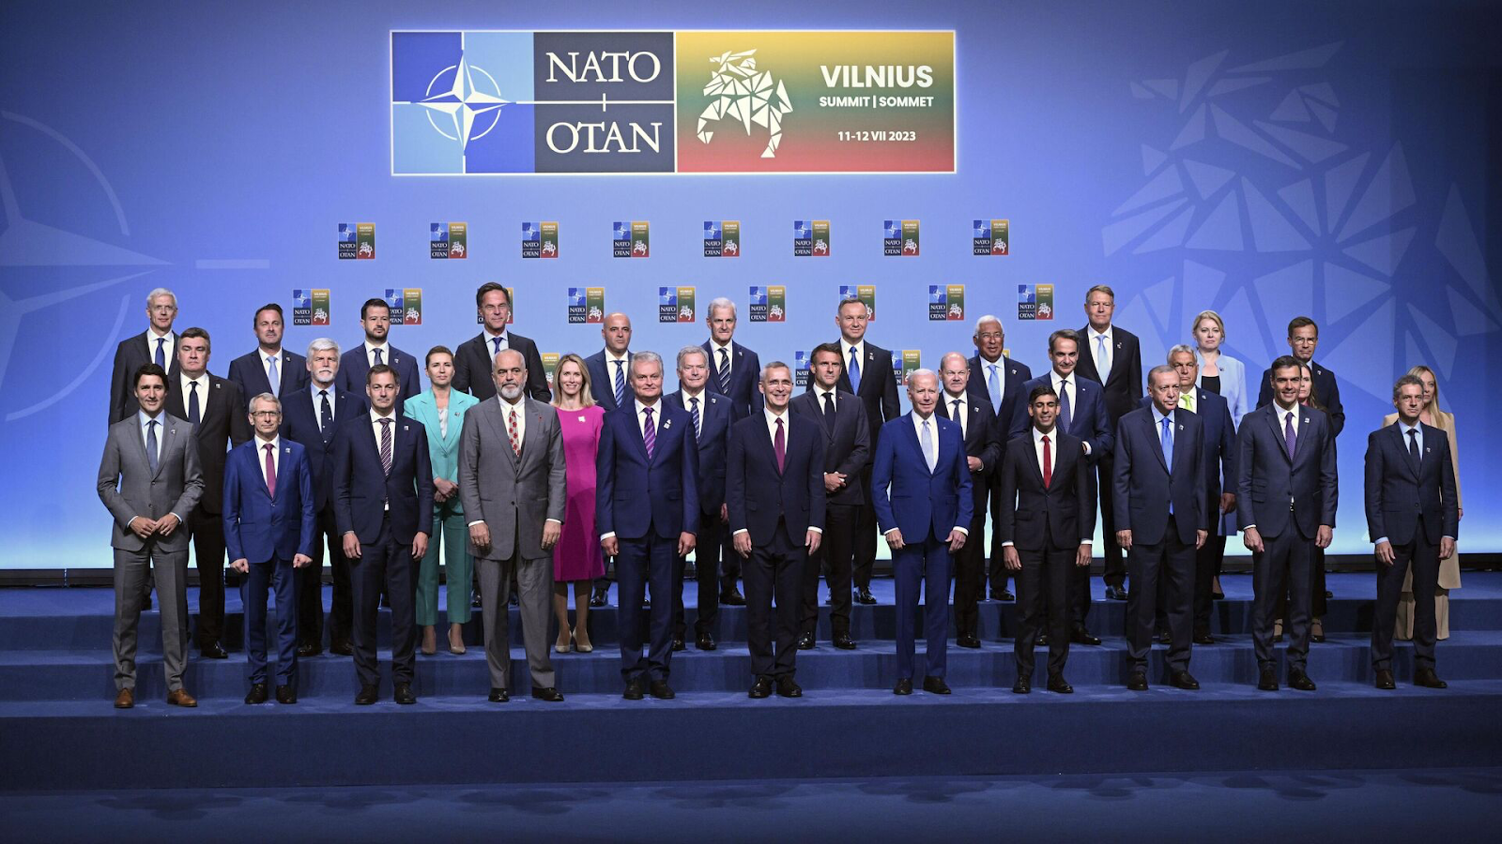
As has already been said, the summit did not make any fundamentally new decisions on Ukraine. The bourgeois leaders and the NATO Secretary General said a lot of words about Ukraine's future as a member of NATO. But at the same time: they did not extend an invitation to join the alliance, nor did they respond to Ukraine's last year's request, nor did they name any specific dates.
Instead, NATO leaders limited themselves to vague language of "supporting Ukraine's aspirations" and proclaiming "to extend an invitation to Ukraine to join the alliance when allies agree and conditions are met", announcing a long-term military assistance programme to modernize the army and transition to NATO standards, as well as the creation of a new body - the Ukraine-NATO Council. The work of this very "council" took place on the second day of the summit.
It was not mentioned in Vilnius what conditions Ukraine should fulfill in order to join NATO. Moreover, the alliance has been demanding certain conditions from Ukraine for 10 years, but it has never clearly formulated them. The Ukrainian bourgeoisie itself periodically draws attention to this.
The summit decisions were recorded in the general declaration adopted by the alliance after the first day of the summit.
Probably feeling a certain irritation with this position of the unit among the ruling circles and pro-governmental layers of Ukraine, Zelensky repeated NATO's statements that Ukraine would receive an invitation as soon as "the security situation permits". The very purpose of the meetings with Western leaders, he said, is in fact to obtain some "certain security guarantees" for Ukraine from the alliance.
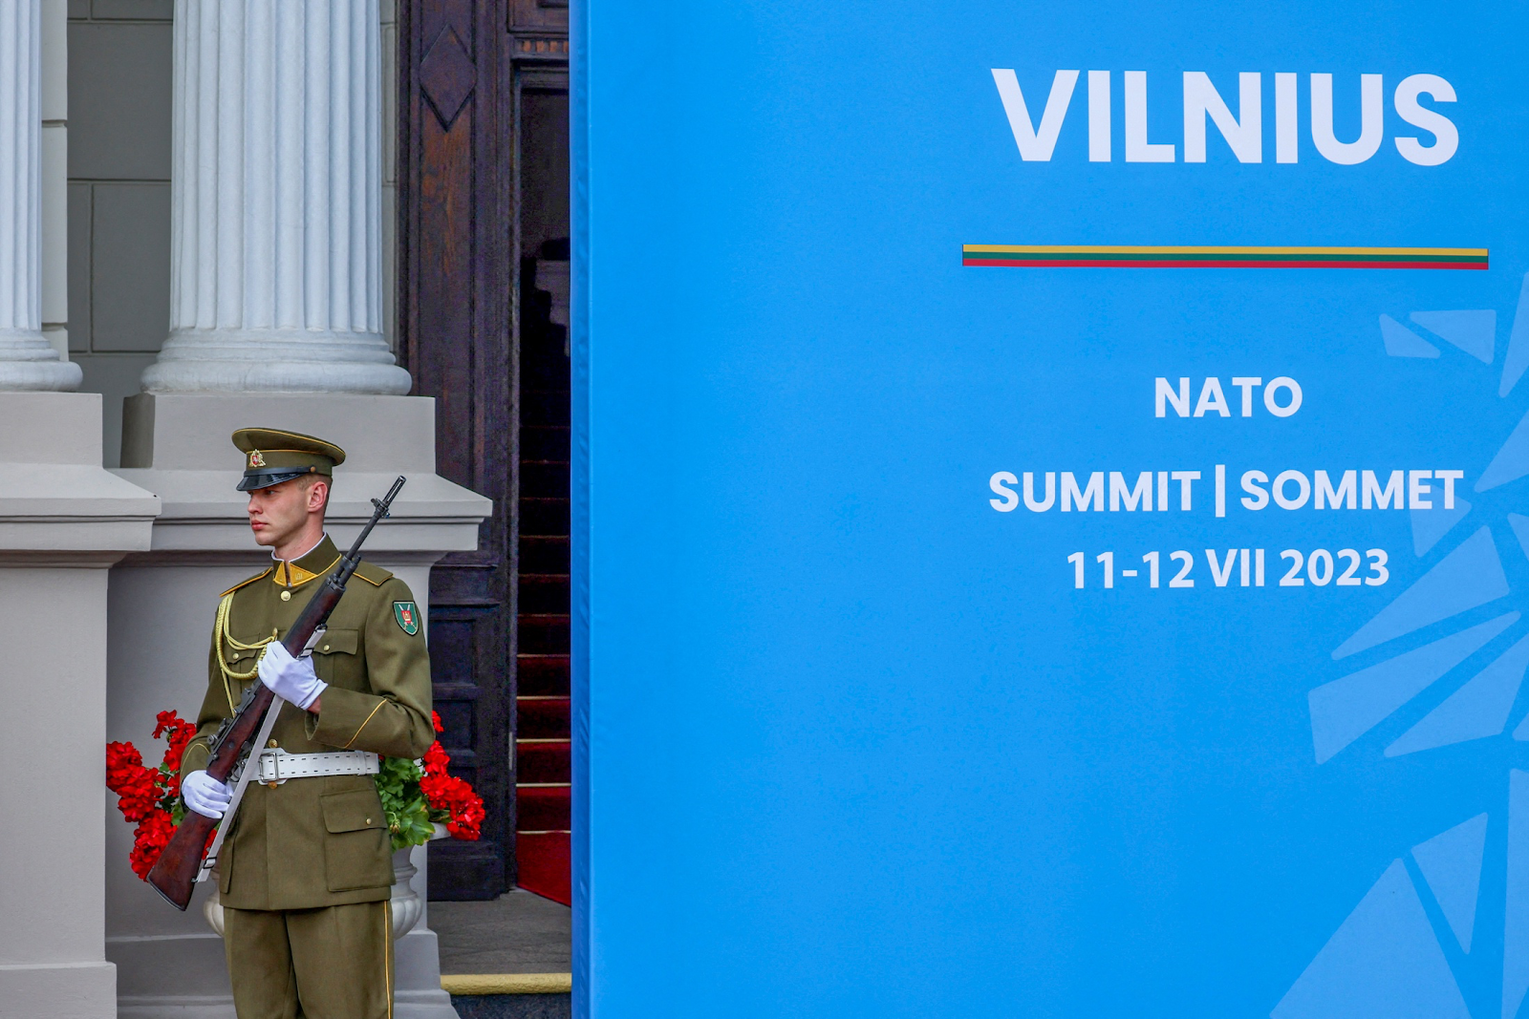
In general, we can say that the Ukrainian authorities have clearly failed to achieve the desired NATO accession, which would have made their situation much easier. As expected, this failure of Ukraine was immediately exploited by Russian chauvinists and propaganda.
Is it worth asking the question: Why does NATO refuse to accept Ukraine as a member of the alliance? After all, NATO has been actively supporting the Ukrainian government and army for a year with multi-billion dollar supplies of military equipment and financial injections. The AFU soldiers are fighting with the help of NATO equipment. In fact, the North Atlantic Alliance is an indirect but extremely active participant in the conflict.

Why not formalise legally the relationship between Ukraine and the "West"?
1. Fear of World War III. Britain's 'The Daily Telegraph' attributes Germany's position to the fear that immediate admission of Ukraine into NATO could lead to war with Russia. The Western media are convincing their populations throughout 2022-2023 that NATO is trying to avoid this in every possible way. Do such explanations have a place?
We do not dismiss the thesis that modern capitalism has once again reached the point where inter-imperialist contradictions and competition between transnational corporations have become so acute that the world is once again approaching a new world war. All over the world we see military and political preparations for it.
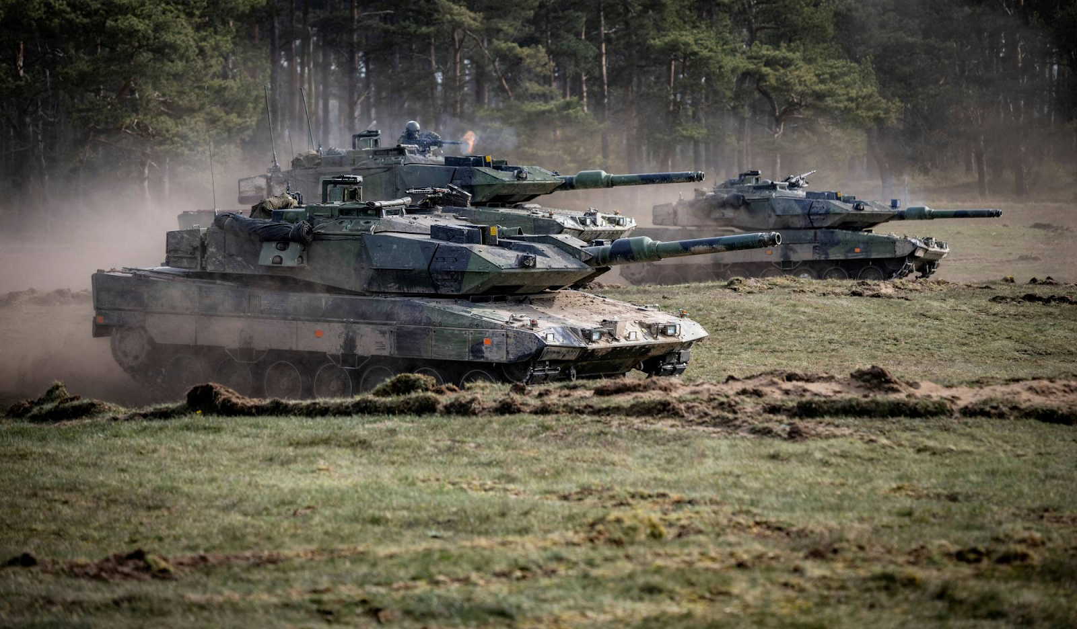
At the same time, a full-scale military conflict in Europe with direct NATO involvement would indeed significantly shake up the international situation and immediately draw China and other countries into its orbit. The prospects of such a rapid outbreak of a new world war seem to be unacceptable not only for Western imperialism, but also for Russia and China.
While maintaining generally tense relations with each other and extremely aggressive rhetoric, the imperialist powers do not go for radical aggravation of the situation and do not try to find a reason for a full-scale war. In this sense, indeed, it can be assumed that the distance that the NATO bloc keeps towards Ukraine is caused by its unwillingness to approach the moment of an open armed clash with Russia and China. The alliance does not consider itself ready for it.
2. Politics by other people's hands. Keeping Ukraine in non-aligned status allows NATO to provide active military support to the AFU without the risk of a clash with the Russian Federation.
Despite numerous statements by Russian officials and propagandists about considering NATO deliveries as "legitimate military objectives," in fact the Russian Armed Forces in no way hinder arms deliveries to Ukraine.
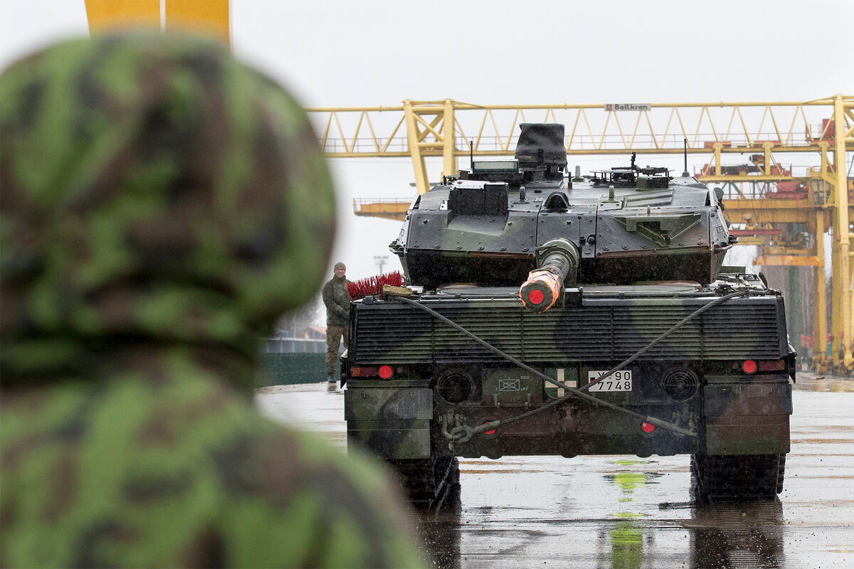
This is a very "convenient" situation for Western capital, which allows it to consolidate its economic subordination of Ukraine and militarily restrain the retaliatory offensive of Russian capital with foreign hands. Transnational energy corporations and financial oligarchs of Europe and America do not need to attract the manpower and population of their countries to defend their positions in the Ukrainian market.
There is no need for them to convert their economies to war, to significantly roll back the current bourgeois-democratic regime and to bear the associated risks of aggravation of class struggle (at least, more than they have now).
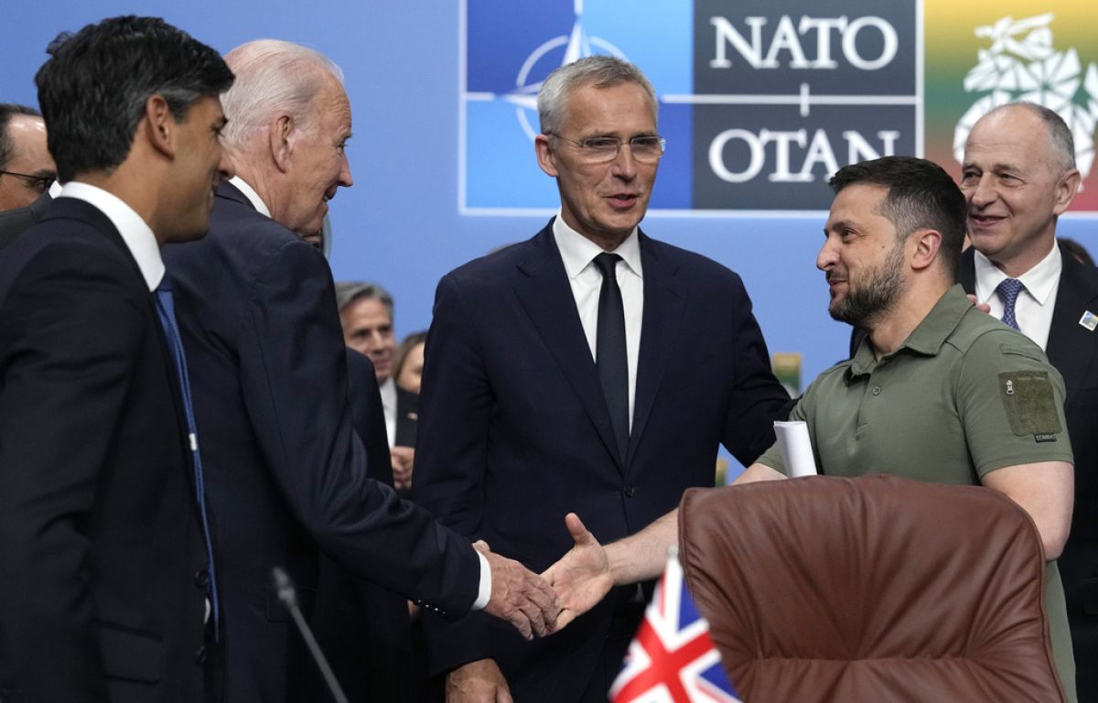
All that is required is to provide financial resources and armaments, while manpower, economy, and soldiers are kindly provided by the Ukrainian oligarchy, which has accepted this "honour" with great willingness: to pay for the interests of Western corporations with the blood of hundreds of thousands of Ukrainian workers. They also bear all the main "costs" of the conflict.
In this sense, the statements of Ukrainian officials and propagandists about a certain "special role" of the "defender of democracy and Western values" of modern capitalist Ukraine have become particularly wretched and hypocritical. Behind all this vile pathos lies a truly cannibalistic attitude towards its own population and a desire to show off to the Western bloc.
3. The field for behind-the-scenes negotiations and conflict regulation. By maintaining formal neutrality or, in any case, a state of peace with Russia, Western countries leave themselves room for "maneuvers": behind-the-scenes negotiations, opportunities to control the course of the conflict, further settlement after the end of hostilities, etc.
Just the other day it became known about contacts of the head of the FIS Sergey Naryshkin with the head of the CIA William Burns during the events of the rebellion of PMC "Wagner" on 24 June. Naryshkin named the head of the CIA as the initiator of the call, but said that it was just a reason for the call, while its main content was devoted to a discussion of "what to do with Ukraine". Although Naryshkin's American "colleague" denies discussing Ukraine, the existence of direct dialogue is a fact.
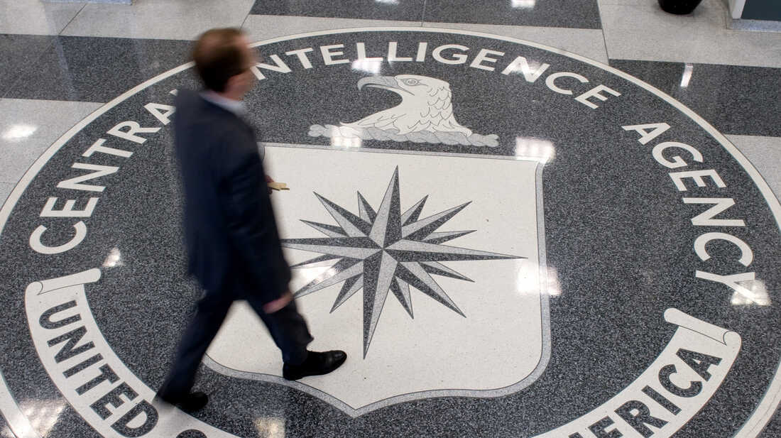
And all this comes to the surface against the background of reports about certain talks held by former high-ranking US officials with Russian Foreign Minister Sergey Lavrov. As befits bourgeois politicians, having been found guilty of conducting secret diplomacy, they hastened to absolve themselves of responsibility, calling the talks unofficial, conducted without the authorisation of the US presidential administration.
NATO's formal non-participation in the conflict makes it much easier to conduct all public and covert, secret negotiations with the Russian leadership. The absence of a state of war with Russia also exempts from all formal procedures for a peaceful resolution of the conflict (whatever it may be), which makes the process easier for Western countries.

II. Growth of militarisation
The topic of Ukraine at the Vilnius summit "captured" the entire information space of Western, Ukrainian and Russian media. One could get the impression that this issue was the only one discussed at the alliance meeting. However, the "Ukrainian issue" very conveniently masked a number of other, no less important issues. First of all, the further active militarisation of Europe.
The main indicator of the growing militarisation of NATO countries is the share of budget expenditures that each member country allocates to military expenditures. Simply put: military budget figures.
The 2006 NATO summit in Riga established the so-called 2% benchmark (Defence Investment Pledge) for military spending. It means that all member states of the alliance are obliged to strive for military spending to be at least 2 per cent of the country's GDP. The 2014 Wales Summit enshrined this benchmark. Countries whose military expenditures were below this benchmark had to stop cutting military spending and strive to reach the coveted 2% of GDP target by 2024.
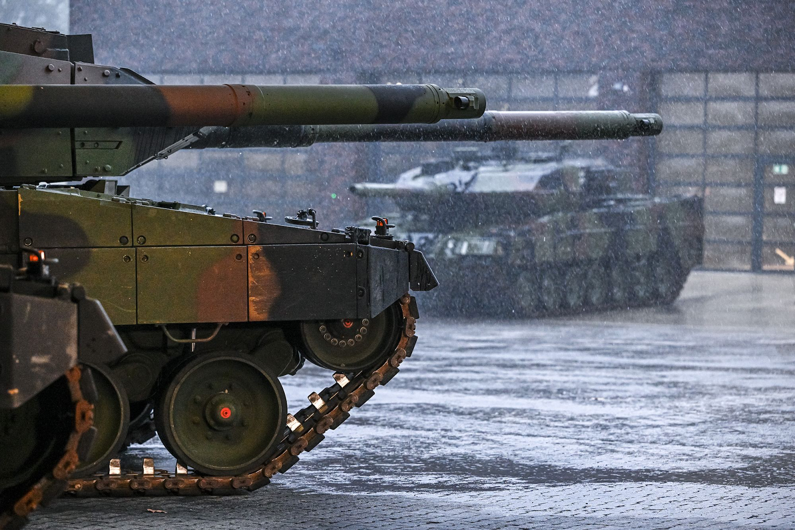
After the benchmark was adopted, most alliance members still failed to reach 2%. In 2014, with the exception of the United States, only two countries spent on military expenditures in line with the minimum, slightly exceeding it: Greece and the United Kingdom. Over the following decade, the growth of military expenditures of the North Atlantic Alliance member states was extremely slow. This discrepancy between the alliance's demand to increase military funding and the inability and/or unwillingness of the bloc's members to do so repeatedly led to heated disputes and strained relations within the alliance.
After becoming the American president, Donald Trump has constantly berated allies for spending too little on military budgets. In 2019, at the London summit, he declared that spending should be 4 per cent. American allies reciprocated: "NATO-scepticism" was widespread among European politicians throughout the second half of the 2010s.
That all changed with the outbreak of a full-scale conflict between Russia and Ukraine in 2022. "NATO-scepticism" was washed away by a wave of Russophobia, chauvinism and militarism and a further rise in right-wing sentiment. A wave of increased military spending and militaristic rhetoric began everywhere in Europe.
The NATO Madrid Summit reaffirmed commitment to the decisions in Wales and announced a plan to decide on further commitments this year. Chancellor Olaf Scholz, following the Social Democratic tradition of betraying workers' interests, has promised to increase spending in Germany's military budget, calling the government's goal to build a "combat-ready, highly modernised Bundeswehr".
The alliance is constantly collecting data on allied defence spending. The latest up-to-date report, presented in early July, clearly shows a huge increase in military spending. According to the report, the two per cent benchmark, excluding the US, was reached and exceeded by 8 countries in 2022-2023: Poland, Estonia, Lithuania, Latvia, Finland, Romania, Hungary and Slovakia.
The largest increase in military expenditures is observed in Poland: by 1.90 p.p., followed by Lithuania (1.54), Latvia (1.27), Slovakia (1.03) and Finland (0.9). But the growth of military expenditures of other members of the alliance, although they did not reach the level of 2% is not less: the highest growth among this category is observed in North Macedonia (0.87) and Bulgaria (0.59).
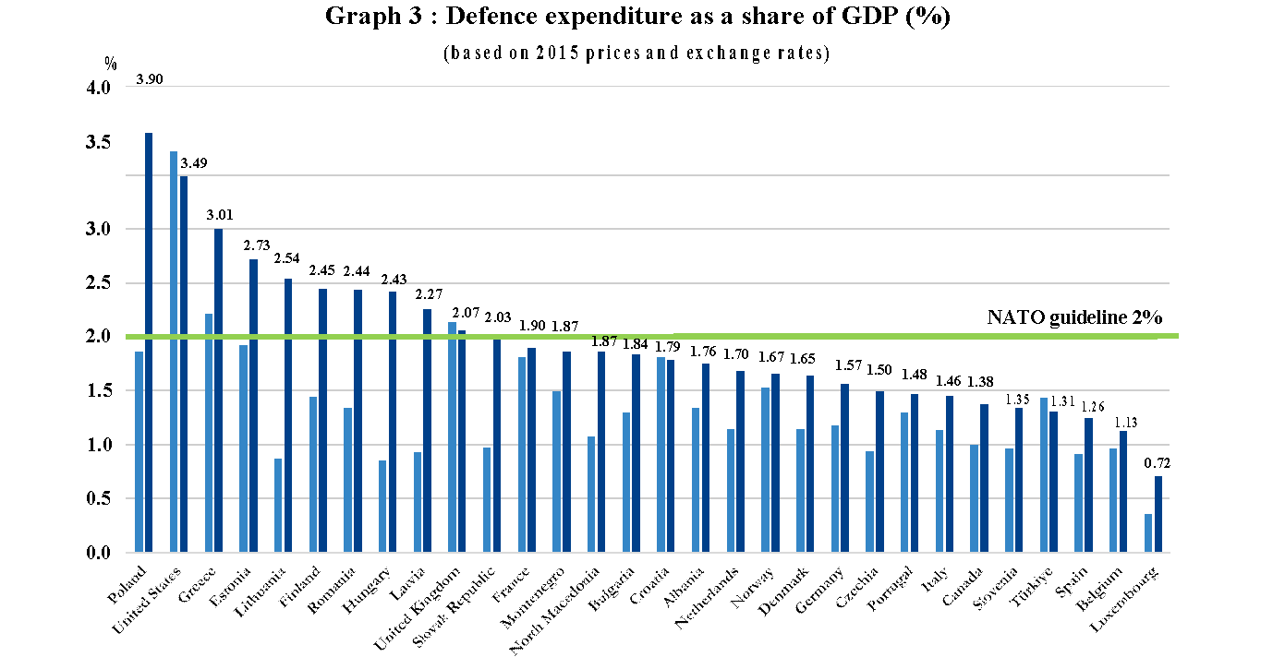
The increase in the share of spending on armaments in the total amount of military expenditures was no less.
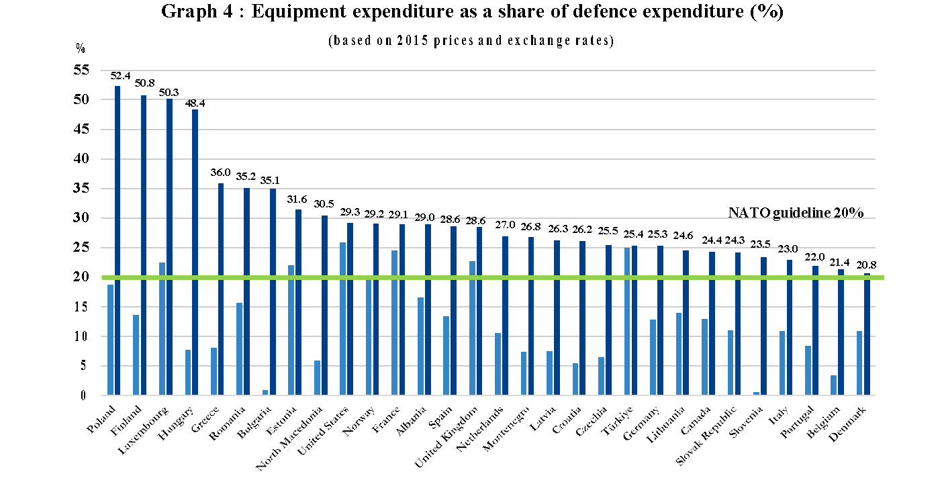
While in current prices the alliance's total military spending in 2022 was $1,172,791 million, in 2023 the figure is estimated at $1,264,115 million. Over the year, the growth in spending totalled more than $90 billion. By comparison, the growth in NATO's military budget in 2022 compared to 2021 was only around 20 billion.
The present summit did not take any new decisions on this issue. In the final declaration, the alliance members reaffirmed their commitment to invest at least 2 per cent of GDP annually in the military sphere, with the caveat that further increases in military investment: "more spending will be required."
A separate paragraph of the declaration was specifically devoted to the development of NATO's military industry. This point, although it was included in the text of the declaration, remained completely without wide coverage both at the summit itself and in media publications. As already mentioned, the "Ukrainian agenda" "absorbed" the entire information flow related to the summit. At the same time, the few reports on decisions in the area of the military-industrial complex deserve attention.
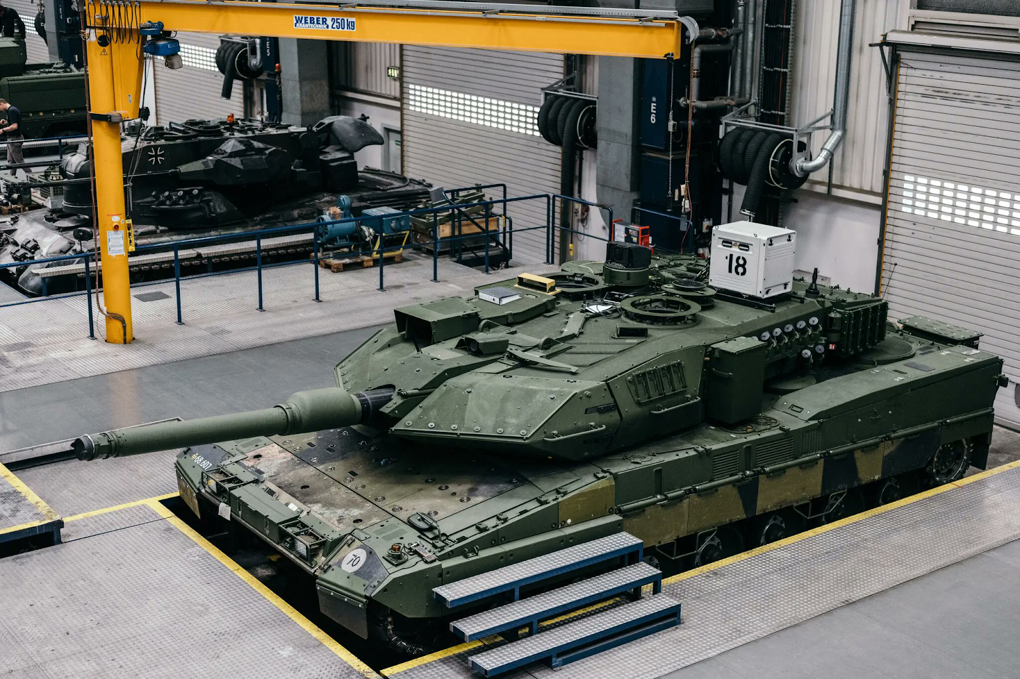
Paragraphs in the declaration state the alliance's intention to develop a stronger military industry in Europe through "close co-operation" in Europe and the Atlantic. In addition, and this was glimpsed by Stoltenberg, some sort of "Defence Production Action Plan" was agreed upon. In the words of the "Secretary General," the plan aims to "accelerate joint procurement, increase production capacity and improve interoperability among NATO members."
Military buildup in Europe, according to the declaration, should take place under NATO's overall leadership "as a convener, standard-setter, requirements setter and aggregator, as well as an enabler to promote sustainable defence industrial capabilities".
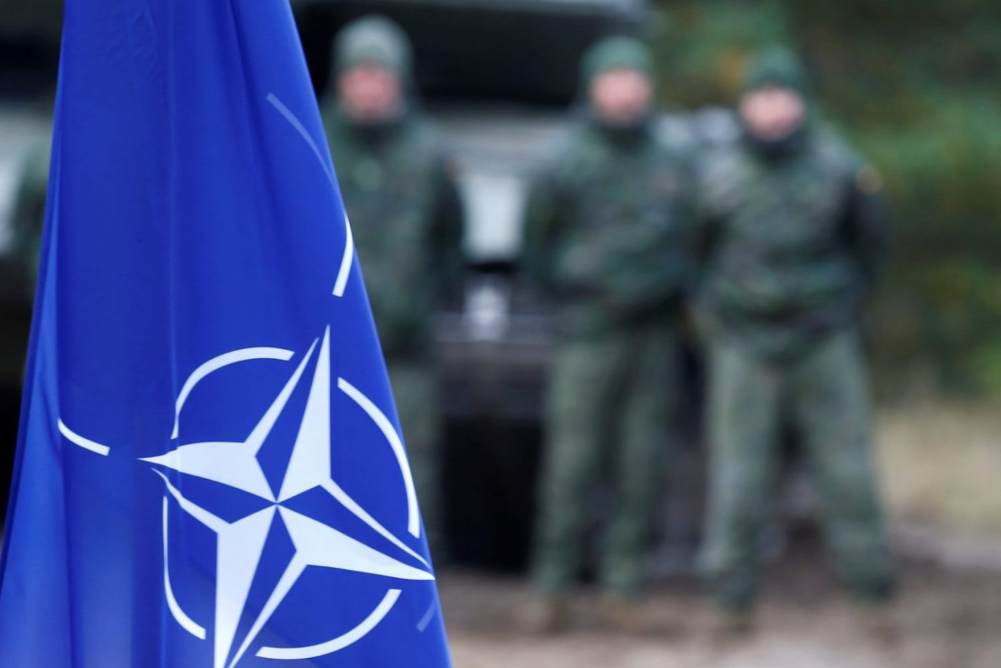
Another of the alliance's objectives in this area is to further improve the alliance's deployment, standardisation, operational response, force integration and force support capabilities to support "high-intensity operations, including crisis response operations, in complex environments".
Western media have been slow to lift the veil of secrecy over the plan, nor has the NATO press office been in a hurry to reveal details. Obviously, the plan contains secret strategic information that the bloc cannot disclose. But what lies behind these extremely general formulations and euphemisms about "interoperability," "a robust and resilient defence industry" and the like?
The answer is: NATO is embarking on the active construction of a military-industrial complex. Based on the wording, Europe will be the center of growth of the military industry. It is likely that investments in the construction of military plants and infrastructure will flow to European countries. The United States, together with the major players in Europe, Germany, France and the United Kingdom, is setting a course for a new militarisation of Europe - for the first time since the end of World War II.
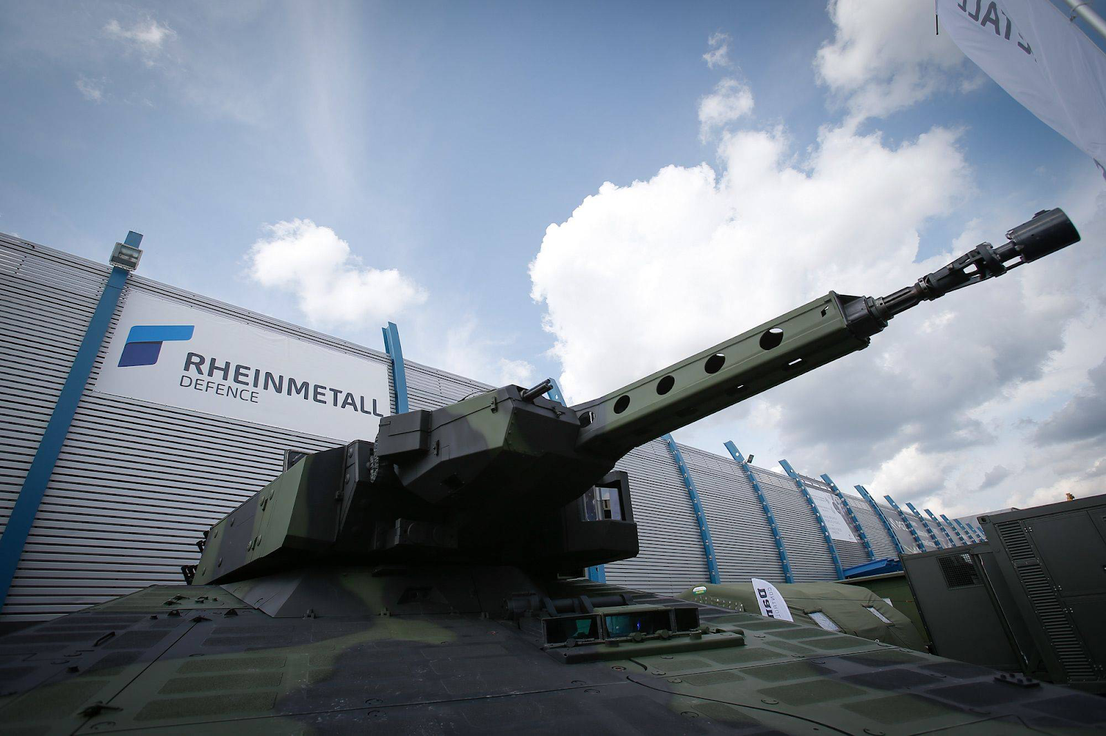
Some clarifications in the final document of the alliance, according to which interoperability and standardisation will be developed "with an initial emphasis on ground munitions" and taking into account the creation of the so-called "Rapid Reaction Force", leave no doubt: Western imperialism is preparing for the creation and development of a large land force in Europe.
What specific tasks will be performed by the alliance forces - the further development of the political and international situation will show.

III. Building up the "Rapid Reaction Force"
The last item to be discussed at the Vilnius summit was the further build-up of the so-called "Rapid Reaction Force".
Back at the Madrid summit, decisions were taken to improve NATO's military plans, including the expansion of the "Rapid Reaction Force". The alliance's press service accompanied the report on the decisions of last year's summit with an infographic. According to it and other media reports, the so-called "Rapid Reaction Force" consists of 300,000 people in constant combat readiness. The deployment of the force is to take place gradually, over a six-month period. It was also reported that the transition to this model was planned to be completed in 2023.
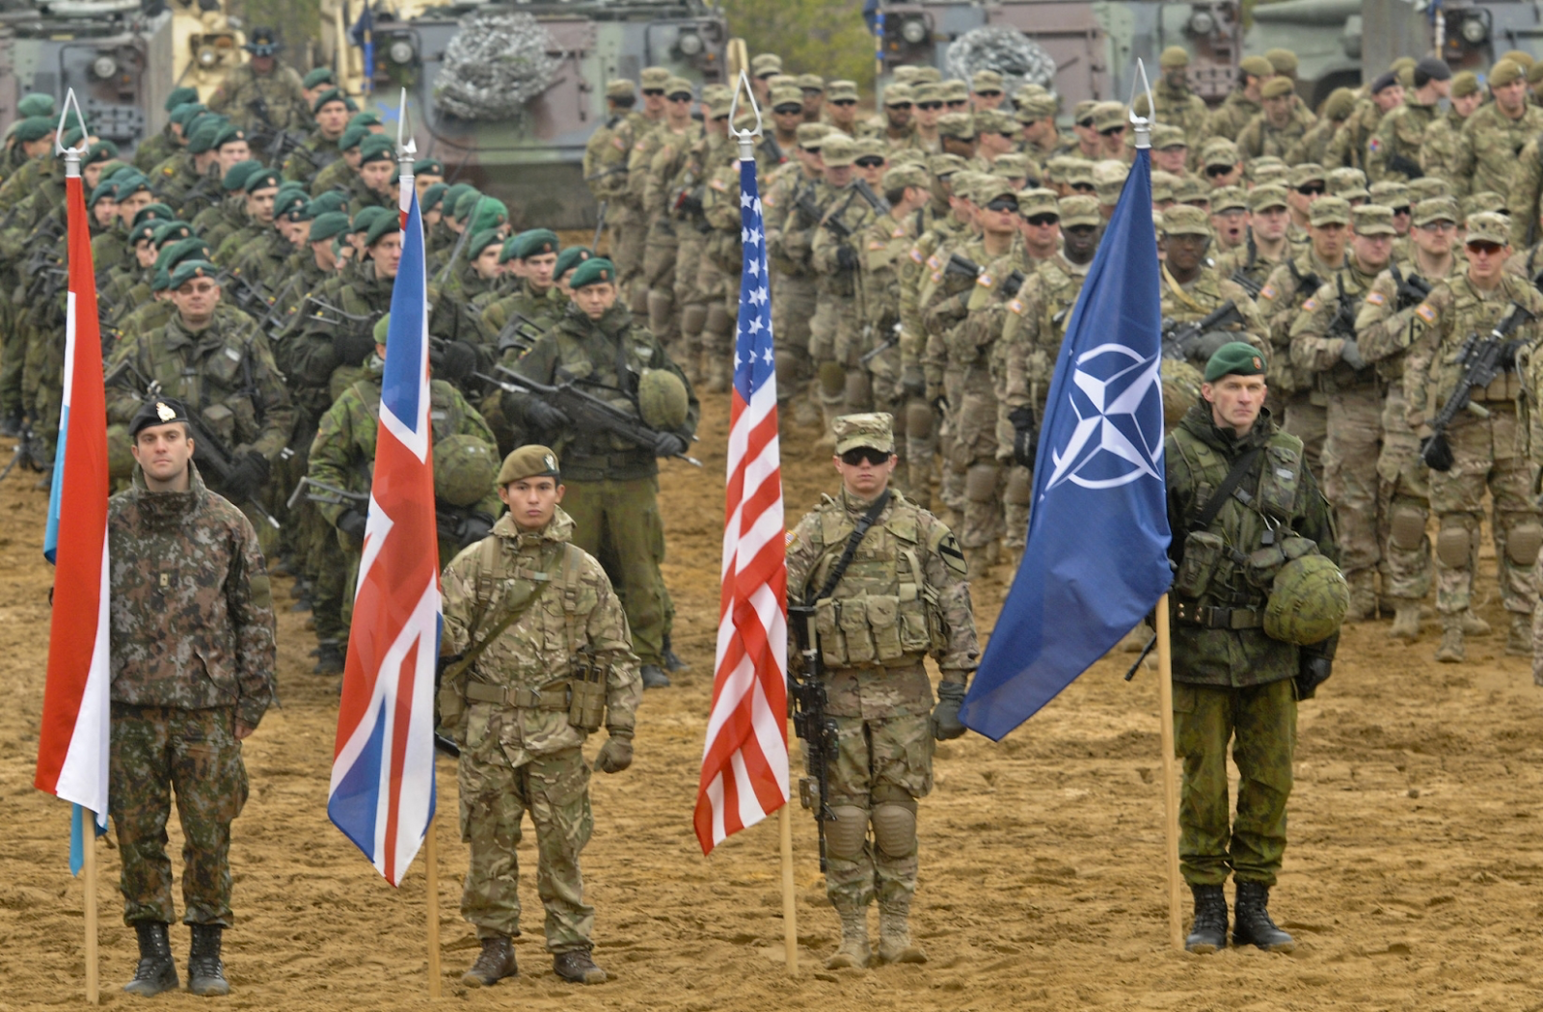
According to media reports, the summit was supposed to approve specific ways to rapidly increase troop presence on land and defence against attacks in the sea, air, "cyberspace" and space.
It is not known what exact decisions were taken on this issue. It is likely that the alliance has developed and agreed on common documents and practical ways of implementing the deployment model. In any case, it is certain that NATO plans to significantly develop the armed forces of the bloc's members in Europe, building up military power in the region.

IV. Russia and China
NATO first called China a threat in 2019. At the same time, the so-called "trade war" between the PRC and the US was taking place: mutual raising of duties on each other's exported goods. Since then, the tension and atmosphere of hostility between the US (hence NATO) and China has only grown.
This year's Vilnius summit did not mark any "détente" but only confirmed the willingness of Western capital to confront Chinese capital.
The final declaration accuses China that its stated ambitions and policies "challenge" NATO's interests, security and values. "The PRC," the text says, "uses a wide range of political, economic and military tools to increase its global presence and projected power, while remaining opaque about its strategy, intentions and military buildup. And in addition, China seeks to control key technological and industrial sectors, critical infrastructure, strategic materials and supply chains.
"It uses its economic leverage to create strategic dependence and increase its influence. It seeks to undermine the rules-based international order, including in space, cyberspace and at sea".
The North Atlantic Alliance is shifting the blame for future clashes to China in advance: "China's malicious hybrid and cyber operations, as well as its confrontational rhetoric and disinformation, target allies and damage the security of the North Atlantic Alliance." Finally, it is China that poses "systemic challenges" to "Euro-Atlantic security."
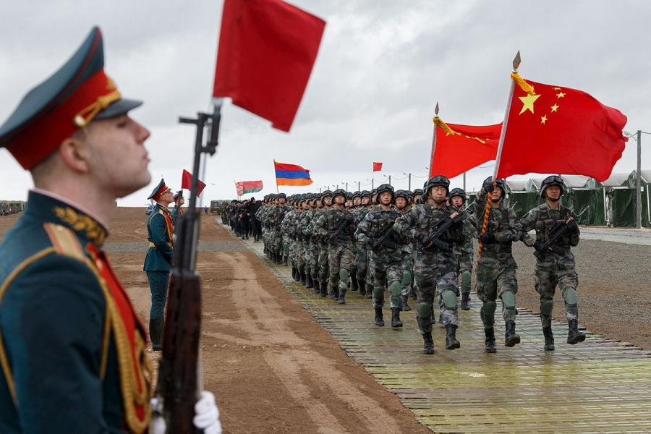
Russia was not ignored. The declaration notes the deepening strategic partnership between China and Russia and their mutual attempts to undermine the international order. The Alliance once again condemned Russia, calling it the most "serious and direct" threat to NATO's security: it is held responsible for the destruction of peace in the Euro-Atlantic area.
Despite courteous reservations about the alliance's openness to "constructive engagement with China," the overall message of NATO statements is clear and boils down to a resolute continuation of the gradual escalation of relations with China.
Of course, this is not a unilateral process at all. China did not stay "in debt" and through its Foreign Ministry spokesman accused NATO of bombing Yugoslavia, hitting the Chinese embassy in Belgrade and fuelling a new Cold War. China's rhetoric here is no different from the statements made at the NATO summit in Vilnius: China also opposes the alliance's expansion into Asia and declares its readiness to defend its "interests and sovereignty".
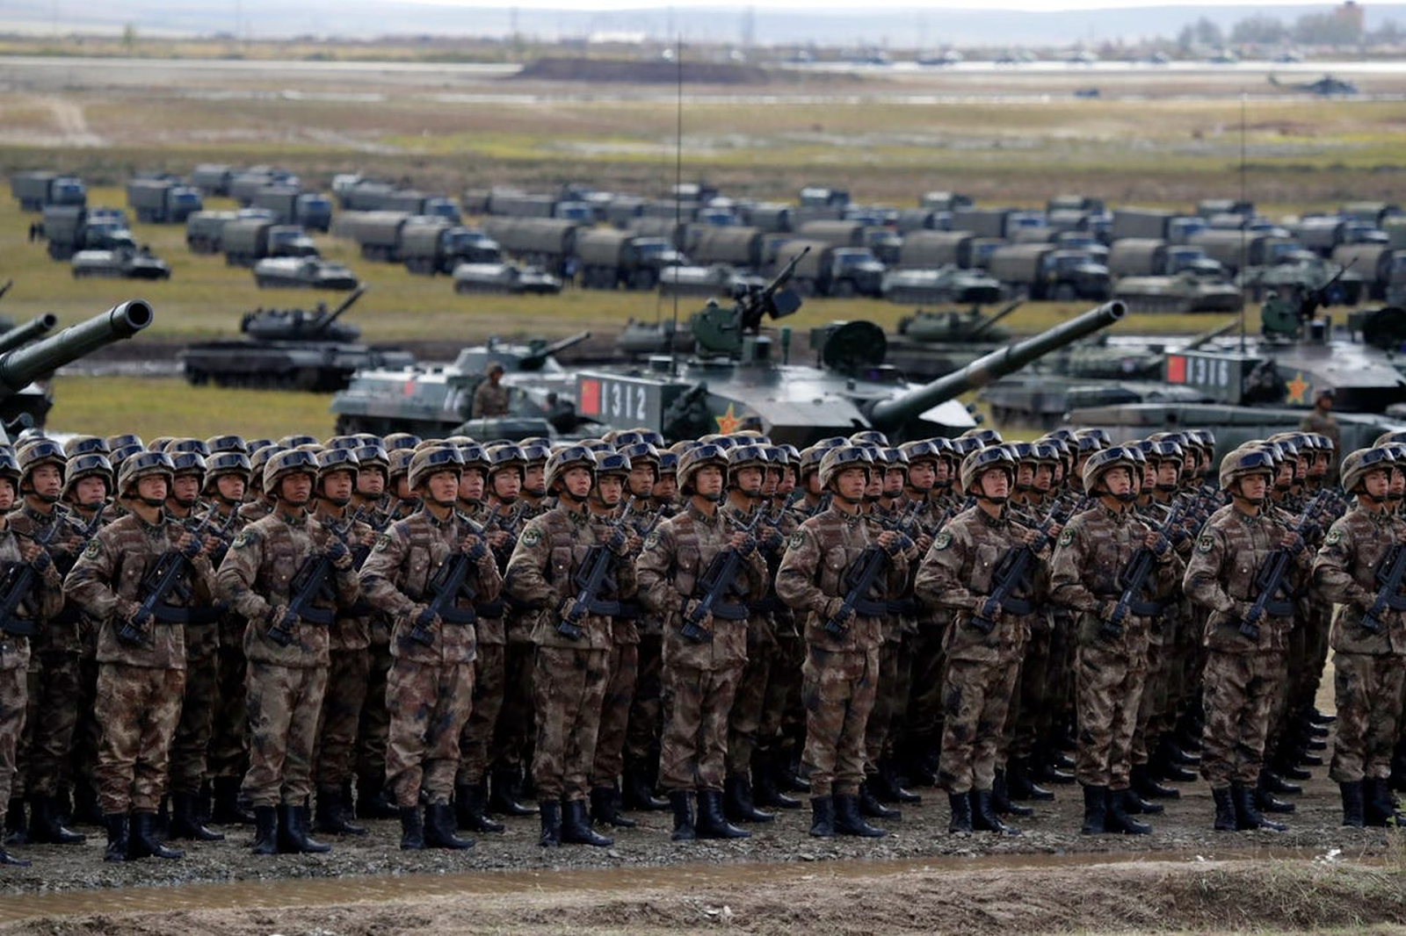
"We openly tell NATO that China will firmly defend its sovereignty, security and development interests, we also firmly oppose NATO's eastward expansion into the Asia-Pacific region. Any action prejudicial to China's legitimate rights and interests will be firmly opposed."
NATO's claims that China is creating "strategic dependence and increasing its influence," as well as its accusations of creating "systemic security problems," "malicious operations," and threats to European and American interests and values, are no less hypocritical than China's responses and similar accusations.
In the end, regardless how hard both sides try to portray the mutual rise in tensions as merely the action of one side, the workers of the world should not be fooled by populist claims. Both sides – Western and Chinese imperialism – have been competing for the redistribution of the world market for many years. Both sides are creating and strengthening a belt of dependent and semi-dependent countries.
Finally, the economic interests of both the NATO bloc (primarily the major Western powers), China, and their allies push them to fight. In this sense, this year's North Atlantic Alliance summit showed nothing new. But at the same time it unequivocally confirmed: the world is entering a new period of clashes between imperialist blocs.
This, in turn, means only one thing: the communists and workers of all countries must as soon as possible rebuild a genuinely communist international movement and be ready to join the struggle against imperialist aggression and for the victory of socialism throughout the world.

Original article

