Ukraine and Sweden Signed an Agreement on the Exchange of Classified Information
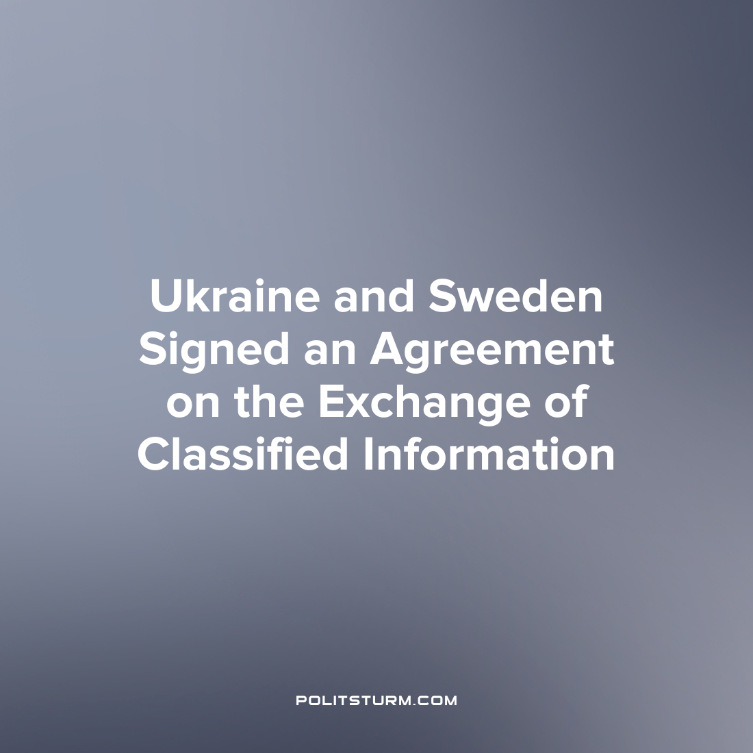

Original article
2023-08-01
2 min read

At the NATO summit in Vilnius, an agreement was signed between Sweden and Ukraine on the exchange of classified information and protecting it from leaks.
In light of recent statements by Turkey and Hungary about their intention to support Sweden's accession to NATO, there is a high probability that the agreements between Ukraine and Sweden will become common to the entire NATO bloc and become a step towards Ukraine's integration into the Alliance.
It is assumed that "secret information" may include state secrets about foreign affairs, as well as information about internal threats. Recall that in April 2023, the Swedish police received permission to conduct secret listening under the law on “preventive coercive measures”. In Ukraine, even before the start of Russia’s ‘Special Military Operation’, many cases of surveillance of opposition political and public figures were recorded. The new agreements will thus allow Sweden, Ukraine and other Western bloc states to join forces to eliminate uncomfortable opposition within these countries.
In addition to the agreement on the exchange of secret information, Sweden and Ukraine also signed an agreement on enhanced military cooperation. These agreements allow the Ukrainian military to conduct test flights on the Swedish Saab JAS 39 Gripen fighter for the first time. In addition, the agreements will greatly facilitate the procedure for the sale and supply of weapons to Ukraine. In particular, Kyiv will be able to order military materials directly from the Swedish Ministry of Defense and place orders for weapons from other sources with the support of Sweden.
Recall that Sweden has provided assistance to Ukraine in the amount of 21.5 billion crowns (about $2 billion US dollars) since February 2022. Of this amount, 16.9 billion crowns ($1.57 billion) was earmarked for military support.
The new agreements between Sweden and Ukraine are obviously beneficial to the ruling classes of both countries. They provide these governments with enhanced opportunities for cooperation in the diplomatic and military spheres, as well as for strengthening control over their populations. Thus, they help the capitalists to protect their economic and political interests from external and internal threats.
However, the working class of both countries will not benefit from such agreements. On the contrary, they will only increase the risk of being repressed for criticizing the ruling class or being drafted to fight in the bourgeois army for the profit of the capitalists. Such exploitation will exist as long as there is capitalism - an economic system that, by its very nature, breeds wars. A lasting and democratic peace can only be established by leaving the capitalist system and establishing socialism.
Sources: Expressen – «Nya avtal med Ukraina – ska dela hemlig info» from July 15th, 2023
Lenta – «Ukraine and Sweden agreed to exchange secret information» from July 12th, 2023
Belarus Today – «Sweden and Ukraine signed two agreements on military cooperation» from July 12th, 2023.

Original article

