Live Signing of U.S.-Ukraine Resource Agreement Falls Apart on Air
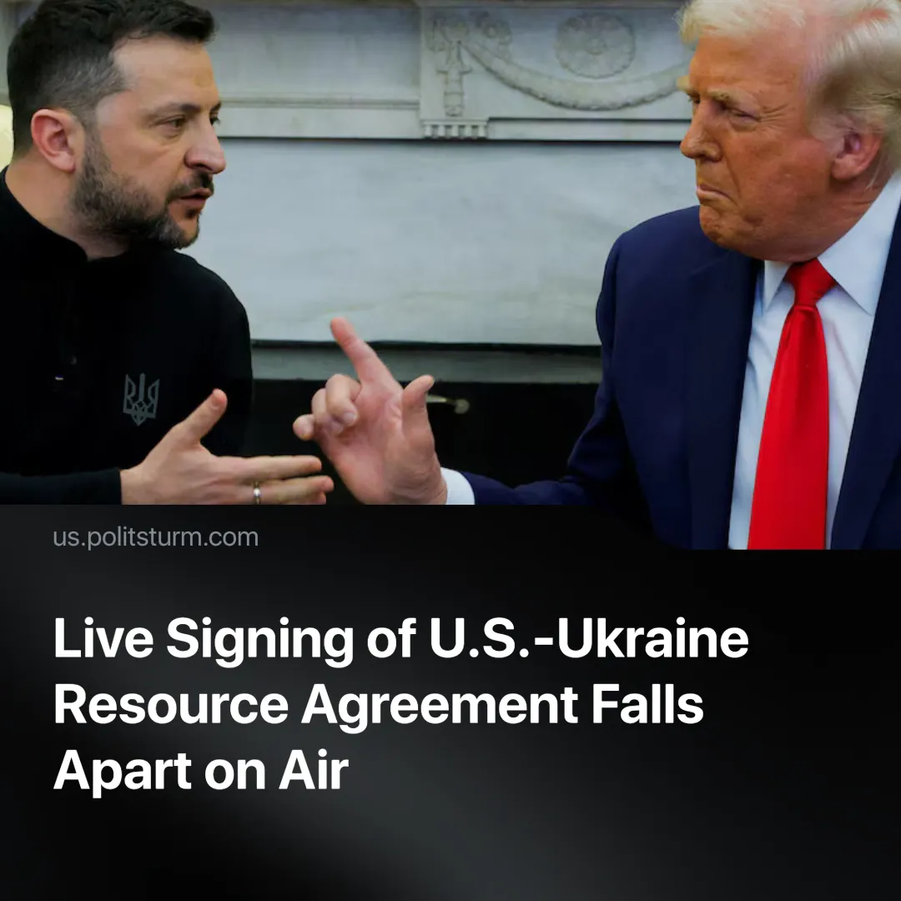

Original article
2025-03-01
3 min read

In a dramatic televised meeting, the planned resource agreement between the U.S. and Ukraine disintegrated before live cameras, exposing the increasingly volatile imperialist order.
Details. On the 28th of February, in an unprecedented moment, a televised 45-minute meeting between Zelenskyy and Trump devolved into a heated argument within the last 10 minutes.
► The initial purpose of the meeting was to sign an agreement giving the U.S. access to Ukraine's rare earth and critical minerals.
► During questions with journalists, Zelenskyy was critical of Trump's approach to Putin. When Trump and J.D. Vance started talking about ending the conflict and the need for negotiations, Ukrainian president then suggested it isn't possible to have a diplomatic approach with Russia: “asking what of diplomacy, JD, are you speaking about?”
► Vice President J.D. Vance defended Trump’s actions, accusing Zelenskyy of trying to litigate the issue in front of American media. He also claimed that Zelenskyy was conducting propaganda tours in Ukraine to downplay the conflict’s severity.
► This exchange quickly devolved into raised voices and Trump repeatedly cutting off Zelenskyy: "You can't tell us 'I want this, I want that'. You have no right to dictate to us... We are on the brink of World War III, but you do not respect the United States... You have no cards in your hand without us, you should be grateful to us, we gave you 350 billion dollars... I know that you are not winning... A ceasefire agreement is inevitable".
► The deal was ultimately not signed. Zelenskyy left the Whitehouse early and a planned news conference between the two leaders was cancelled.
Context. The proposed deal would have given the U.S. control over Ukrainian rare earth minerals, which are vital for advanced technologies including military applications, renewable energy, and electronics.
► Central to the deal was a Reconstruction Investment Fund designed to channel 50% of Ukraine's state-owned resource revenues into rebuilding and infrastructure projects. Although the U.S. pledged "support" for Ukraine's economic stability and peace, it did so without providing direct security guarantees. In effect, the scheme ultimately served as a means to plunder Ukraine's natural wealth.
► The U.S. has shifted toward a more overtly "America First" foreign policy in which the Trump administration believes it can renegotiate better deals with “allies” by playing hardball.
Important to Know. The resource deal has collapsed. This means that the Russian ‘special military operation’ in Ukraine will continue for now.
► The whole scene was a populist media show-off, given that both presidents were former actors. Trump wanted to show the firmness of his "America First" views and his willingness to tell White House guests "know their place". He even remarked, “This is going to be great television”.
► Zelensky, for his part, played the role of a "proud and strong leader" capable of defending his course in the face of the US President – an ally who is increasingly turning into a "former ally".
► It is possible that Trump purposely provoked Zelenskyy and caused the deals to break down to assert more pressure and receive a better deal. After the conference, Trump posted a message on social media: "President Zelenskyy is not ready for Peace... He can come back when he is ready for Peace."
► The scandal between Trump and Zelensky may serve as an additional argument in favor of the US President's statements about the need for elections in Ukraine. Trump has previously done so, labeling Zelenskyy a “dictator” and hinting at the necessity for elections. This was repeated in the interview when Trump suggested Zelenskyy ask the Ukrainian population how they feel about a ceasefire.
► As American support for Ukraine diminishes, the country may turn toward the increasingly militarising European Union. After the news of the conference's results, various EU leaders rushed to make statements in support of Ukraine. This shift could potentially pave the way for renewed rapprochement between Russia and the United States as both seek to realign global power dynamics.
Conclusion. The nature of capitalist “allies and enemies” is laid bare. For capitalist nations, only profit can drive decisions. This “breakdown” is not merely an isolated failure, but a vivid demonstration of how imperialist powers manipulate crises and spectacle to further their economic agendas. The genuine needs of workers — for peace and economic security — are never a consideration.

Original article

