UK Union Launches First Branch For Games Workers
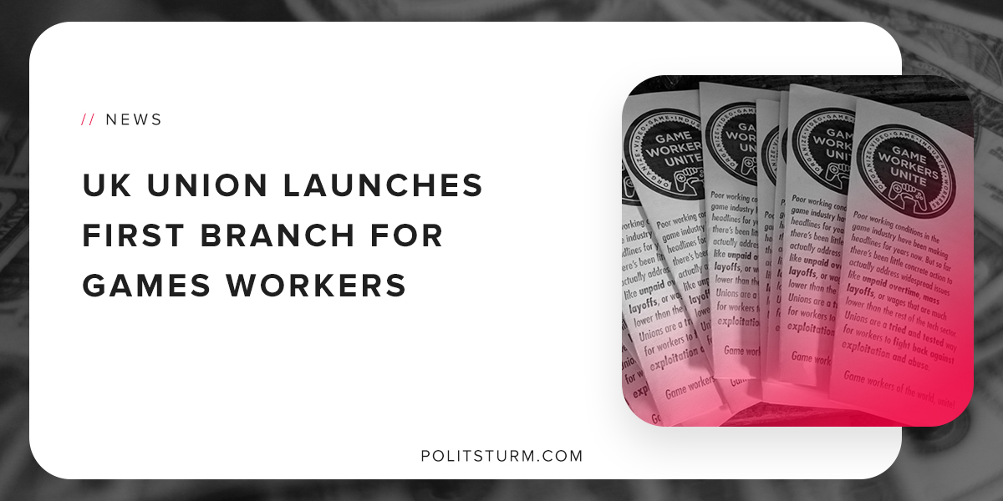

Original article
2018-12-19
1 min read

On December 16th, 2018 the Games Workers United branch will have its inaugural meeting. The branch is part of the Independent Workers Union of Great Britain (IWGB) and will represent workers in the UK video game industry.
The union is going to be open to all past, current, and future members of the video game industry and it excludes those who have the ability to hire and fire other workers.
The branch is one of the first in the world to represent video game workers and has several stated objectives.
The branch plans to address unpaid overtime, zero-hour contracts, and a lack of diversity in the industry.
Zero-hour contracts are a form of a labor contract in which the employer is not required to provide regular work for the employee, but it requires the employee to be on-call in the event that work becomes available.
IWGB General Secretary Dr Jason Moyer-Lee said: “The game workers’ decision to unionise with the IWGB should be a wake up call for the UK’s gaming industry. The IWGB is proud to support these workers and looks forward to shining a massive spotlight on the industry.”
The unionization of the games workers in the UK will help address the grievances brought forth by the members. However, the capitalist economic system by its very existence presupposes exploitative social relations of production and the entire system must be abolished to end the exploitation of workers.
Source

Original article

