1,500 Strong British Steelworkers Strike Called Off
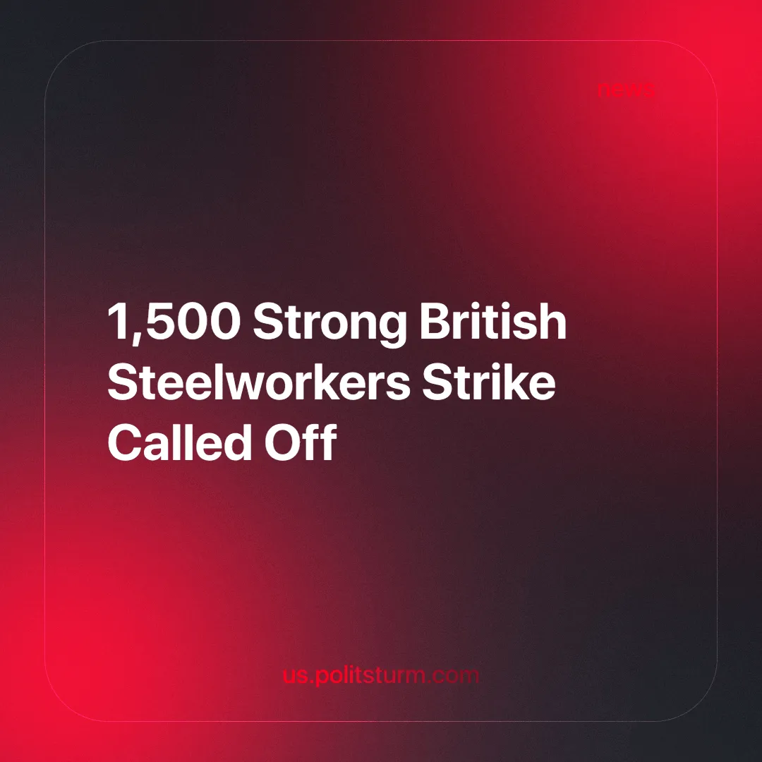

Original article
2024-07-03
4 min read

Tata Steel workers in south Wales have called off an indefinite strike originally planned for the 8th of July after a response from UK boss, Rajesh Nash, over the weekend regarding fresh talks about future investment in the site [1].
Unite made a statement saying Tata: “was now prepared to enter into negotiations about future investment for its operations and not just redundancies.” and “Investment from Labour secured by Unite will be key to the future of the site.”[1]
The original strike was in response to the company's plan to close two blast furnaces, one already beginning closure this week and the second by the end of September, and switch to a single electric arc furnace, not due to become active until 2027, which could lead to 2,800 job losses [2].
Unite, representing 1,500 workers at Port Talbot and Llanwern, led the planned strike; what would have been the first such action by steelworkers in over 40 years. Sharon Graham, Unite general secretary, stressed that the workers were "not just fighting for their jobs - they are fighting for the future of their communities and the future of steel in Wales". An earlier report suggested that the closure could lead to up to 9,500 job losses in the local area, which would devastate the working-class communities [3].
Previously, Unite workers had imposed an overtime ban and taken "work to rule"¹ action. Predictably, Tata Steel responded with threats, urging Unite to suspend action and return to talks and warning that continued industrial action would lead to the withdrawal of "enhanced redundancy packages" [2].
Following the announcement of the strike, Tata Steel escalated its retaliation by threatening to shut down both blast furnaces at Port Talbot on the 7th of July, 3 months earlier than originally planned. The company is claiming that it could not have ensured safe and stable operations during the strike, allowing them to shut the furnaces earlier than planned, capitalist law serves business above all, is the poverty caused by these shutdowns not a “safety” concern also? At the same time, this shifts the blame for the potential shutdown onto the striking workers in an attempt to pit them against each other and undermine the industrial action. Tata Steel also launched a legal action to challenge the validity of Unite's ballot [4].
Since the end of the strike, Tata Steel has announced that it will cancel plans for early closure [1].
Two other unions involved in the dispute, Community and GMB, refrained from planning immediate industrial action, opting to wait for the results of the forthcoming general election in the hope that the Labour Party will follow through on its promise of £3 billion investment in the UK steel industry, resulting in fewer job losses [5][6]. Since, Unite appears to have joined them in this hope. It should be pointed out that The Labour Party's manifesto has been publicly endorsed by billionaire John Caudwell and has declared itself the party of growth - meaning the growth of profits. It is unlikely that they will offer any real concessions for the workers, but instead further austerity.
We have previously written about a £500 million aid package given to Tata Steel to convert its operations to the 'greener' electric arc furnace. In that material, we highlighted the decline of British steelmaking since the mid to late 20th century as steel production moved to other countries in search of a higher rate of profit. The increased industrial action is a direct response to this decline, which is having a devastating effect on the local community.
But how successful would this strike have been? As of 2024, Tata Steel employs around 78,000 workers, meaning that this strike represents around 2% of their total workforce. Tata Steel is the 10th largest steel producer globally [7], it has factories all over the world and is able to take large losses with little impact on the company's profits. They are fighting a goliath. It is clear that a much wider struggle is needed to "save our steel"².
Hesitant unions hoping for concessions from another capitalist government will only achieve a managed industrial decline because capitalism ensures that production is organised to maximise profits, not to meet needs. Steel, essential to modern industrial production, is subject to uneven development driven by the profit motive, resulting in investment only where the highest returns are expected. For British steel to become profitable again, the wages of workers in Britain must be reduced.
This is shown by the huge losses made by Tata Steel despite heavy subsidies from the British government. The continuing onslaught of austerity on the British working class is designed to take social wealth out of the programmes used by workers and put it into the hands of the capitalists. Often this is used to bring in foreign investment, so any subsidies given for re-industrialisation are not a means of serving Britain and its citizens, but of allowing foreign capitalists to plunder the country. After all, Tata Steel is an Indian company.
In contrast, socialism aims for even industrial development based on societal needs, making steel production crucial for building and expanding the industrial base necessary to meet the growing needs of the people. Only through socialism, where a rational and scientific economic plan is developed with the full participation of the working class, can Britain rebuild its steel industry. Strikes are instrumental in helping workers understand these realities. As Lenin discusses in On Strikes:
“Every strike brings thoughts of socialism very forcibly to the worker’s mind, thoughts of the struggle of the entire working class for emancipation from the oppression of capital.”
Political and economic strikes can only be fully effective when their goals are fully clarified with the guidance of a genuine Marxist-Leninist party, something the UK currently lacks. We are dedicated to forming such a party. Join us in this struggle.
Sources:
1.Tata cancels early closure of Port Talbot furnaces after Unite calls off strike | Steel industry | The Guardian
2.Tata Steel workers call first strike for 40 years - BBC News
3.Port Talbot: Tata plans could cost thousands more jobs - report - BBC News
4.Port Talbot: Tata plant could shut two months early due to strike - BBC News (bbci.co.uk)
5.Labour pledges bright future for UK steel with plan to ‘Get Britain Building’ – The Labour Party
6.Tata Steel: Keep Port Talbot running until after election, union says - BBC News
7.Top Producers - worldsteel.org
Footnotes:
¹A "work-to-rule" strike is when employees perform their duties strictly according to the rules and regulations of their contract, without any additional effort or flexibility.
²A popular slogan in the UK steel strike movement.

Original article

