British Royal Family to Receive a “£45 Million Pay Rise”
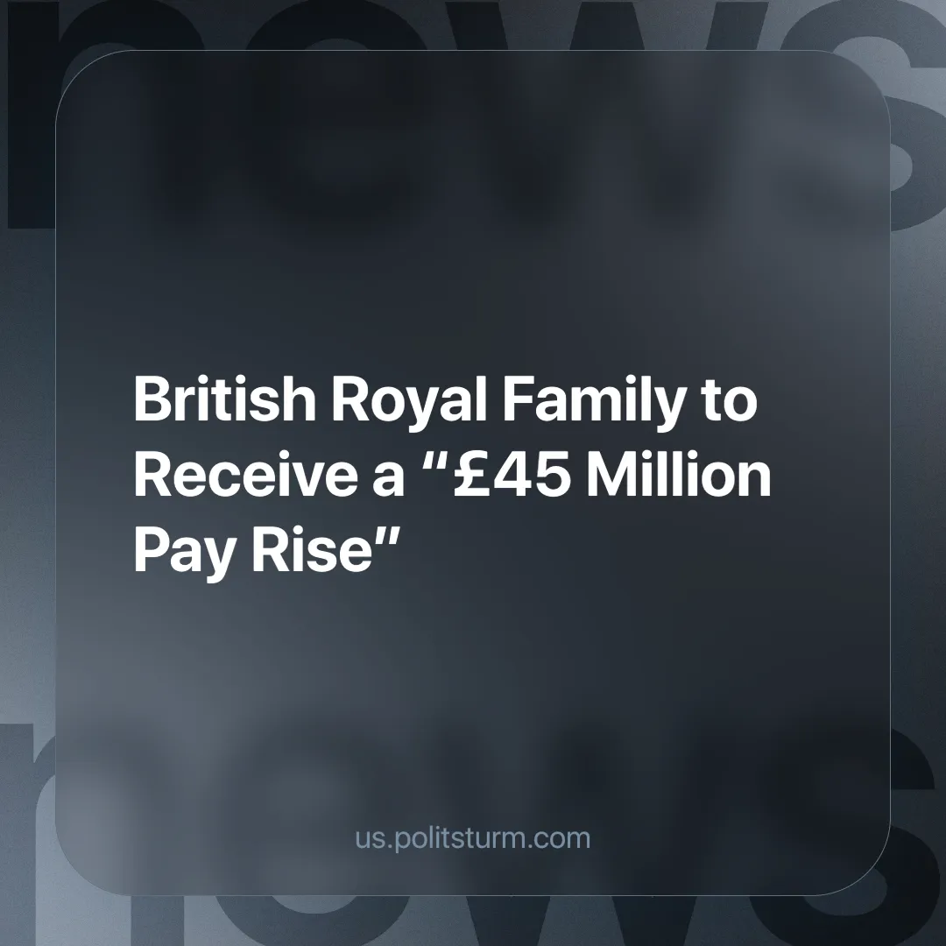

Original article
2024-09-13
3 min read

While ordinary Britons are struggling with the rising cost of living, the British monarchy is set to receive an extra £45 million in 2025, taking the sovereign grant from £86.3 million to £132 million. This 53% increase is due to the soaring profits of the Crown Estate, which is essentially a property company [1].
The Crown Estate, which owns a huge portfolio of land and property across the UK, made a profit of £1.1 billion last year, largely due to six new offshore wind farms [1].
The Sovereign Grant is the British government's mechanism for funding the "official duties" of the British monarchy, such as the completion of the final stages of a 10-year, £369 million renovation of Buckingham Palace and two new helicopters, which officials say the new revenue will be used to pay for [2].
Of course, last year the King, in his 'humility', requested that the monarchy's funding be reduced from 25% to 12% of the Crown Estate's net profits, ostensibly because he wanted the profits to be used for the 'wider public good'; despite this reduction, they still have the aforementioned extra £45 million [2]. The remaining profits go to the UK Treasury, presumably to be used to subsidise private companies in the interest of the 'public', who may even be working on similar 'green' projects on the King's land [3].
But where does all this wealth come from? From the royals themselves? No, it does not. The royal family is a relic of the feudal mode of production when kings and lords owned large estates by the 'right of God'.
A "mode of production" refers to the way in which people secure their means of subsistence and where the surplus is distributed. It is made up of two integral parts, the first being the productive forces, such as raw materials, human labour, the tools we use and so on. As well as the relations of production, which are the definite relations formed between different people, groups and classes in the process of production, such as capitalist relations. The currently dominant capitalist relations consist primarily of a class of people who own no other means of living than the sale of their ability to labour (the working class) and those who own the land and means of production to whom the workers sell their labour (the capitalists).
In the feudal mode of production, economic power was based on land ownership and wealth was generated through agricultural labour by peasants who were tied to the land and obliged to serve their landlords. As capitalism rose and the feudal mode died out, the royal families either lost state power in revolutions or found ways to integrate themselves into the capitalist system.
In 1760, King George III transferred the Crown lands to the new capitalist state in exchange for a fixed annual payment, then known as the Civil List. This allowed the monarchy to adapt its wealth to the new capitalist mode of production while ensuring financial stability through state support. In essence, this hasn't changed to this day.
The Crown Estate's profits today are, of course, made possible by the extraction of surplus value, i.e. the value produced by workers in excess of their wages, mainly through rent from private companies using its land and property. The workers who build and maintain the wind farms generate surplus value through their labour, which is first extracted by the private company running the operation, and then, simply by owning the land, the monarchy takes a share of the surplus extracted by the private company.
As always, the capitalist minority lie on their backs and profits while the majority of workers become increasingly impoverished. They are now an unnecessary element in the organisation of production; everything in the modern world is made with the labour of thousands of workers around the world. Production is overwhelmingly social, but the majority of the results of said production are appropriated by a handful of billionaires. Instead, modern large-scale production can be planned on a scientific basis and by and for the workers themselves to meet the growing needs of the majority of working people.
To achieve this, the workers must have a party that works for their objective class interest, socialism, on the basis of the scientific doctrine that best reflects their interests, Marxism-Leninism. At present there is no such party in Britain. We are in the process of training the future cadres and forming such a party. Join us.
Sources:
[1] BBC News — "Royal finances: Monarchy to get £45m extra funding" — July 24, 2024.
[2] Evening Standard — "Royal family’s income to rise by £45m after Crown Estate profits surge" — July 24, 2024​.
[3] GOV.UK — "Record breaking funding for clean energy in Britain" — July 31, 2024.

Original article

