UK State to Raise Taxes and Cut Spending
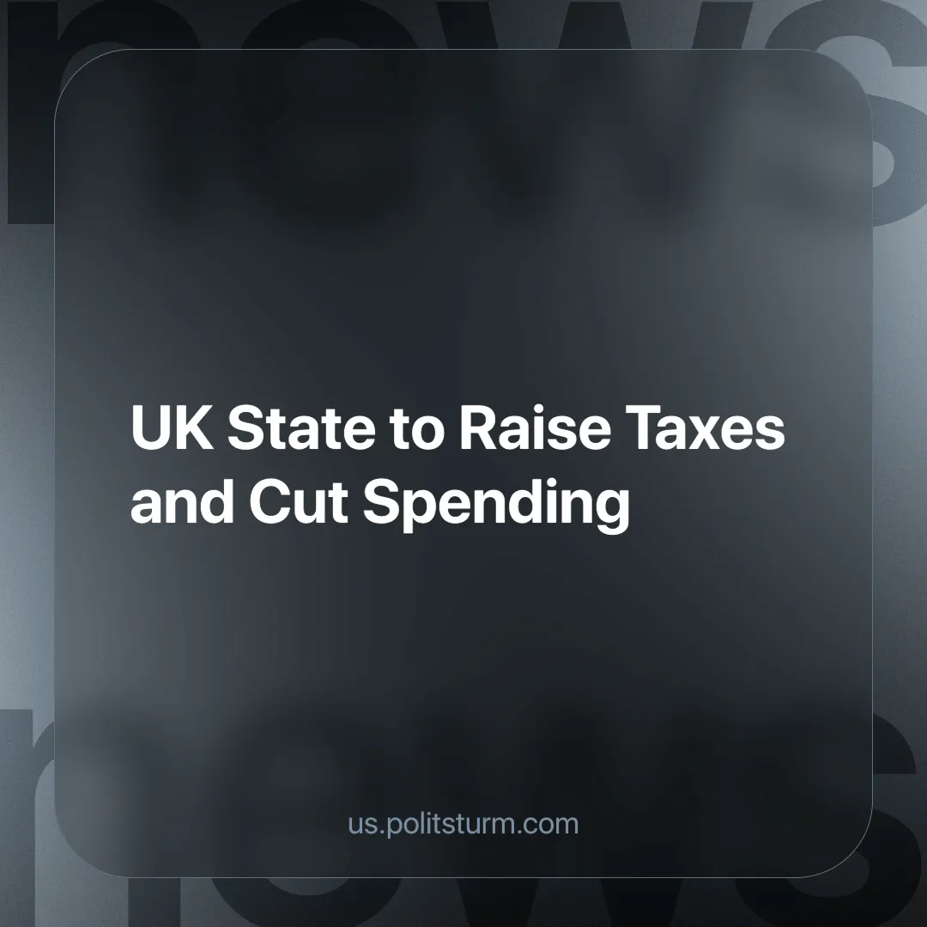

Original article
2024-09-05
3 min read

The UK’s Chancellor of the Exchequer, Rachel Reeves plans to raise taxes and cut spending in the British state’s October public budget. Of course, as usual, this will fall on the shoulders of the working class [1].
After being sworn into Parliament in July, the new Labour government insisted that it had a £22 billion "black hole" to fill in the public finances. This claim comes from the HM Treasury's 'Public Spending Audit', which highlights a number of 'unfunded policy decisions' made since the 2021 Spending Review that have 'increased the pressure on public spending in 2024-2025 by a total of £2.6 billion'. These policy decisions included: additional funding for buses, including an extension of a £2 fare cap; the extension of the Household Support Fund, which provides essential payments to struggling families; spending on asylum support; and military aid to Ukraine [2].
Referring to the audit, the Chancellor claimed that the current government was unaware of the overspending and that it had been covered up by the previous Conservative government [3]. She followed this with the announcement that there would be £5.5 billion worth of cuts in 2024 and over £8 billion in 2025. It seems they are planning to ease the working class into more austerity, well, isn't that kind [4]!
The Office for Budget Responsibility (OBR) has since launched a review to see if the Chancellor is right to say that the Conservative government lied, while the director of the Institute of Fiscal Studies(IFS), Paul Johnson, has said that 'not everything we have heard should have come as a terrible surprise'. In May, the IFS had predicted that many public services would "face cuts of between £10 billion and £20 billion a year" [4].
Following the announcement of the "£22 billion black hole", Rachel Reeves immediately announced major cuts to hospital and road projects and the scrapping of the universal winter fuel payment for pensioners, affecting around 10 million older people. “Anti-poverty” groups such as the End Fuel Poverty Coalition have criticised the cuts, stating that this winter "some older people will face the highest energy bills on record", while potentially creating a public health emergency [5][6].
This brings us to the current situation, where the Labour government is now preparing people for further spending cuts and higher taxes. On 27 August, the PM, Keir Starmer, gave a speech in which he warned that the budget would be "painful" and asked the country to "accept short-term pain for long-term good" [6].
He has supposedly ruled out tax rises on who he refers to as "working people", while at the same time concealing the content of the spending cuts, which are essentially a reduction in the workers’ share of the social wealth. Any possible tax increases will generally serve to subsidise capitalist projects across Britain in the name of "growth", i.e. the growth of profits.
The Labour government represents the same interests as the previous Conservative government or any other capitalist state. That is to maintain the rule of capital and to ensure maximum profit. With the whole world divided into different capitalist blocs and the crisis of profitability deepening, the capitalist class in all countries has laid siege to its own domestic working class, taking back concessions won by previous workers' movements during periods when they were more organised and powerful.
The capitalists are only able to do this because of the absence of a strong workers' movement, whose objective political goals are brought to consciousness by a genuine party of the working class, made up of workers armed with the scientific theory that fully reflects their interests: Marxism-Leninism.
There are no such parties in Britain, and we are working to train the future cadres of such an organisation, as well as the formation of the party itself. Join us
Sources:
[1] The Guardian — "Rachel Reeves planning to raise taxes and cut spending in October budget | Autumn budget 2024" — August 20, 2024.
[2] GOV.UK — "Fixing the foundations" — July 29, 2024.
[3] UK Parliament — "Public Spending: Inheritance - Hansard" — July 29, 2024.
[4] Full Fact — "Is Labour right to claim the public finances are worse than expected?" — July 30, 2024.
[5] The Guardian — "Reeves scraps social care cap and some winter fuel payments to plug ‘£22bn hole’ | Rachel Reeves" — July 29, 2024.
[6] BBC News — "Budget will be painful, Keir Starmer warns in Downing Street speech" —August 27, 2024.
[7] GOV.UK — "Keir Starmer's speech on fixing the foundations of our country: 27 August 2024" — August 27, 2024.

Original article

