UK PM and Conservative Leader: "We are the party of property-owning democracy"
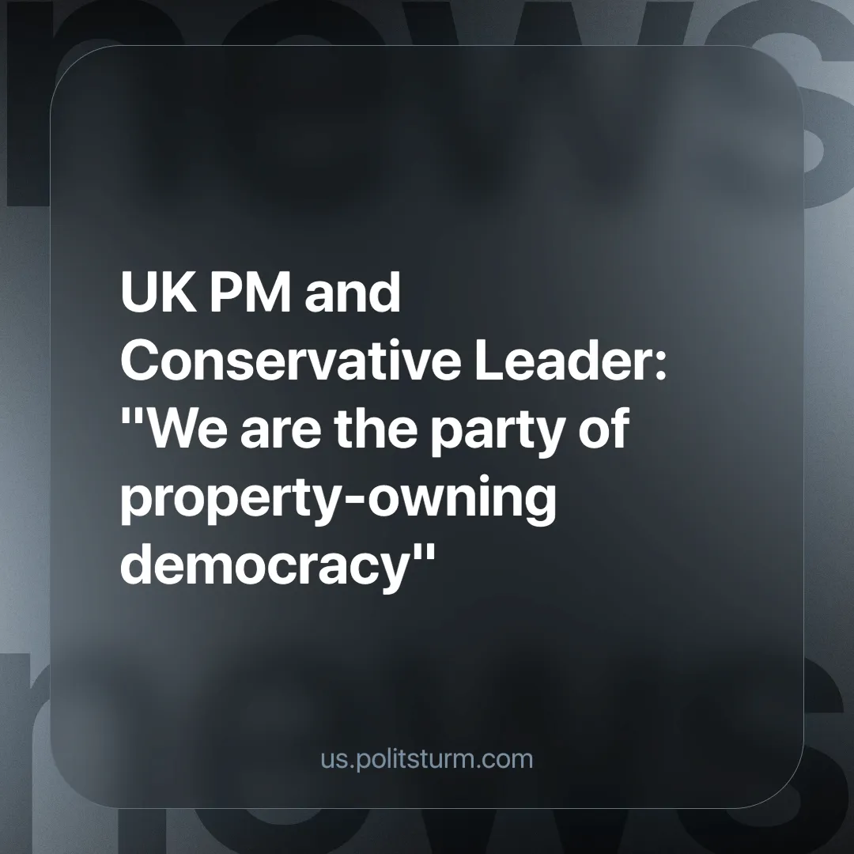

Original article
2024-06-21
3 min read

On 11 June, the UK Conservative Party launched its manifesto. After announcing a pledge to abolish stamp duty for first-time buyers permanently, it declared, "We are the party of the property-owning democracy!" This is true, but for which owners of property?
The Prime Minister promised to introduce a raft of measures to "help a new generation get on the property ladder" [1], including a "new and improved" 'Help to Buy' scheme, plans to permanently cut stamp duty for first-time buyers on properties up to £425,000, a target to build 1.6 million new homes over 5 years, a ban on no-fault evictions and finally a tax cut on profits for landlords who sell homes to tenants [2].
The previous £29 billion 'Help to Buy' scheme allowed buyers to put down a 5% deposit in return for the UK government providing an equity loan of up to 20% of the property's value (40% in London), with the remainder of the house covered by a mortgage. The scheme has since been criticised in a House of Lords report for failing to increase housing supply and actually inflating house prices [3]. The National Audit Office found in its report that the scheme significantly benefited large property developers, with five companies accounting for half of all sales using the scheme [4].
As the proposed new policy is aimed at a 'new generation', it is important to highlight home ownership by age group. Data collected by the Institute for Fiscal Studies shows that over the past 20 years, home ownership among adults aged 25-35 has fallen from 55% in 1997 to 35% in 2017 [5].
When Rishi Sunak mentions so-called 'property-owning democracy', he is invoking a Thatcherite fantasy in which every Briton has a stake in the domestic market, and as such has a greater degree of control over their own finances and freedoms. This tactic is used to make ordinary people believe that they too will have a stake in their policies of 'growth', while at the same time besieging the welfare measures for ordinary working people, providing them with austerity and subsidies for the rich instead.
The basis of capital is the extraction of surplus created by a worker who has nothing else to sell but his or her own ability to work (i.e. they own no private property). A class of dispossessed workers, compelled to sell their labour to the owners of the means of production, is a prerequisite for capitalism. The more destitute this class is, the more desperate they are and so the cheaper they agree to sell their labour. In addition, every penny that the capitalist remunerates the labourer with is a penny that the capitalist is not taking as profit themselves. Consequently, the workers are increasingly impoverished - those who do not own any private property are even being stripped of much of their personal property - while the owners of capital continue to multiply their wealth!
Therefore, the interests of the workers and capitalists are irreconcilable and antagonistic. So the dream of a "property-owning democracy" collapses and all that remains is a democracy for the present private property-owning classes, i.e. the capitalists, which is in effect a dictatorship of their rule over the labouring classes. In this sense alone, Rishi Sunak is an honest man.
There are already plenty of empty houses in Britain to deal with any real immediate 'housing shortage', but in capitalist nations, houses aren't built for living in, they are treated like anything else, as a commodity to be bought and sold on the market. That is why thousands of new luxury developments spring up to be bought as second or third homes, or be speculated on by the rich, while thousands go homeless. This means that under capitalism the question of who gets housing can ultimately only be answered by supply and demand. Previous "social" housing policies, designed to moderate the market and thus calm the temper of a revolutionary movement that emerged in the middle of the last century, are now being dismantled and plundered in the absence of both a strong revolutionary movement domestically and an emerging socialist bloc internationally.
To really tackle the housing crisis we need to go beyond these superficial reforms. The state under capitalism serves the interests of capital, not the working class. Only a socialist state can solve the housing problem through rational and democratic planning of the economy so that it serves the many, not the few. This can only be achieved under the leadership of a genuine Communist party, guided by Marxism-Leninism, which does not currently exist in Britain.
Sources:
1.Live coverage of Conservative manifesto launch (youtube.com)
2.Rishi Sunak promises to relaunch Help to Buy scheme - BBC News
3.Help to Buy has pushed up house prices in England, says report (ft.com)
4.Help to Buy scheme handed billions to people who could afford homes, spending watchdog finds | The Independent | The Independent
5.GB9%2520-%2520housing%2520pre-release%2520-%2520final%2520from%2520Judith.pdf (ifs.org.uk)
6. Home ownership in the UK: Key statistics for 2024 - Finder UKPreview

Original article

